2nd Grade English Exam ( second Term ) for the first period ( Unit 6 )
Student’s name : ………………………………………………….. class : ……………………….

- Read the following passage and answer the questions below:
Food , exercise and sleep are keys to good health . Food keeps us strong and helps us grow . A young man needs more food than an old man . Boys usually eat more than girls . Exercise helps the muscles to keep strong and it is good for the circulation of the blood . Sleep and rest also necessary for a healthy life .
A-What are the keys to good health?
……………………………………………………………………………
B- Choose :
- a young man need ( more – less – same ) food than an old man.
- ( Food - exercise – sleep ) is necessary for a healthy life .
C- Put ( √ ) or ( × ):
1-Boys eat more than girls ( )
2-Sleep helps the muscles to keep strong and is good for the circulation of the blood ( )
3-Food keeps us strong and helps us grow ( )

- Grammar :
A - ( choose the correct answer ) :
- Where ( was – were – am ) the football game ?
- They ( was – were – do ) at school
- I ( go – went – going ) to my friend yesterday.
- We ( ate – eat – eats ) at a restaurant last weekend.
- We ( wasn’t – weren’t – not were ) invited in the party last night.
- They ( played – plays – play ) the match yesterday.
- The cake is ( very – extremely ) delicious .
- It ( was – were – am ) hot last night.
- Vocabulary :

A -Choose the correct number from (A ) and write in ( B )
(A ) (B)
 |  | That's too bad | 1
To show you are sorry about something |  | You did? | 2
To express surprise |  | Out of this world | 3

B - ( Write the correct word under the picture ) :
Angry – robot - calligraphy - nervous - sleepy

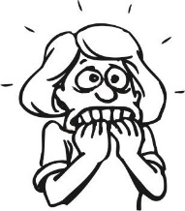
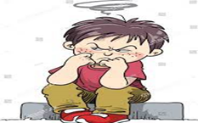


Good luck Teacher : Samia Al Saeed
-------------------------------
-------------------------------
-------------------------------
-------------------------------

