Name: ……………………………….. Class 1/….. First Period Exam – Second semester

---------
Comprehension; Read the text and answer the questions.
My name is Amal. I'm Saudi. I live in Madinah.
I'm fourteen years old. My email address is Amal@web.com.
My phone number is 555-310-998.
A) choose the correct answer:
1- Amal is from............ a) Oman b) Yemen c) Saudi Arabia
2- she lives in............ a) America b) Canada c) Madinah
3- she is...........years old a) eighteen b) fourteen c) nineteen
4- Her email address is........ a) hameed@web.com b) ali@web.com c) Amal@web.com

A-Match the pictures to the correct word:
1.mall 2.rug 3.hotel 4.stove 5. sofa
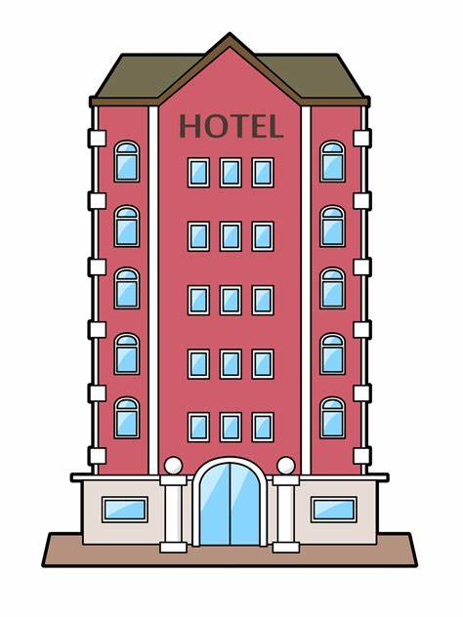

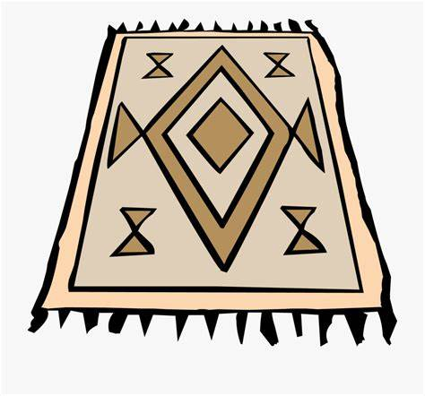
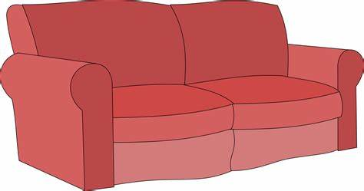


.............…… …………….. …………… …..…..….….. ……………..
B- Choose:
1-We live ( in – on – for) the twelfth floor.
2-Healthy food is ( good – better – best ) than fast food.
3-Ahmad is ( tall – taller – tallest ) than Ali.
4-( Is – Am - Are ) there curtains in the kitchen?
5-We read ( or – and – but ) write in class.

D-make a question then answer.
1-There is a desk in the bedroom. ……………………………………………………….……?

E-Choose the correct answer.
1-The mouse is ( under – far from )the table. 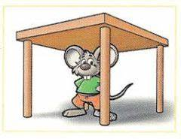

2-the fox is (between – next to ) the tree. 

F-Unscramble the words:
- paml …………………… 
- nkba ……………….… 


G-Write the missing letters.
- .b---d ( h – e– o )

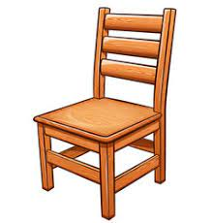

- ch---ir ( c – a – m )

GOOD LUCK
T/ Areej AlHausoni

