20

English Language
Midterm Exam
\3\1444
King of Saudi Arabia
Ministry of Education
4th Intermediate Grade

Class\ |  | Student's name

4
Section A: Write a paragraph about your House:
1. What is your name? Where do you live?
2. Do you live in a house or an apartment?
3. How many rooms your house has?
4. What is your favorite room?
______________________________________________________________________________
______________________________________________________________________________
______________________________________________________________________________
______________________________________________________________________________
______________________________________________________________________________
Section B: Read and answer the following questions:
My favorite mall is Al-Othem Shopping Centre. It is in Dammam .It is very big and it has many floors. There are many shops. It also has a large supermarket. There are many places that sell tasty food. Shopping in Al-Othem is easy.
5
A-Question :
1-Where is Al-Othem shopping centre ?
…………………………………………………………………………..
2-Are there many shops ?
……………………………………………….
B-Choose :
1- There is a large …………………………….. in AL-Othem shopping centre .
A. pharmacy B. supermarket C. bank
C-Put ( ) or ( ) :
1- Shopping in AL-Othem is easy. ( )
2- AL-Othem has one floor. ( )
5
Section B: "Grammar" Choose the correct answer
1. ___________ some flowers on the table. They look nice.
a. There aren’t b. Is there c. There are d. are
2. 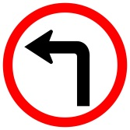
a. Turn left b. Go down c.Turn right d. Go staight
3.The apple is ……… the boxes 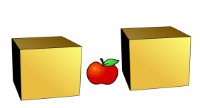
a. far from b. on c. in d. between

4- Make this sentence negative:
There is a bathroom downstairs
----------------------------------------------
Complete the sentences with the comparative or superlative forms of the adjectives.
1. The bookstore is ________than the library. (popular)
2. That restaurant has the ___________ food in town. (bad)

Write (or, but, and )to fill in the blank.
1. There’s a bed ____ a mirror in the bedroom .
2. You can read a book _____ a story.

Section C: Vocabulary" Write the correct word under each picture:
5

( bathtub – dining table – flowers - bed - stove)

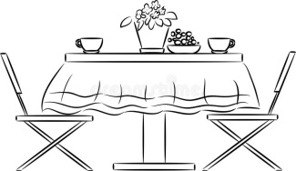 | 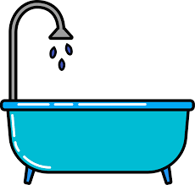 | 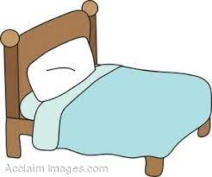 | 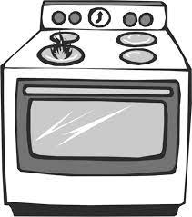

Match the words with their meaning.
1. a place to buy a book |  | a. Restaurant
2. a place to take a walk |  | b. Book store.
3. a place to eat |  | c. Park

1
Write the missing letters :
- The bathroom has a (si.…k)
- I put my book on the (t...ble)
- Our class in on the second (f..oor)
- I exercise at the (g..m)

Good luck Miss.Massoma

