

المملكة العربية السعودية الصف الرابع الابتدائي
وزارة التعليم الفصل الدراسي الثالث
مدرسة : ........................................... الزمن : ____ ساعة

الاختبار النهائي لمادة اللغة الإنجليزية للصف الرابع الابتدائي الفصل الدراسي الثالث للعام الدراسي __________ هـ

-Choose the correct answer:
- He is -------- 
- Happy b- Scared c – hungry d- angry
__________________________________________________________
- He is -----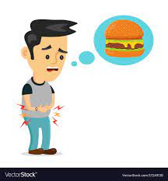
a-Happy b- Scared c – hungry d- angry
_______________________________________________________
- Do you have a pet?

- Yes, I have a fish . b- I like English c- I am hungry d- No, thanks.

_________________________________________________________
- What is the matter?

a- I like Friday b- I like English c- I am hungry d- No, thanks.
_____________________________________________________________
- It is -------- to day. 

a – sunny b- rainy c-cloudy d- snowy
______________________________________________________________________

- Sunday., Monday , Tuesday ---------

a- Friday b- Saturday c- Thursday d- Wednesday
______________________________________________________________________
- ---eep 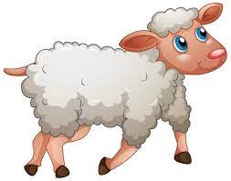

- Sh b- S c- R d- M

8-The sound of bird is----------

Cluck ,cluck b- Tweet,tweet c- Moo,moo d- Baaa,baaa
______________________________________________________________________
9- What day do you like ?

- I like pizza b- I like Sunday c- I like orange d- I like English
______________________________________________________________________
10- ----- iger
- T b- M c- F d- N
__________________________________________________________ 11- 20 – 21 - ------ - 23

- 22 b- 24 c- 26 d- 28
__________________________________________________________ 12- 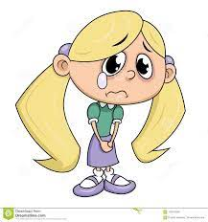She is ------

- Happy b- sad c- thirsty d—scared
__________________________________________________________ 13- These are 2 ---------- 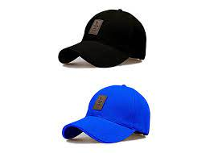

- Cap b- caps c- shoes d- skirt
__________________________________________________________
14-Those T-shirts ------ blue.

- Is b- are c- am d- on
__________________________________________________________
15- This is a ----------- 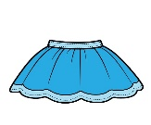

- Glasses b- shoes c- cap d- skirt
__________________________________________________________
16- This is a -------------------------- 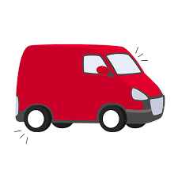

A- fan b- van c – tap d- bear
17- The weather today is -------------------------------
a- sunny b- cloudy c- rainy d- snowy
__________________________________________________________
18- This is a ----------------------------------------- 
a- van b- vase c- laptop d-umbrella
__________________________________________________________
19 – The weather today is ---------------- 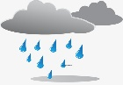

a- sunny b- cloudy c- rainy d- snowy
_________________________________________________________
20 - How many circles? 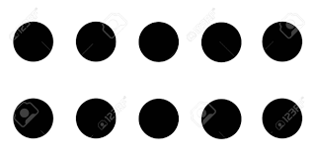

- 10 b-20 c-30 d-40
_________________________________________________________
21 – This is a ------------------------- 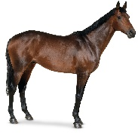
- Zebra b- wolf c- fox d- horse

______________________________________________________________________
22- Are these your shoes?

a- Yes, Iam. b- Yes, she is. c- Yes, it is. c- Yes they are.
____________________________________________________________________
23 – Are you happy? 
- Yes, I am. b- Yes,she is. c- Yes, he is. d-Yes, it is.

24- How many stars ? 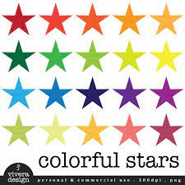

a- 10 b- 20 c- 30 d- 40
____________________________________________________________________
25- I ------------ scared.

A- is b- am c- are d- it.
____________________________________________________________________
26- He ------- a farmer.
a- am b- is c- are d-have
____________________________________________________________________
27- ------ icken 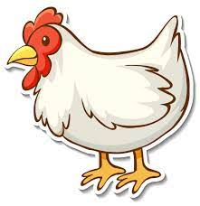
a- s b-ch c- k d- th

____________________________________________________________________
28- The capital letter of ( r) is:

- V b- G c- R d- M
____________________________________________________________________

29- The capital letter of (g) is:
- N b- G c- D d- F
____________________________________________________________________
30- Who is sleepy? 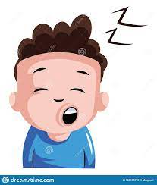

A-They are sleepy b-You are sleepy c- He is sleepy. c-We are sleepy.
____________________________________________________________________
Best wishes ...

