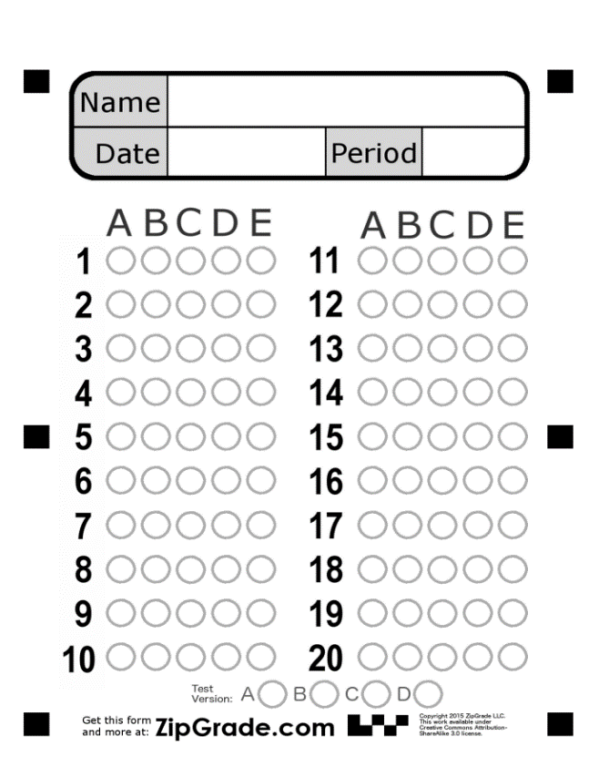
Listening:

Listen to the audio “Personal Profile” then answer the following questions:

1-The man's name is ……………………:
a-Krain.
b- Greg.
c- Georg.

2-where was he born? :
a-Arizona.
b-Kansas.
c- Colorado.

3-What is his major in university?
a-He is majoring in Economy.
b-He is majoring in English studies
c-He is majoring in Telecommunication

4- where does he work?
a- at a book store.
b- at a restaurant.
c-at a grocery store.

5- what is thing the man like to do in his free time? :
a-driving
b- camping
c- reading

Listening

Listen to the audio “Personal Profile” then answer the following questions:

1-The man's name is ……………………:
a-Krain.
b- Greg.
c- Georg.

2-where was he born? :
a-Arizona.
b-Kansas.
c- Colorado.

3-What is his major in university?
a-He is majoring in Economy.
b-He is majoring in English studies
c-He is majoring in Telecommunication

4- where does he work?
a- at a book store.
b- at a restaurant.
c-at a grocery store.

5- what is thing the man like to do in his free time? :
a-driving
b- camping
c- reading

Good Luck …. Tr. Alia Alsalman

Test # 1 – Listening
Name: Class:

