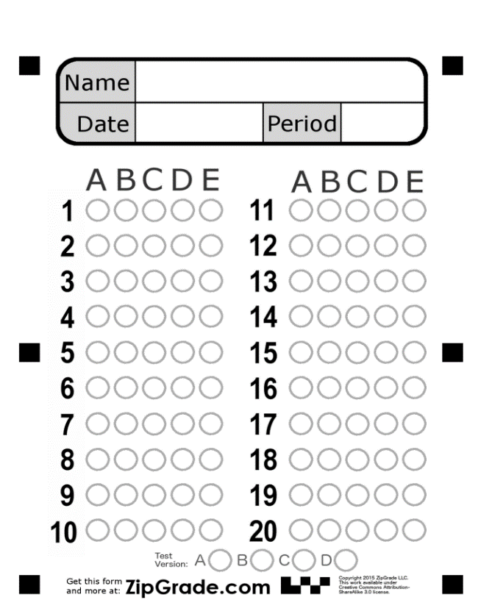
Listening

Listen to the audio “Sleeping Problem” then answer the following questions:

1-The man wakes up at …………….. :
a-12:00 p.m.
b- 1:00 p.m.
c- 2:00 p.m.

2-Where does the man need to go today?
a-He has a job interview.
b-He is going to work.
c- He has a class.

3-The man’s sister feels that he should get up at …….. :
a-6:45 a.m.
b-6:14 a.m.
c-6:30 a.m.

4- His sister tells him to go to bed at ……. for his routine :
a- 9:00 p.m.
b- 10:00 p.m.
c-09:30 p.m.

5- His sister has seen him fall asleep while he was…… :
a-driving
b- watching TV
c-eating dinner

Good Luck …. Tr. Alia Alsalman

Listening:
Listen to the audio “Sleeping Problem” then answer the following questions:

1-The man wakes up at …………….. :
a-12:00 p.m.
b- 1:00 p.m.
c- 2:00 p.m.

2-Where does the man need to go today? :
a-He has a job interview.
b-He is going to work.
c- He has a class.

3-The man’s sister feels that he should get up at …….. :
a-6:45 a.m.
b-6:14 a.m.
c-6:30 a.m.

4- His sister tells him to go to bed at ……. for his routine:
a-9:00 p.m.
b- 10:00 p.m.
c-09:30 p.m.

5- His sister has seen him fall asleep while he was…… :
a-driving
b- watching TV
c-eating dinner

Test # 1 – Listening
Name: Class:

Test # 1 – Listening
Name: Class:

