1- Composition
6
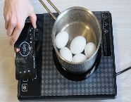
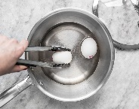
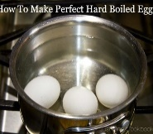
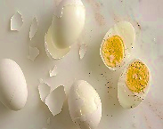
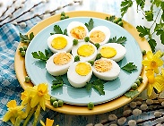
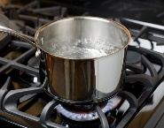
* Write a paragraph about ( How to make boil eggs ) use the answers of these questions :
1-First…………………
a) peel three banana b) boil some water
2- Next……………………
a) Cut up the bananas b) put the eggs into the water
3- after that……………………….
a) white 3-5 minutes b) put the bananas into the blender
4- Then…………………….
a) remove the egg from the water b) pour the milk into the blender
5- Next………………….
a) turn on the blender b) add some salt
6- Finally……………………….
a) drink the banana milk shake b) serve the eggs
How to make boil eggs
...................................................................................................................................................................................................................................................................................................................................................................................................................................................................................................................................................................................................................................................................................................................................................................................................................................................................................................................................................................................................................................................................................................................................................................................................................................

( 2 ) اقلبي الصفحة

2- Comprehension
Read the passage then answer the questions*
Dentist
I am John and I am a dentist Check your teeth and gums. Some patient come to my office with very bad toothaches. I treat all my patients properly and tell them to smile always. In my free time l love to sing
---------------------------------------------------
6
Answer the following questions:
A – Choose the correct answer:
1) John is……………
a- Doctor b- teacher c- dentist
2) What does John love in his free time?
a- dance b- sleep c- sing
3) His name is…………………..
a- John b- Jake c- Mole
4) he check your…………………..
a- teeth and gums b- legs and hands c- eyes and ears
------------------------------------------------------
B- Choose the correct answers ( True) or ( False )
1) In his free time he love to sing
a- True b- False
2) he tell his patients to crying always
a-True B- False
---------------------------------------------------------------------------------------------------------------------------------------
3- Grammar
A – Choose the correct answer:
1- They .............work in school.
7
a) don't b) doesn't c) isn't
2- Is there .........................juice ?
a) too b) any c) as
3- The neighbor..................................lives downstairs is a chef t?
a) who b) which c) when
-------------------------------------------------------
( 3 ) اقلبي الصفحة

4- Are you working ?
a) yes, they are b) yes, I am c) yes, he is
5- She ………cooking lunch now
a) is b) are c) was
6- I eat ......................................apples
a) to many b) to much c) alot
-------------------------------------------------------------
B- The present form from these verb :
7
1- He ( go ) a) went b) was c) goes
-------------------------------------------------------------------------------------------------
4- vocabulary

A – Choose the correct word under each pictures:
--------------------------------------------------------------------------------------------------------
 | 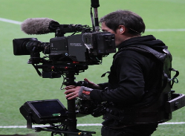 | 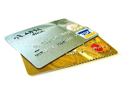 | 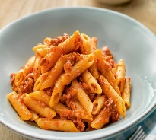 | 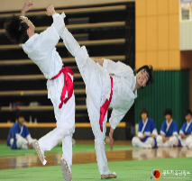 | 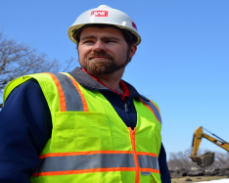
a- eating in restaurant  b- sleeping in hotel  c- swim | a- Director  b- Cameraman  C- actor | a- credit card  b- hotel  c-address | a-soup  b-pasta  c- fish | a- martial art  b-football  c-basketball | a-lawyer  b- civil engineer  c- teacher
B- Choose the right opposite of these word :
1- ( inside )X ……………… a) in front b) outside c) read
------------------------------------------------------------------------------------------------------------------
5- Orthography

4

C- Choose the correct litters :
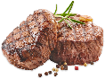
1- nu.......s a) g b) r c) d
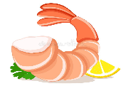
2- stea…………. a) r b) k c) h
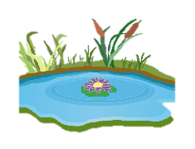
3- shri….p a) m b) n c) w
4- po……d a) e b) n c) z

( 4 ) انتهت الأسئلة مع تمنياتي لكن بالتوفيق

