Revision Unit 2 – Sea Animals

AA

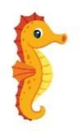
Choose

1. What is that?
A . It's a seahorse. B . It's a seal.
- What do you think about sharks?
A. I like dolphins. B. I think they are scary.
3. Which of the following is a sea animal? A . seahorse. B. horse.
ة

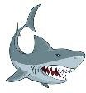
Circle the correct answer.

1. This is a shark. |  | 
2. The dolphin is cute.  |  | 
3.starfish has 6 arms. |  | 
4.octopus has 8 arms. |  | 

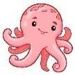
- Unscramble and write
  - think - I – whales – fast - are.
………………………………………………………………………………………………
  - a – the – There – is – chair – on – mouse
………………………………………………………………………………………………
  - s – l l – g – u – a – e .
………………………………………………………………………………………………

Choose.
- Baby seals are (cute – cuter- the cutest) than seahorse.
- Whales are ( big – bogger-the biggest).
- As ( slow – slower – the slowest) as a seahorse.
- A dolphin is the ( fast – faster – fastest) .
- What ( is - are – am ) those?
- Starfish ( has - have ) 5 arms.

5. Do as shown brackets.
- A dolphin is cuter.

( correct)

- I think sharks scary. ( complete)

Write.

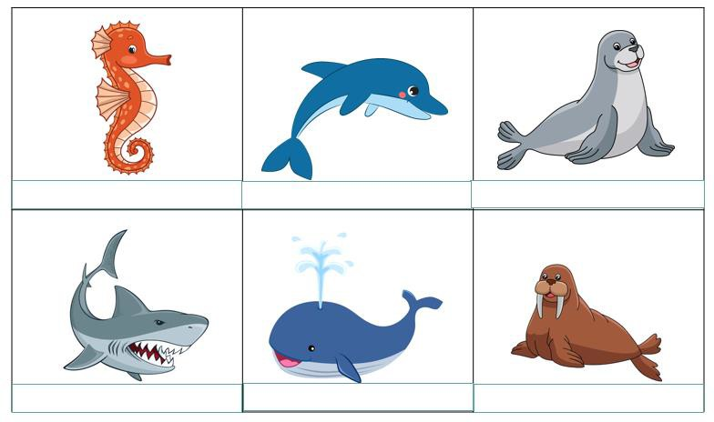
seal - seahorse – walrus -shark -dolphin - whale





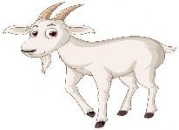
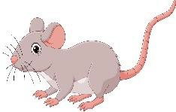
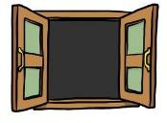
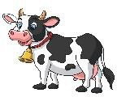

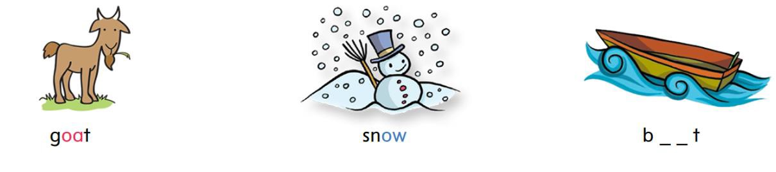
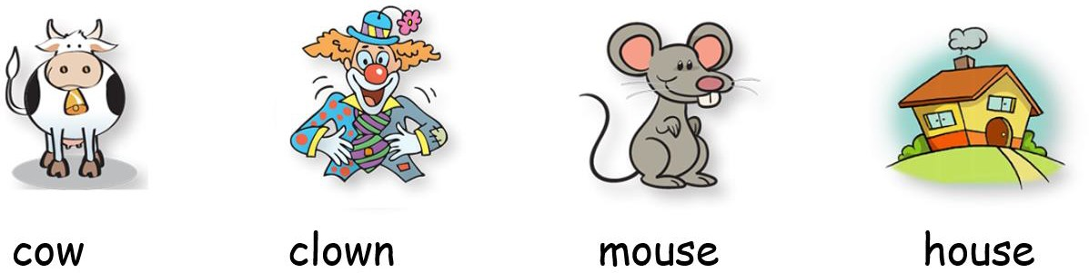
- Match
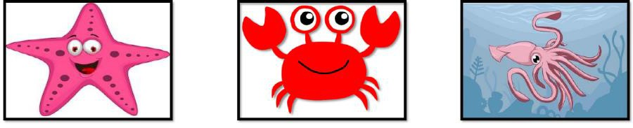
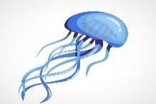
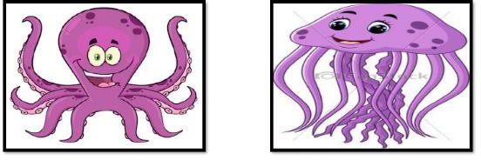
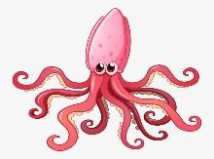

Crab starfish squid jellyfish octopus


Choose the correct letter: ( ou - ow - oa )

g_ _t sn_ _ b_ _t
h_ _se c_ _ m_ _se g _ _ t wind_ _

c_ _ cl_ _n m_ _se h_ _se

