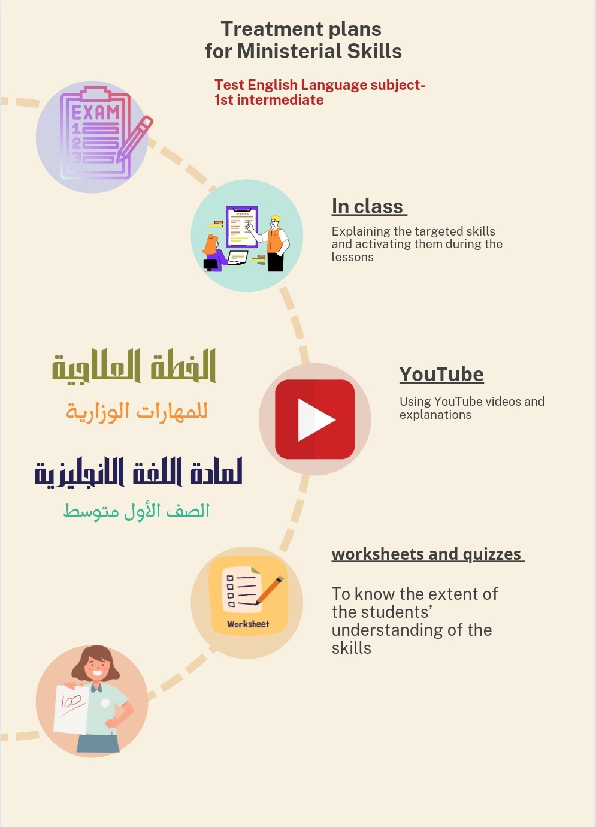

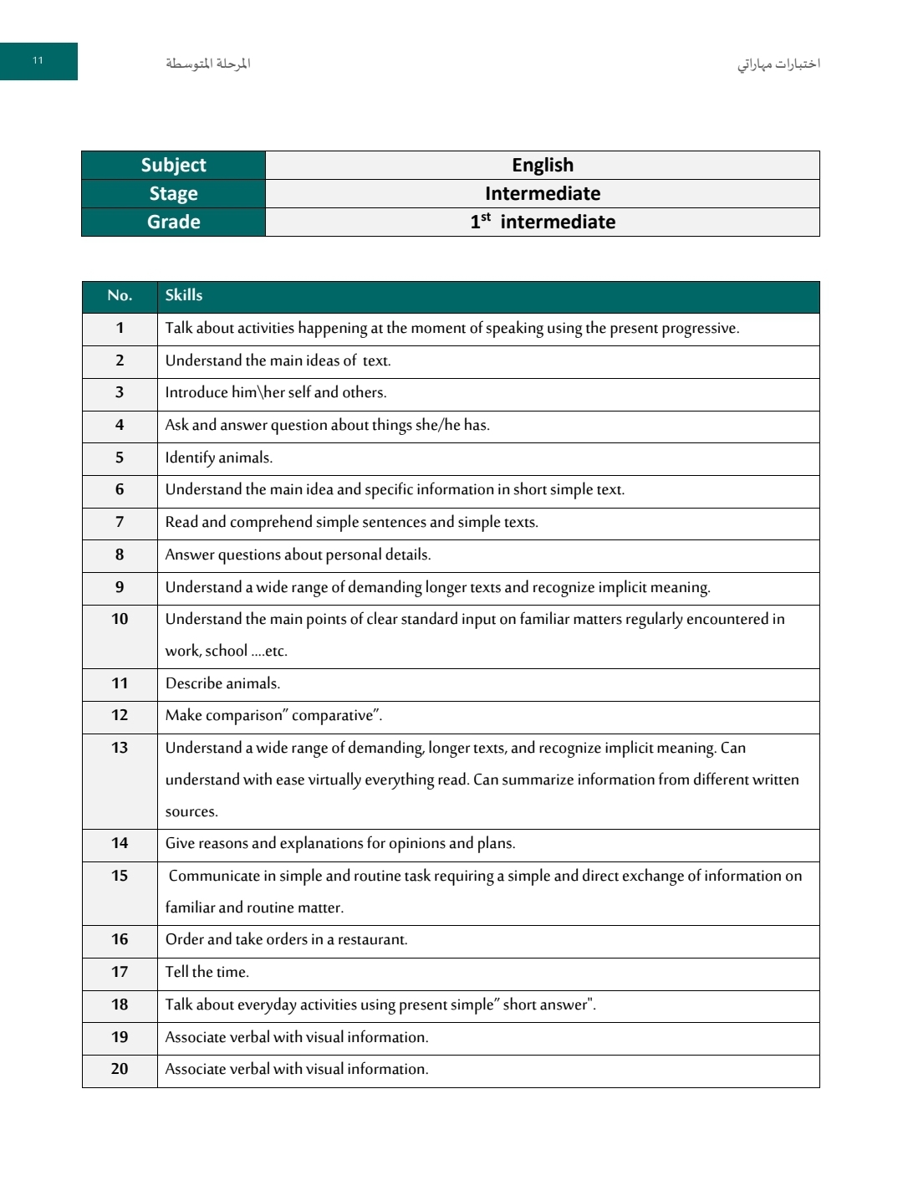

الإجراءات المتبعة لعلاج المهارات المفقودة
للصف الاول متوسط

Procedure 1 | Procedure 1 | Skills. | No
WORKSHEET | ACTIVATE QUESTIONS AND CONVERSATIONS ABOUT INTRODUCING THEMSELVES AND  OTHERS DAILY IN CLASS | INTRODUCE HIM HER SELF AND OTHERS. | Skill 3
https://www.liveworksheets.com/w/en/english-second-language-esl/1620180 | ACTIVATE QUESTIONS RELATED TO PERSONAL DETAILS AND ANSWER THEM DAILY IN CLASSES | ANSWER QUESTIONS ABOUT PERSONAL DETAILS. | Skill 8
https://www.liveworksheets.com/w/en/english-second-language-esl/47390 | https://www.youtube.com/watch?v=Rs-UA2jOry0&t=290s | MAKE COMPARISON" COMPARATIVE" | -Skill-12
https://www.liveworksheets.com/w/en/english-second-language-esl/625733 | https://www.youtube.com/watch?v=0DS4X7YDjeA | TELL THE TIME | Skill-17
https://www.liveworksheets.com/w/en/english-second-language-esl/970938 | EXPLANATION OF THE  SIMPLE PRESENT TENSE RULE AND ITS USES  https://www.youtube.com/watch?v=7nc03DZr1gY&t=1253s | TALK ABOUT EVERYDAY ACTIVITIES USING PRESENT SIMPLE" SHORT ANSWER | Skill-18

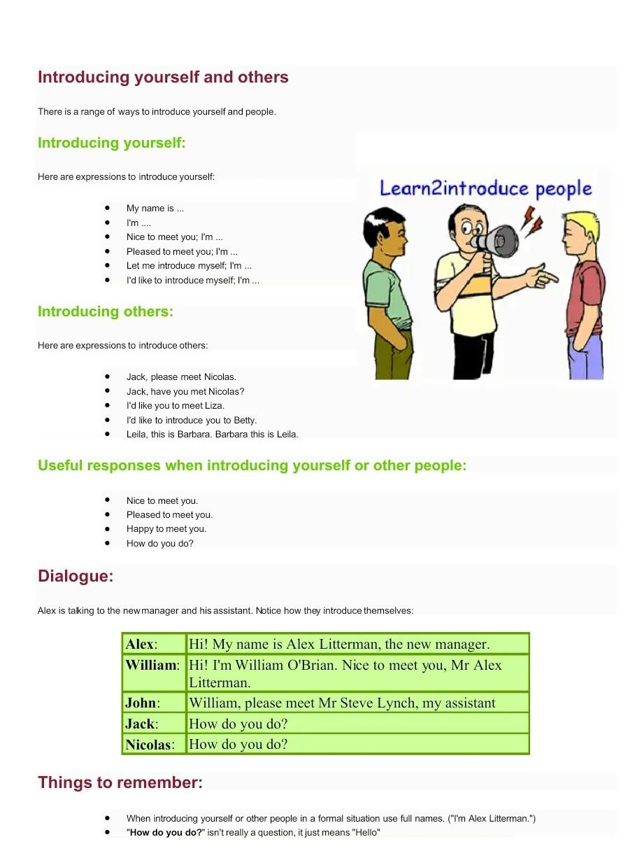

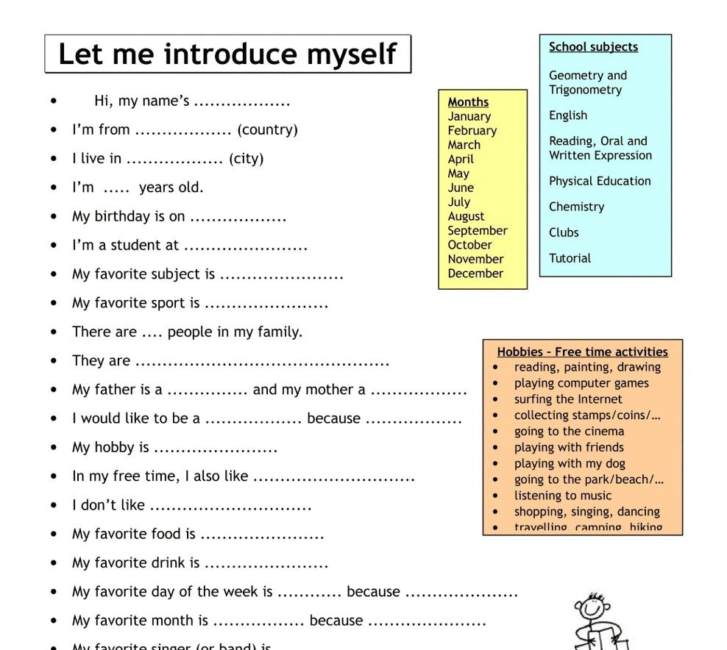

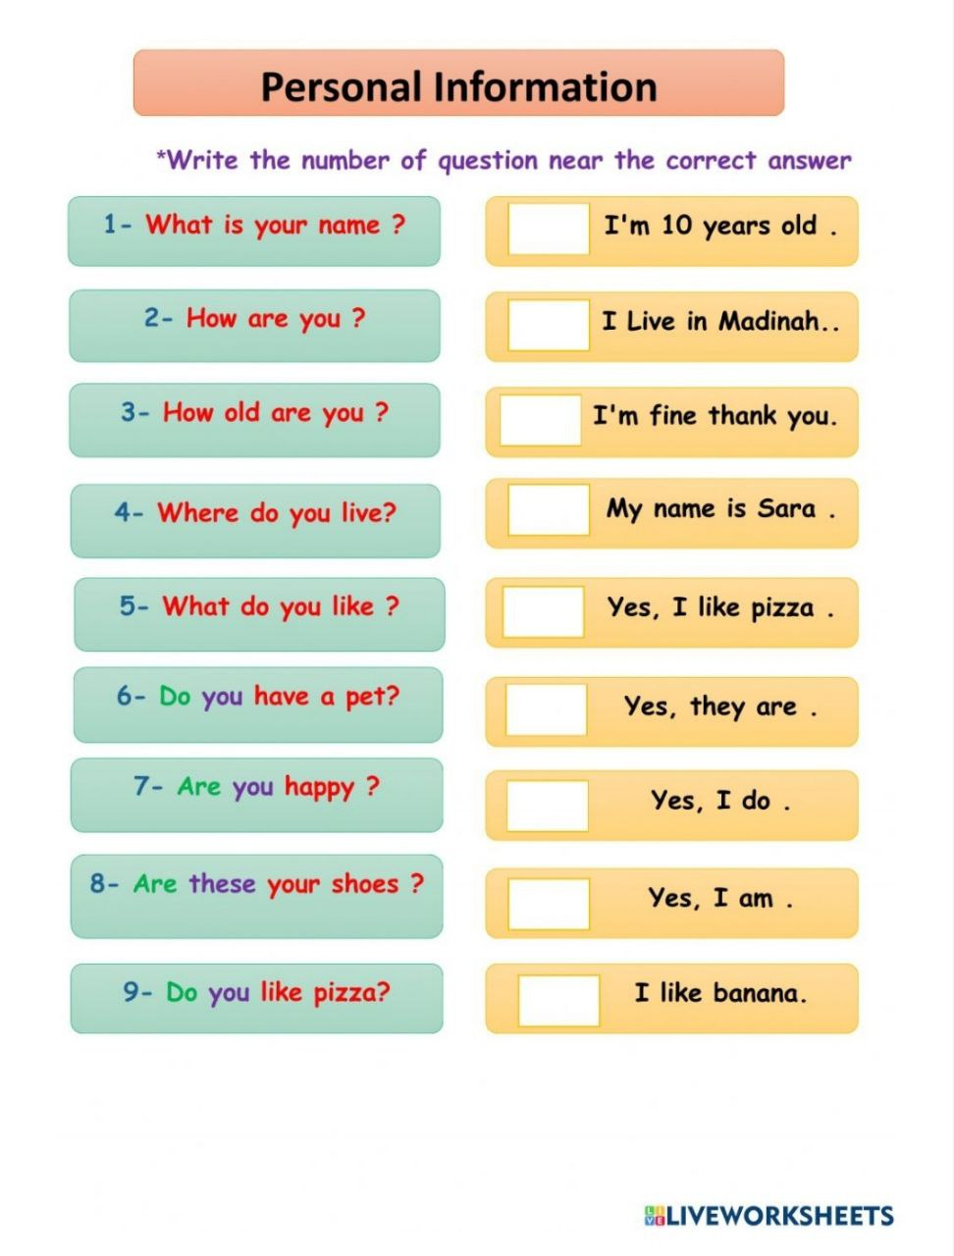

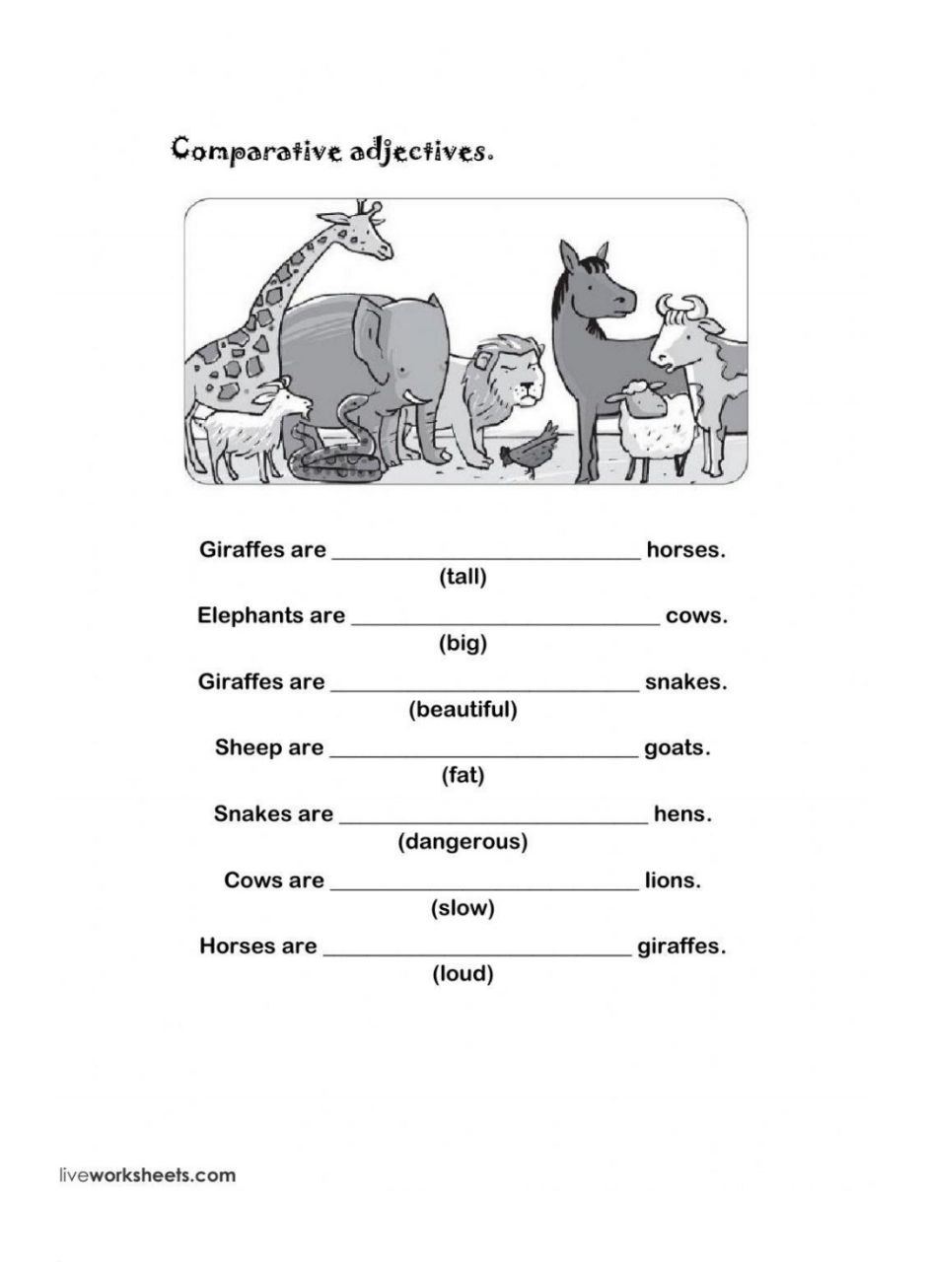

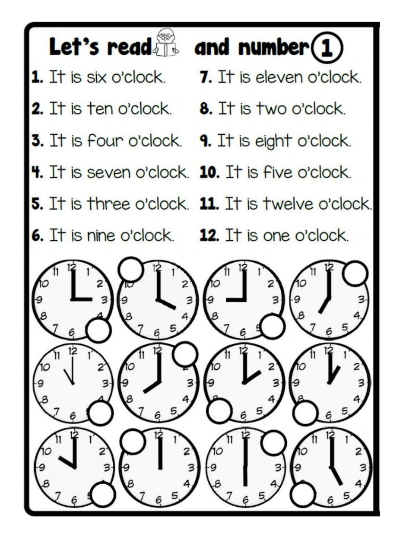

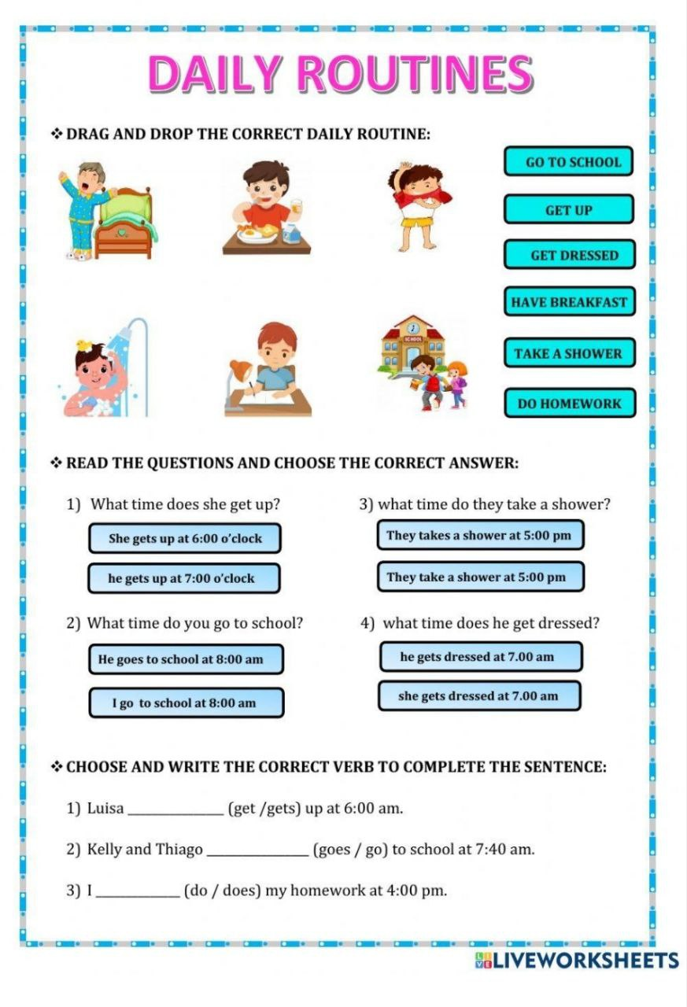

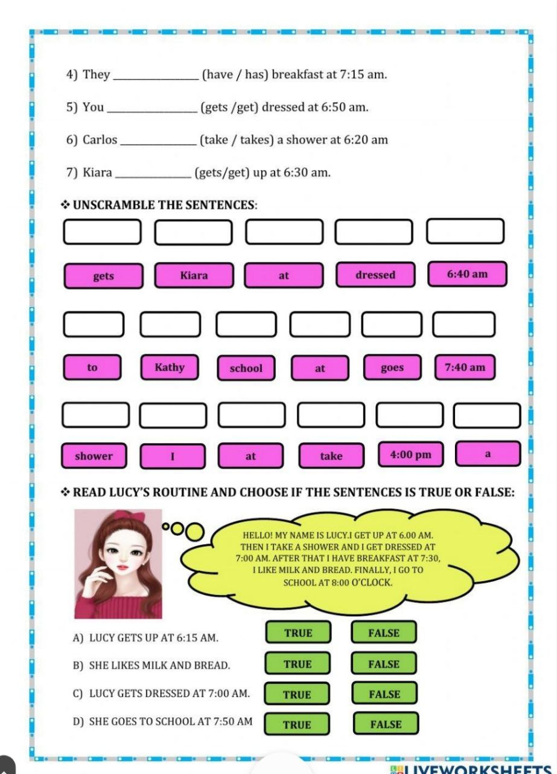

اختبار المهارات (المفقودة) لمهارتي الوزاري 1445-أول متوسط (10 نقطة)
خطة علاجية لرفع المستوى في المهارات المفقودة

https://forms.office.com/Pages/ShareFormPage.aspx?id=mnR-H370zUOmdAWktpBqYrZsbjVcdSRFty2KZCpolmhUQlc5TUlQSjg0UVA1NUNaRVM1MjNBSVcxTi4u&sharetoken=Bx6tXoCikLz7dSHulpDg

اسم الطالبة | الدرجة

