

Name ………………………………… Class ………………………………

_______________________________________________________________________________________________________________________

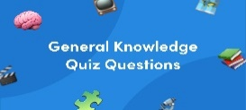
General Questions

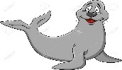
1 – What is that?
A . It's a seahorse. B . It's a seal.
2 – What do you think about sharks?
A. I like dolphins. B. I think they are scary .
3 – Which of the following is a sea animal ?
A . seahorse . B. horse .


________________________________________________________________________________________________________________________________________________________________________________________________

Reading short sentences
1. The whale is small.

2. The dolphin is cute.

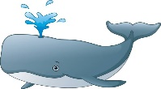
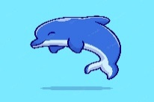



Controlled writing

______________________ |  |  | 1– think - I – whales – big - are. ( rearrange )
slow | scary | fast | 2. Seahorse is ___________ . ( choose)

biggest | big | bigger | 1 – The whale is ______ .
cutest | cuter | cute | 2- The baby seal is the _______.
as | has | is | 3. As fast ___ a dolphin .
am | is | are | 4- What ___ those ?
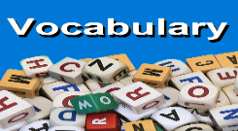
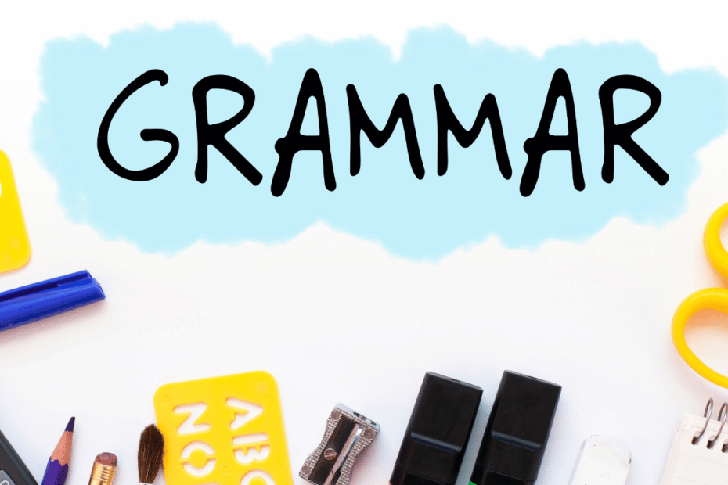
_______________________________________________________________________________________________________________________________________________________________________________________________
Grammar

Vocabulary
seal - seahorse – crab -starfish

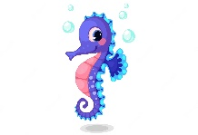 | 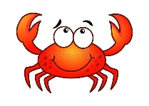 | 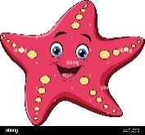 | 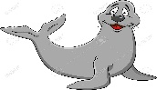
---------- | ---------- | --------- | ---------

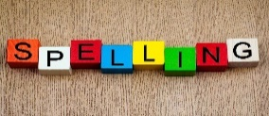

Orthography (spelling)
Choose the correct letter: ( ou - ow - oa )

 | 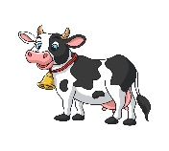 | 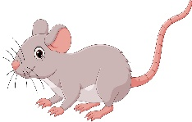 | 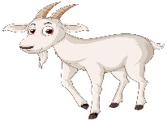 | 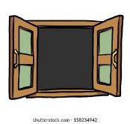
h_ _se | c_ _ | m_ _se | g _ _ t | wind_ _

Controlled writing

4

------------------------------------------------------------------------------------------------------------------------------------------------------------

Good luck

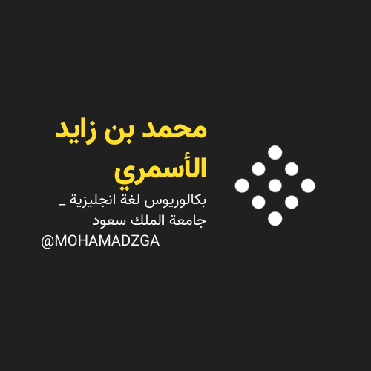

لا تنسوني من صالح دعائكم




M_zaid0

