




Super Goal2 Note book
2nd intermediate Grade

Student name:………………………………………………………………
School:…………………………………………………………….………….
Class:……………………………………………………………………………
Teacher's name:……………………………………………………..........

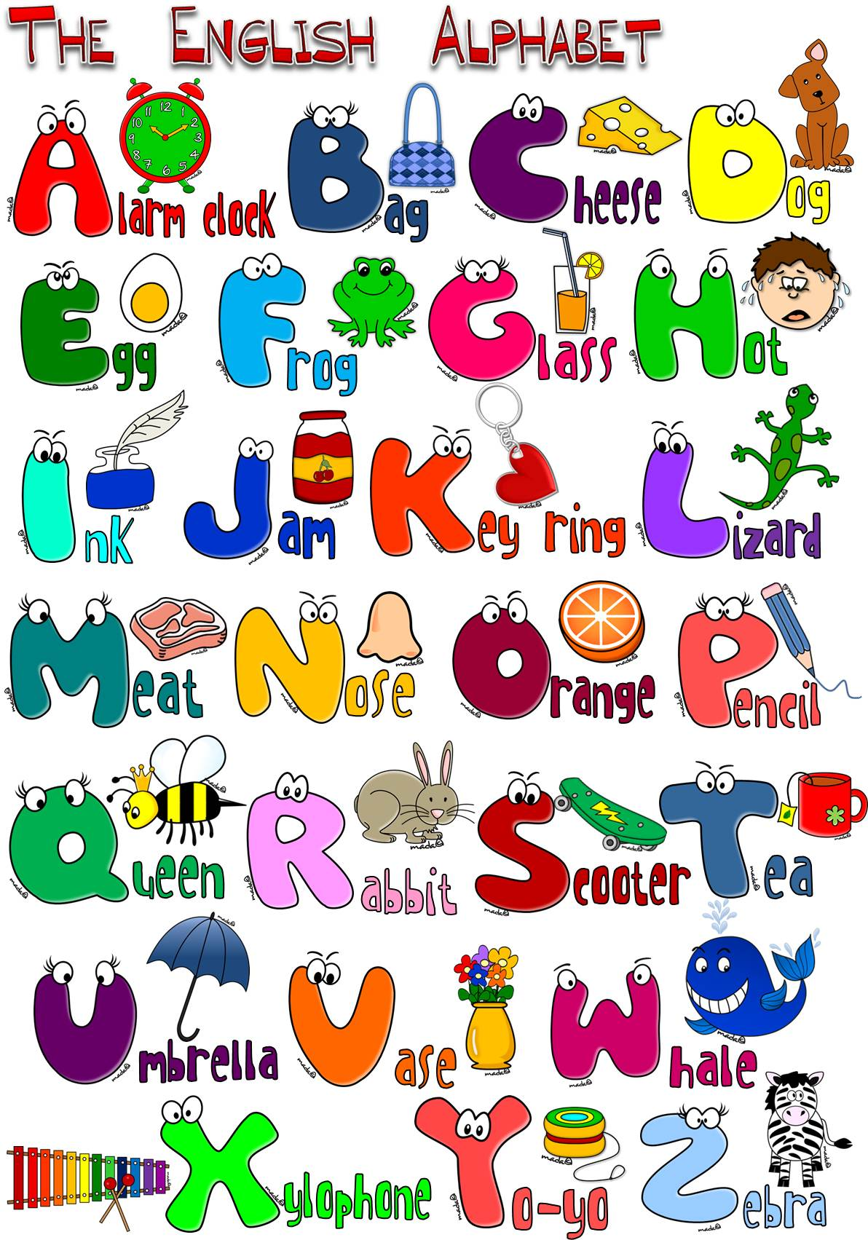

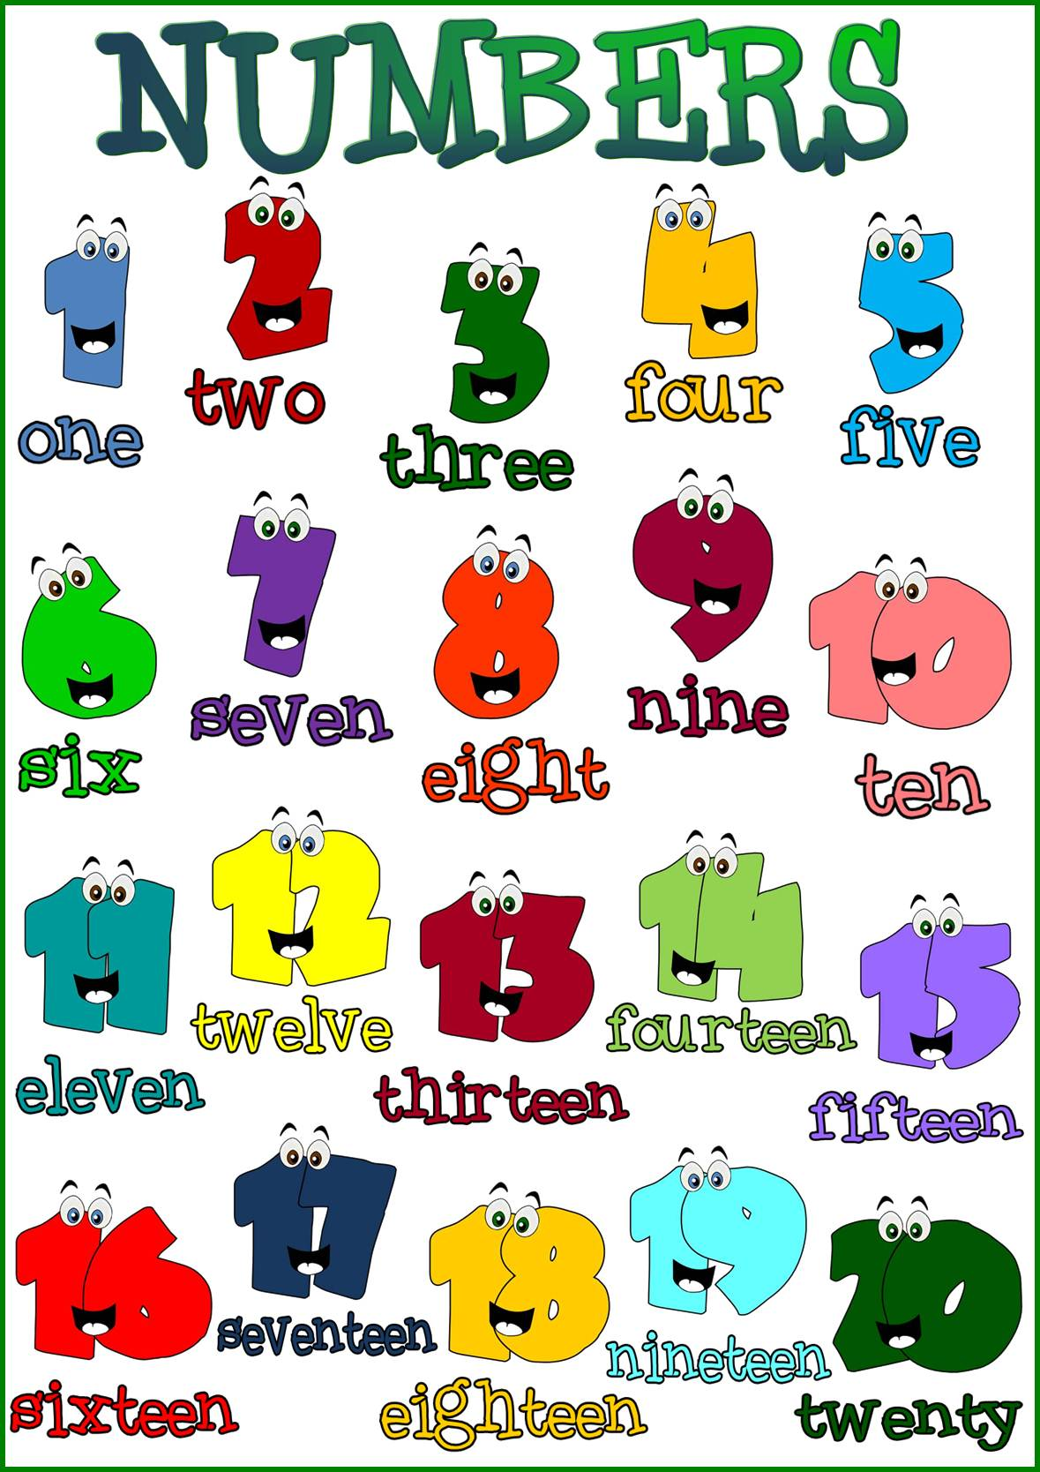

A1 Listen & Discuss
Date: \ \14

New Vocabulary:

Words | Kind | Meaning | Examples

Greeting and Introduction
*Greeting: *Goodbyes:
Hello,……..\ Hi,……….. Good bye \Bye\See you later
Good morning\ Good afternoon \ Good evening See you soon nice to meet you again
I'm glad\ I'm happy\ I'm pleased to see you
How are you? - I'm Fine, thanks. And you?
How have you been? _Very well. And you?

Study tool box
Expressions to introduce yourself:
- My name is …………………
- I'm ……………………..
- Let,s me introduce myself,I'm …………..
- I'd like to introduce myself; I'm …………….
- Nice to meet you.
- Pleased to meet you.

*classify the following items under the correct column:
[ good morning – bye – see you later – good evening – sunshine]
Greeting | Good bye

Grammar
Date: \ \14

Verb to be:
Short form
He's  She's  He's  Is not  Are not | They're  We're  You're  Isn't  Aren't | I'm
Verb To Be
is | are | am
He  she    He | they  we  you | I
The short forms with apostrophes (‘) are contractions

Examples:
----------------------------------------------------
*Information questions :
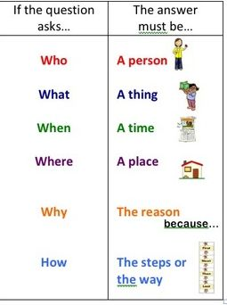
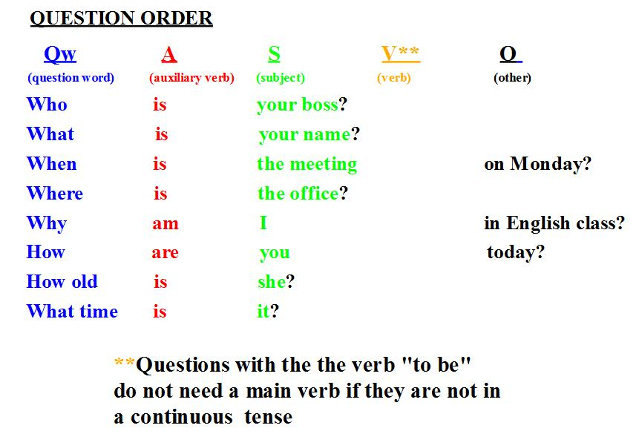

*Choose the correct answer:
1-It [ are – is – am ] a cute cat.
2-My father [ am – are – is ] a taxi driver.
3-We [ are – is – am ] good friends.
4-David [ are – am – is ] our family doctor.
5-My grandparents [ is – are – am ] old.
6-Sara and I [ are – am – is ] happy.
7-[ she – they – I ] am hunger.

AACtivity:
Ask about the underlined words:
1- I am 16 years old.
…………………………………………….?
2- They are students .
……………………………………………..?

*Do as shown between brackets:
1-The chair [ be ] brown. [ write the correct verb to be ]
----------------------------------------------------------
2-The sky ------ full of stars. [Complete with the suitable verb to be]
3-Tomi and Rani [ be ] pupils . [ write the correct verb to be ]
----------------------------------------------------------
4-a\she is -------- b\ I am ------------ [ Give the short form]

Date: \ \14
about you

Personal Information Questions

Read the following in column A and match them with the right answer in column B:

1-What 's your first name?
2-What's your last name?
3-What's your full name?
4-How old are you?
5-Where are you from?
6-Where do you live?
7-What do you do?
8-what's your nationality?
9-What's your e-mail?
10-What's your phone number?
( )I am from ……………
( )I am ………. Years old.
( ) My first name………
( )My full name is ……………………………
( ) I live in …………….
( ) My phone number is ……………..
( ) My nationality is ………….
( ) I am a ………………………….
( ) My e-mail is ………………….
( ) My last name is ………………..


Column A Column B


complete the following conversation:
I am here for ………..
What is the purpose of your trip?

How long are you staying?
I am staying for………

I will stay ……………………….….. …………………… ………………….
What is your address in this country ?


Conversation
Date: \ \14

New Vocabulary:

Words | Kind | Meaning | Examples
Answer these questions from the conversation:
- Where are the people in the picture?
................................................................................................
2-Where is Ibrahim last name ?
……………………………………………………………………………………………..
3-What is his room number?
…………………………………………………………………………………………..
******************************************************************************

Reading
Date: \ \14

New Vocabulary:
Words | Kind | Meaning | Examples

Reading Questions:
1-What does S.A.Y.H.A mean ?
……………………………………………………………………….
2-Is there a youth hostel in your town ?
……………………………………………………………………..
3-How many youth hostels are there around the world?
………………………………………………………………………


{{{{{{{
9 Writing
Date: \ \14

Use Can / Could/ May politely ask
a question

Formal Language
- Reservation
- Make requests



Answer the questions in your pupil book page ( 8 ). Make a paragraph from these answers:
…………………………………………………..
……………………………………………………………………………………………………………………………………………………………………………………………………………………………………………………………………………………………………………………………………………………………………………………………………………………………………………………………………………………………………………………………………………………………………………………………………………………………………………………………………………………………………………………………………………………………………………………………………………………………………………………………………………………………………………………………………………………………………………………………………………………………………………………………………………………………………………………………………
Rules of writing
*Write the title with capital letters and underlined
*Leave a space of five letter in the beginning of the paragraph.
*End each sentence with a full stop.
*Start the new sentence with a capital letter


project
Date: \ \14

Make a list of prepositions of place :
Project ideas Your plane

Resources needed Assessment
( equipment – materials )
During project End of project

Reflection Methods ( individual – group – whole class)

Date: \ \14
11 Form , Meaning and Function

Match the pictures and the sentences .

2
1
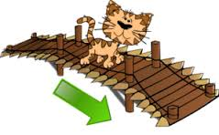
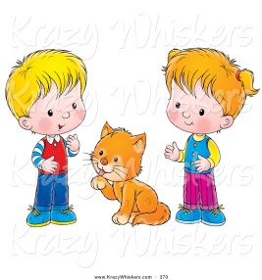

The bear is near the tree.

The boy is next to the snowman

4
3
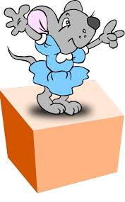
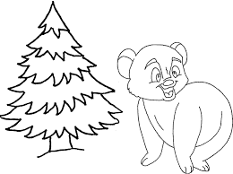

The cat is between the boys .

The cat is across from the bridge .

6
5
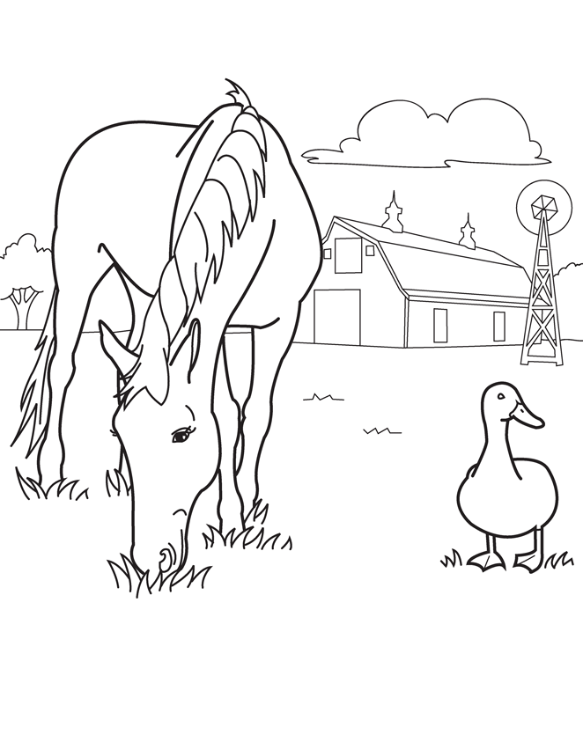
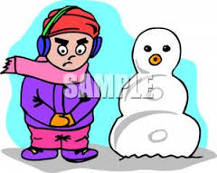

The mouse is on the box .

The house is far from the animals .

A1 Listen & Discuss
Date: \ \14

New Vocabulary::
Words | Kind | Meaning | Examples

Do you like to watch films ?
………………………………………………………………………….
What is wrong in the picture ?
…………………………………………………………………………

Note:
Date: \ \14
2 Grammar

*Present progressive:
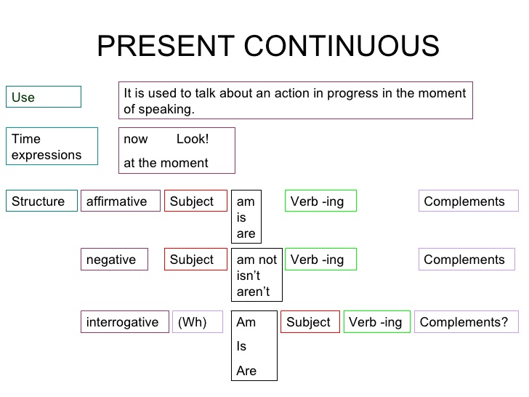

p.s:
Don't add ing to the following verbs :
Like , love , want , see , smell , taste , hear

Activity .


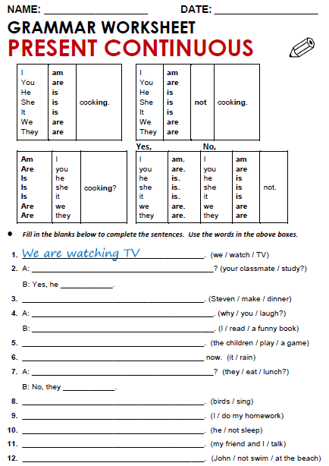
conversation
Date: \ \14

New Vocabulary:

Words | Kind | Meaning | Examples
1-Match the words with its meaning:
A |  | B
So |  | With no one else's help
All by myself |  | A strong no answer .
Not at all |  | A way to start a new topic in a conversation
2-Write the correct word under each picture:


[ scene - martial arts - location ]

1-……………………… 2-………………………

Reading
Date: \ \14

New Vocabulary:
Words | Kind | Meaning | Examples

1-Answer the following questions :

What do you know about web videos and e- learning ?

……………………………………………………………………………………………

writing riting
Date: \ \14

Writing corner
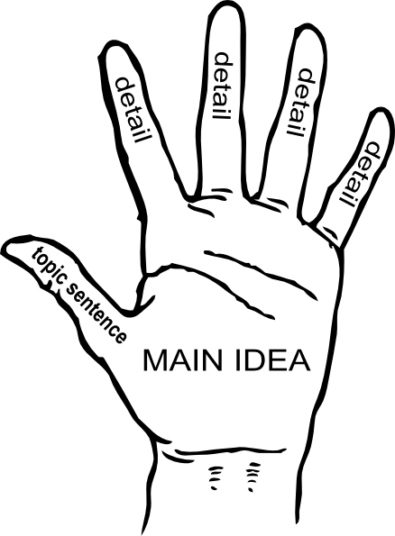

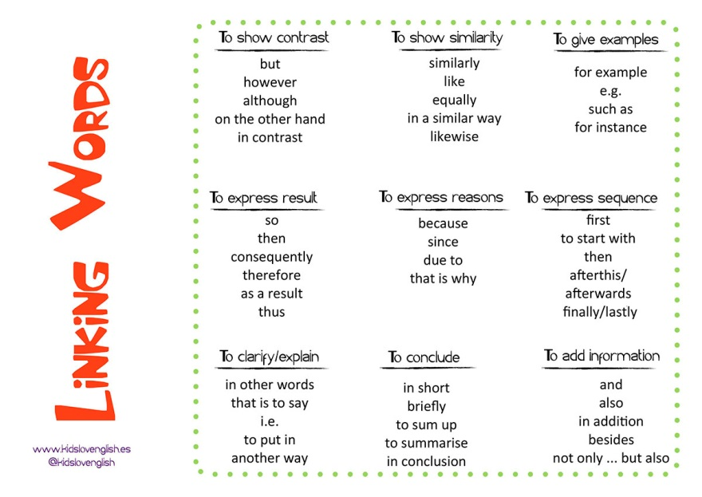.

write a paragraph about Using internet for learning using the chart on page 16 :

……………………………………………..
…………………………………………………………………………………………………………………………………………………………………………………………………………………………………………………………………………………………………………………………………………………………………………………………………………………………………………………………………………………………………………………………………………………………………………………………………………………………………………………………………………………………………………………………………………………………………………………………………………………………………………………………………………………………………………………………………………………………………………………………………………………………………………………………………………………………………………………………………………………………………………………………………………………………………………………………………………………………………………………………………………………………………………………………………………………………………………………………………………………………..…………………………………………………………………………………………………………………………………………………………………………………………………………………………..

Date: \ \14

project

Write a short comic :

Date: \ \14

Form, Meaning and Function

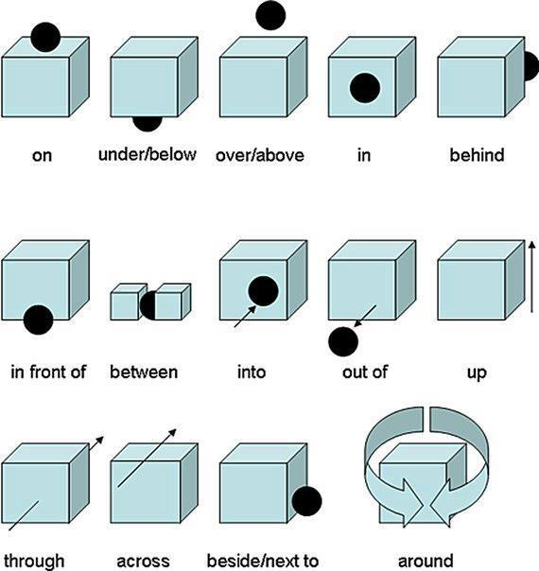

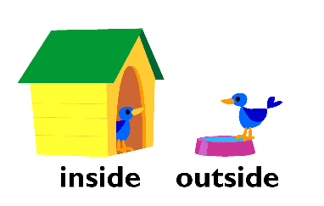

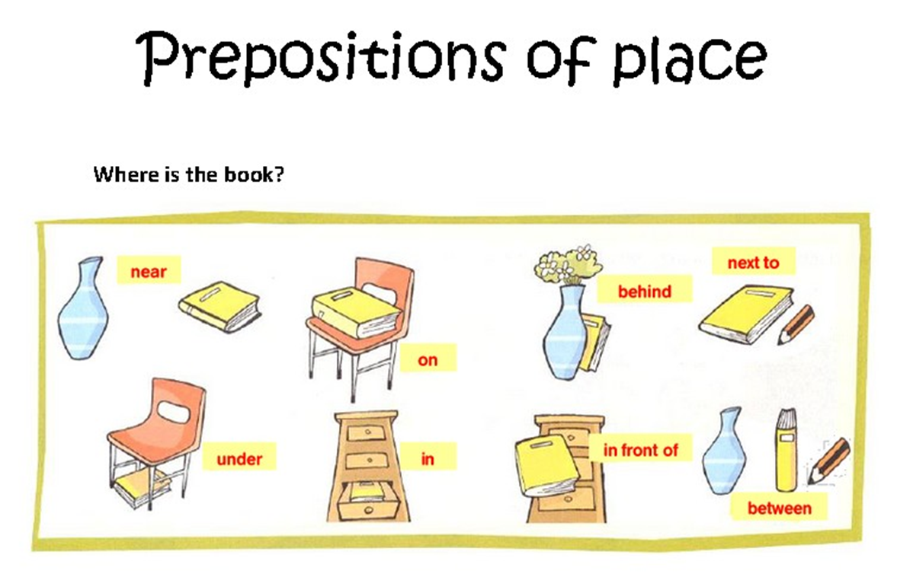

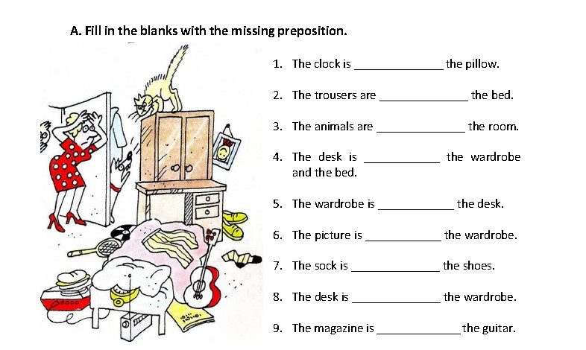

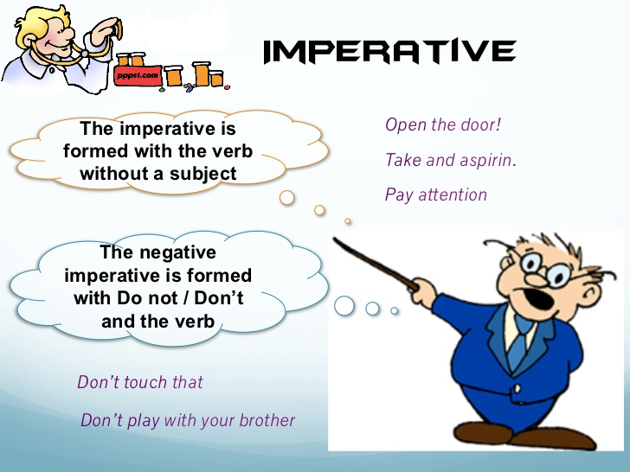

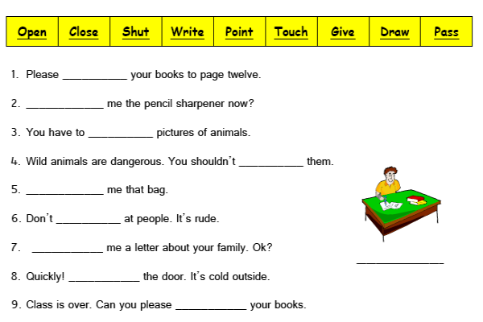

1 Listen and Discuss
Date: \ \14

New Vocabulary:
Words | Kind | Meaning | Examples

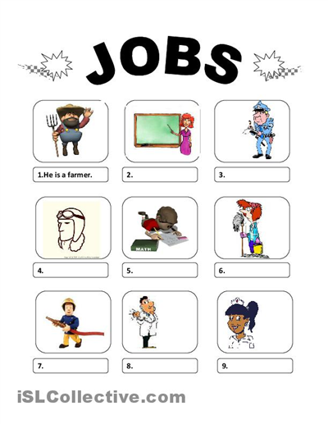

Grammar
Date: \ \14

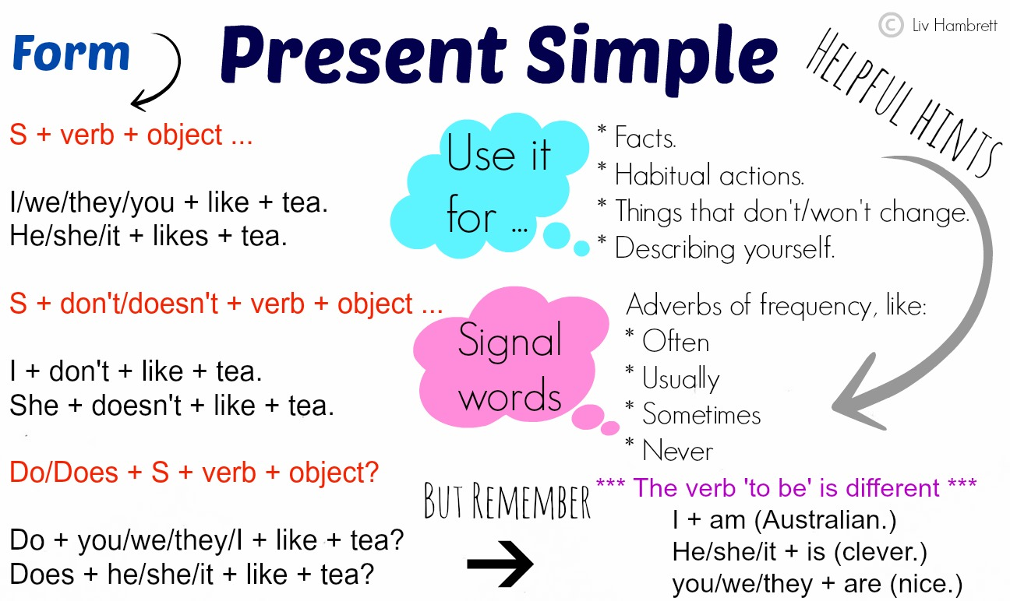

:

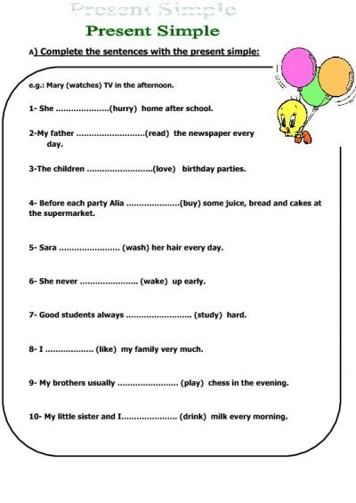

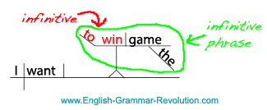
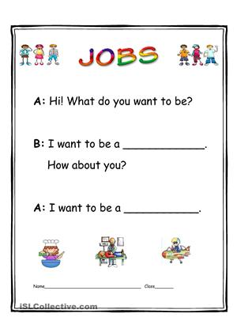

about you
Date: \ \14

What do you think are interesting jobs? Bad jobs ?
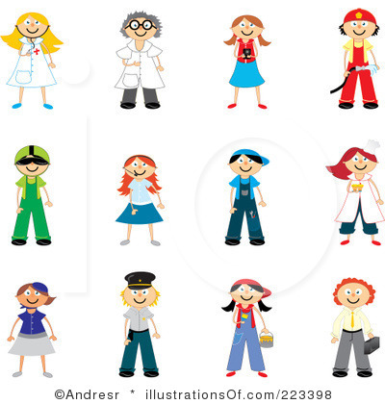

7 conversation
Date: \ \14

New Vocabulary:
Words | Kind | Meaning | Examples
Questions about the conversationn:

1- What does David's father do ?
………………………………………………………………………………….

2- What does Ross father's do ?
………………………………………………………………………………….

Date: \ \14
Reading

New Vocabulary:
Words | Kind | Meaning | Examples
Write the correct word under each picture:


[ Moon -spacecraft – Pinter – heart – submarine ]
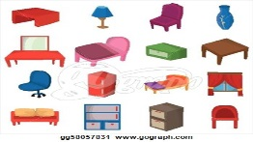


1-……………………………….. 2-………………………………… .. 3-……………………………

Date: \ \14
Writing

Write about your Dream Job . Use your notes from the chart in A and ideas from this unit.
Use the connectors : and , but , because .

………………………………………………………………………………………………………………………………………………………………………………………………………………………………………………………………………………………………………………………………………………………………………………………………………………………………………………………………………………………………………………………………………………………………………………………………………………………………………………………………………………………………………………………………………………………………………………………………………………………………………………………………………………………………………………………………………………………………………………………………………………………………………………………………………………………………………………………………………………………………………………………………………………………………………………………………………………………………………………………………………………………………………………………………………………………………………………………………………………………………………………………………………………………………………………………………………………………………………………………………………………………………………………………………………………………………………………………………………………………………………………………………………………………………………………………………………………………………………………………………………………………………………………………………………………………………………………………
………………………………………………………………………………………………………………………………………………………………………………………………………………………………………………………………………………………………………………………………………………………………………………………………………………………………………………………………………………………………………………………………………………………………………………………………………………………………………………………………………………………………………………………………………………………………………………………………………………………………………………………………………………………………………………………………………………………………………………………………………………………………………………………………………………………………………………………………………………………………………………………………………………………………………………………………………………………………………………………………………………………………………………………………………………………………………………………………………………………………………………………………………………………………………………………………………………………………………………………………………………………………………………………………………………………………………………………………………………………………………………………………………………………………………………………………………………………………………………………………………………………………………………………………………………………………………………………

Project
Date: \ \14

Work and try to collect some pictures about different occupations outside of class and write a short summary about it:

…………………………

…………………………………………………………………………………………………………………………………………………………………………………………………………………………………………………………………………………………………………………………………………………………………………………………………………………………………………………………………………………..

…………………………

……………………………..

……………………………………………………………………………………………………………………………………………………………………………………………………………………………………………………………………………………………………………………………………………………………………………………………………………………………………………………………….........................................

Picture

Picture

………………………………….
……………………………………………………………………………………………………………………………………………………………………………………………………………………………………………………………………………………………………………………………………………………………………………………………………………………………………………………………………………………………………………………………….

………………………………
…………………………………………………………………………………………………………………………………………………………………………………………………………………………………………………………………………………………………………………………………………………………………………………………………………………………………………………………………………………………………………………………………………………………………………………………..

Picture

Picture

Form, Meaning & Function
Date: \ \14

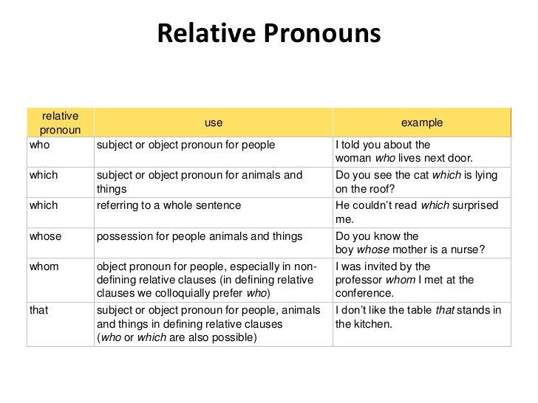

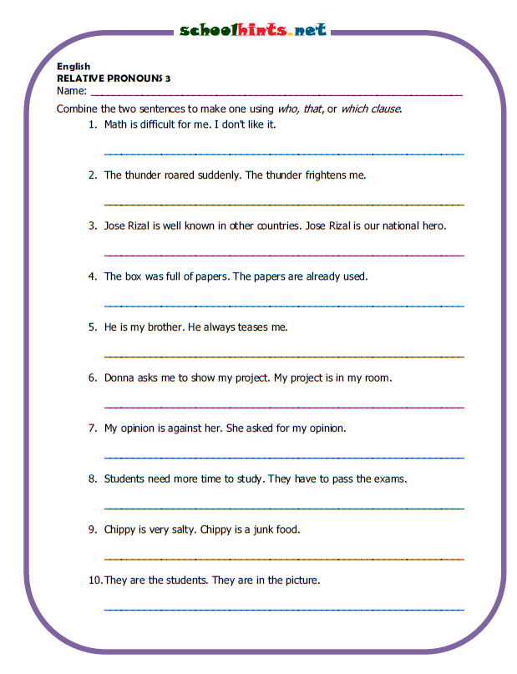


Date: \ \14
1 listen & discuss

" و عن شبابه فيما أفناه "
New Vocabulary:

Words | Kind | Meaning | Examples
Draw and color the activity :

1.

1-work out 2. Play hockey 3. Reading

Write the correct word under each picture:

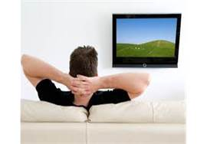
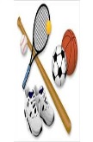
[watch TV – ride a horse – rollerblade – workout - surf the internet – ride a bike - reading ]




1-…………………… 2-………………………… 3-…………………………. 4-……………………… 5-……………………… 6-…………………..

Date: \ \14
Grammar

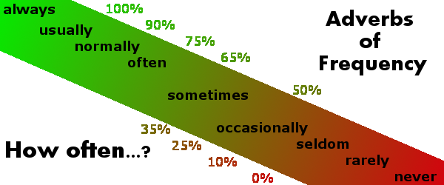

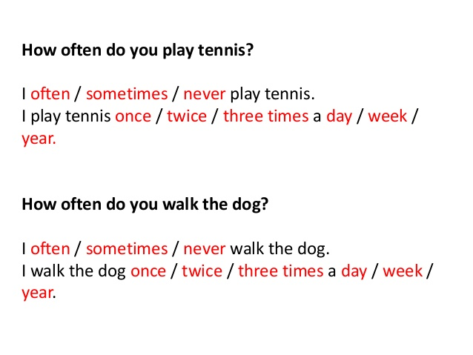

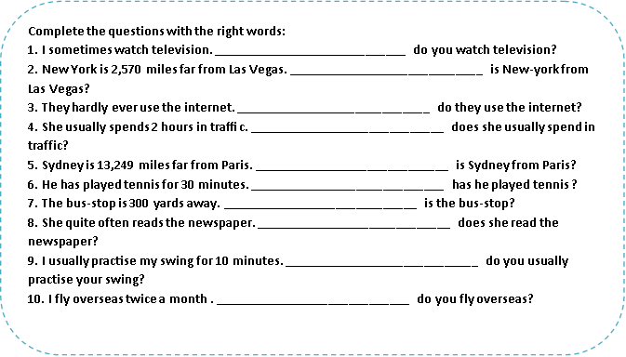

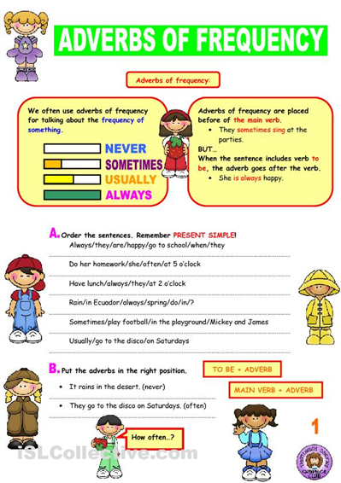

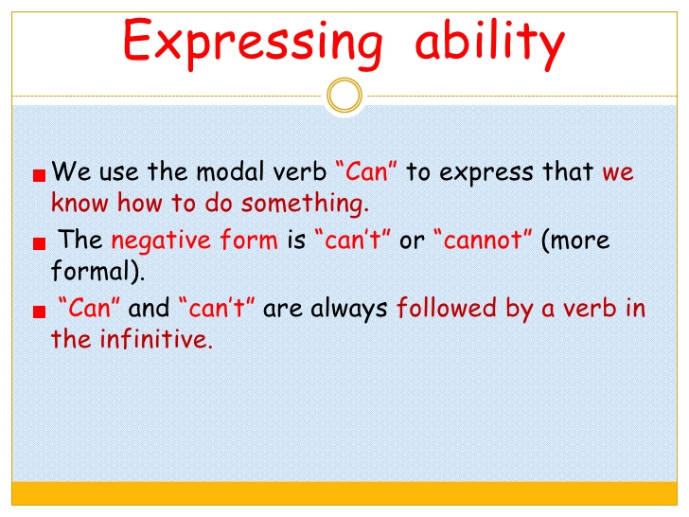

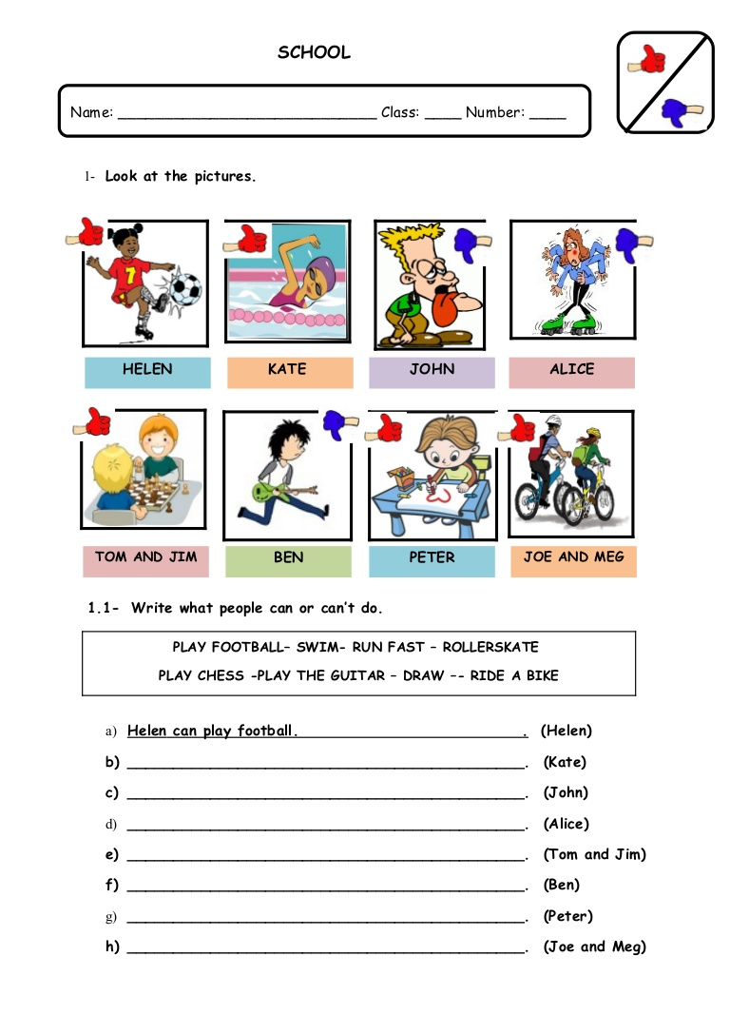
conversation
Date: \ \14

New Vocabulary:
Words | Kind | Meaning | Examples

Match:
1-I see an expression to confirm you understand correctly .
2-you mean …………. I understand .
a way to make an invitation .

Reading
Date: \ \14

New Vocabulary:
Words | Kind | Meaning | Examples

Questions:
1-What is aero modeling ?

………………………………………………………………………………

2-Does this hobby cost money ?

…………………………………………………………………………………

Writing
Date: \ \14

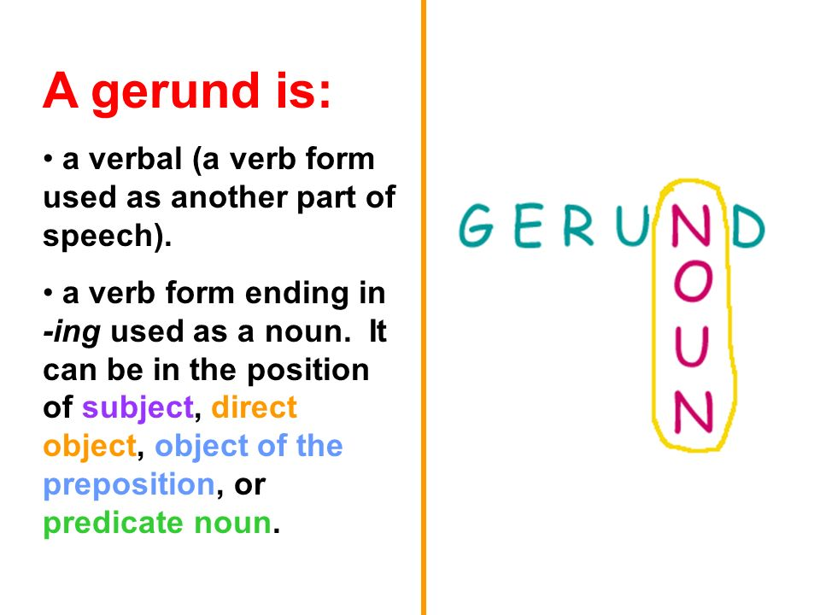

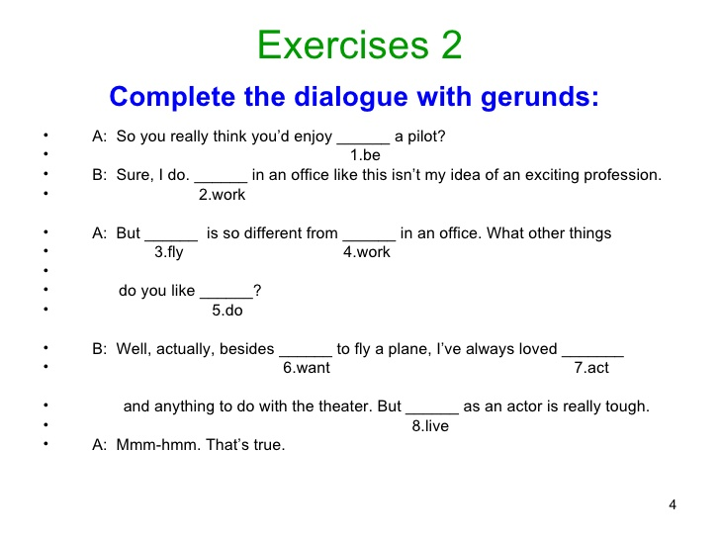

project
Date: \ \14

*Choose an unusual hobby and make information about it:

……………………………………………………………………………………………………………………………………………………………………………………………………………………………………………………………………………………………………………………………………………………………………………………………………………………………………………………………………………………………………………………………………………………………………………………………………………………………………………………………………………………………………………………………………………………………………………………………………………………………………………………………………………………………………………………………………………………………………………………………………………………………………………………………………………………………………………………………………………………………………………………………………………………………………………………………………………………………………………………………………………………………………………………………………………………………………………………………………………………………………………………………………………………………………………..

Hobby
………………….

Picture

From, meaning and Function
Date: \ \14

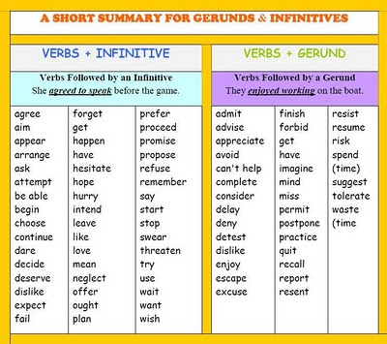

1-listen & discuss
Date: \ \14

قال تعالى:" وكلوا و اشربوا و لاتسرفوا "
New Vocabulary:
Words | Kind | Meaning | Examples

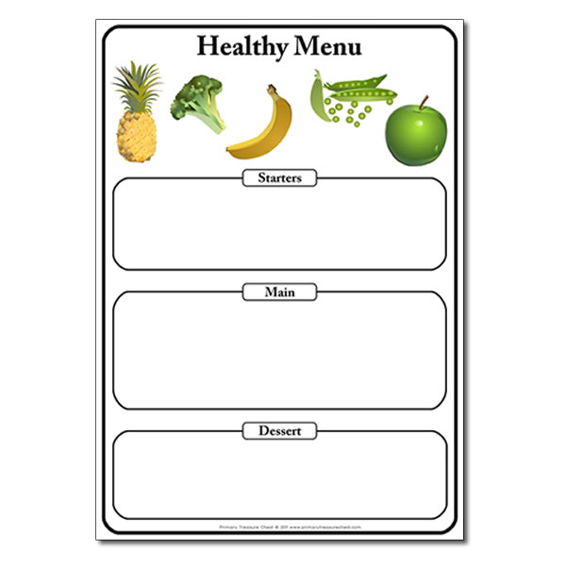

2Grammar
Date: \ \14

\\\\\\\
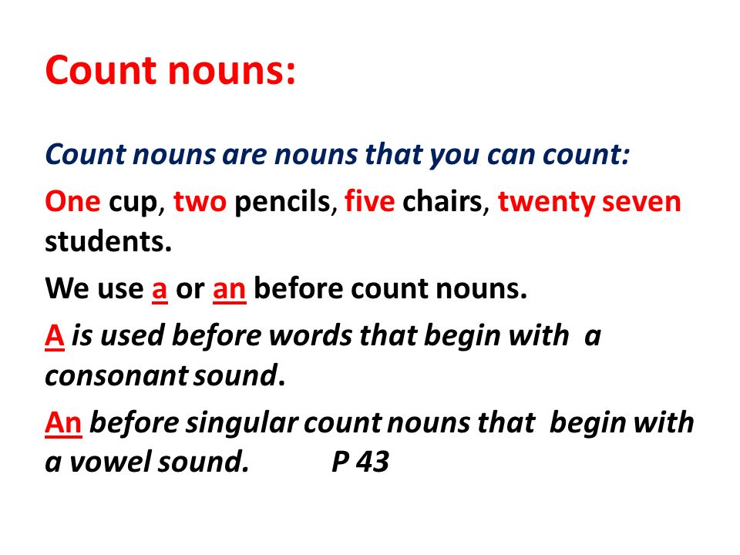

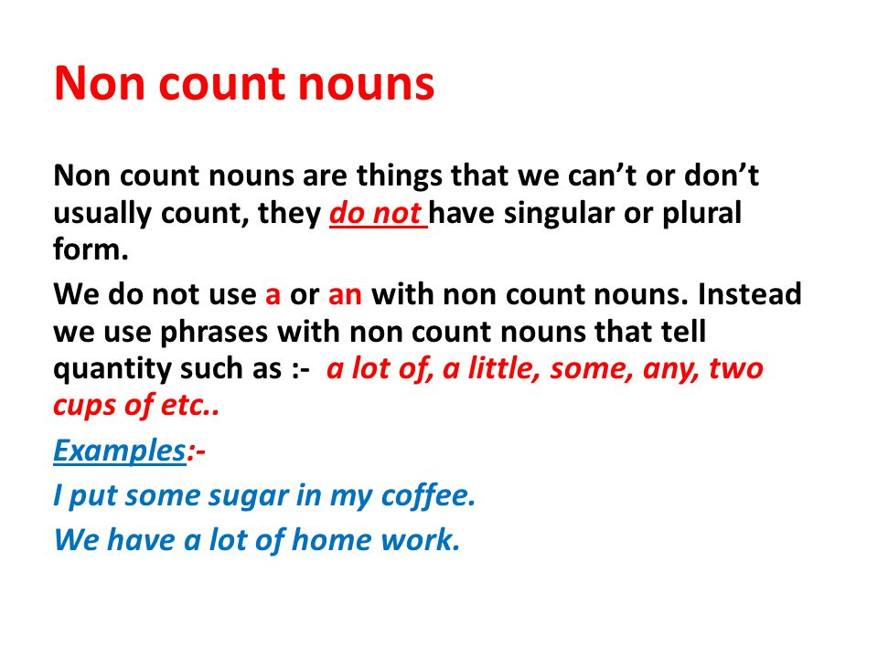

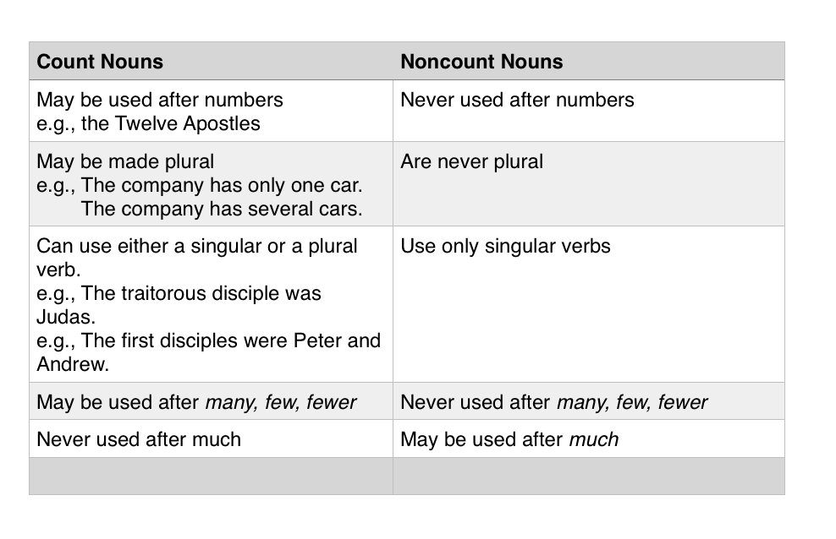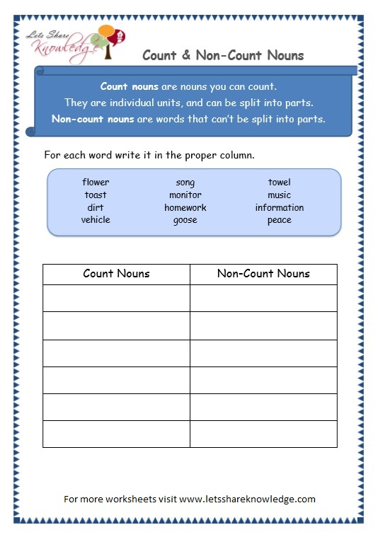

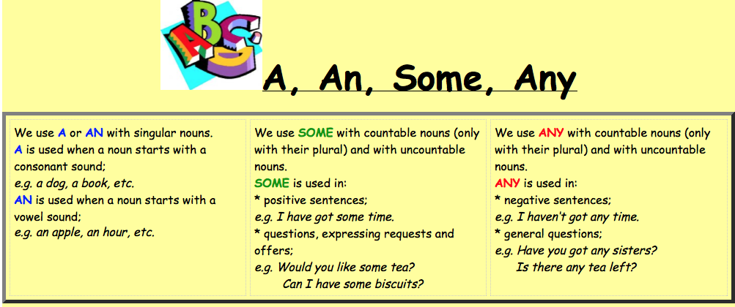

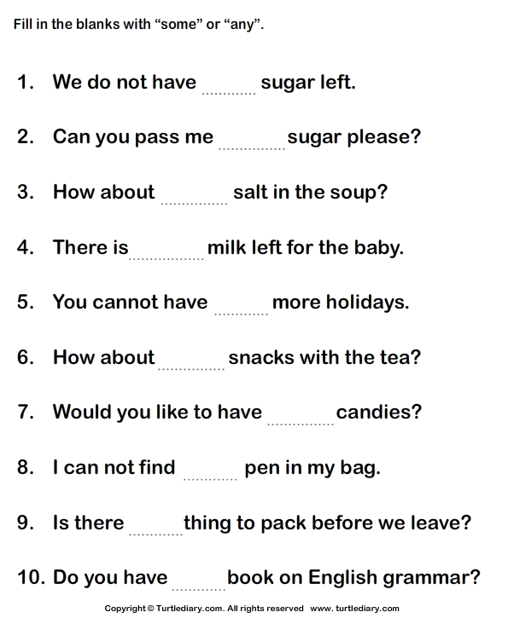

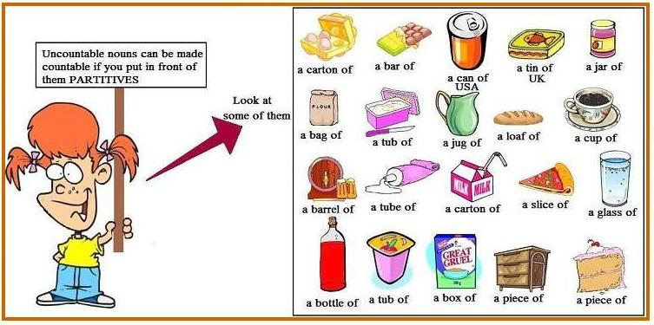

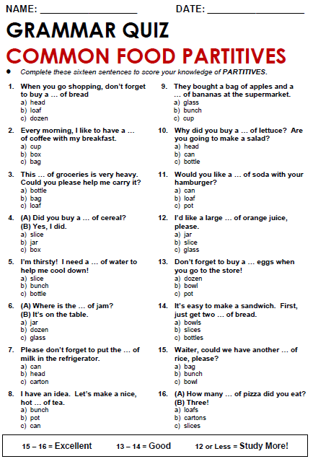

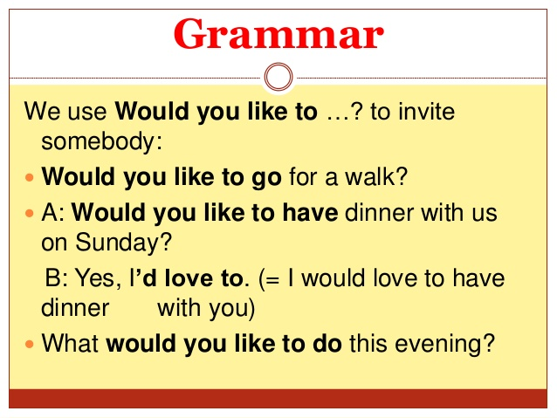

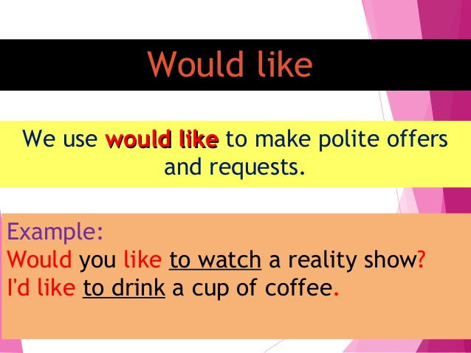

Choose the correct answer in the following:

1
Sara: some cake?
Marta: Yes, please.
2
Steve: What sort of music ?
Andy: Most types, but especially dance music.
3
Jana: a banana?
Nicola: No, thanks, I'm not hungry.
4
Liz: bananas?
Paul: Yes, I love them. I have one every morning.
5
Tony: Do you play tennis?
Mike: Yes, I do.
Tony: a game now?
Mike: Yeah, sure. Great idea!
6 I'm hot and thirsty. a cold drink.
7 I'm tired. to go to bed now.
8 I'd like , please.
9 I like . They're my favourite fruit.
10 I to go to Italy for a holiday next year

conversation
Date: \ \14

New Vocabulary:
Words | Kind | Meaning | Examples
Match:
1-I' ll have I have
2-Let me see I want to think .
I want
Mention three expressions you use in a restaurant while ordering food:
1-…………………………………………………………………….

2-…………………………………………………………………….

3-…………………………………………………………………….

Reading
Date: \ \14

New Vocabulary:
Words | Kind | Meaning | Examples
Write the correct word under each picture:
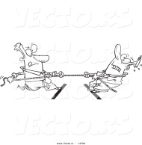
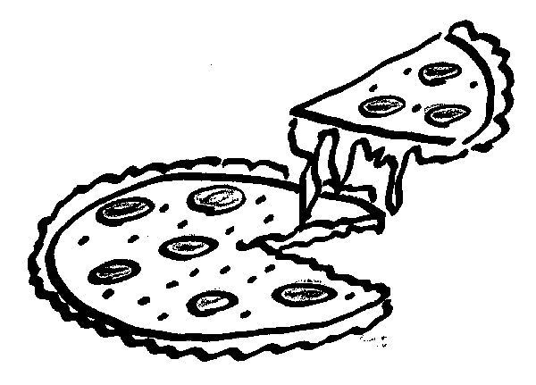
[ pizza – compete – globalization ]

1-……………………… 2-……………………….

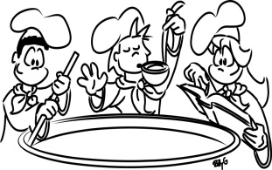
Writing
Date: \ \14

*Write a recipe for a dish that you know how to make :

project
Date: \ \14

* Make a typical menu from your country . Include food for breakfast , lunch and dinner. Add some pictures.

Date: \ \14
Form , meaning and Function
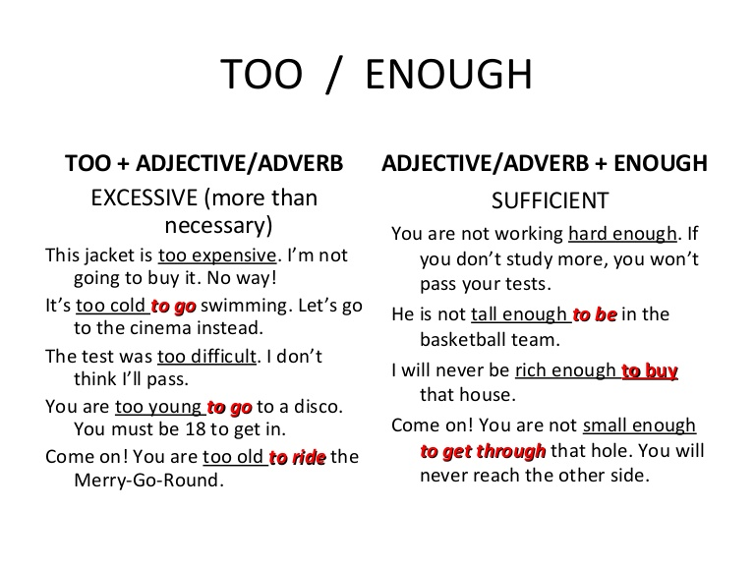
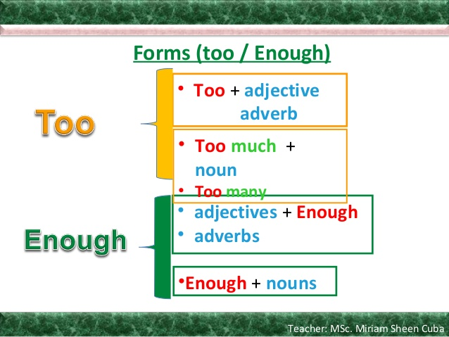

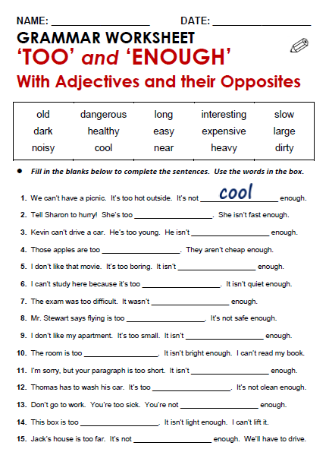

Date: \ \14
1 Listen & discuss

New Vocabulary:
Words | Kind | Meaning | Examples
General Questions:
1-Where can you see dinosaurs ?
……………………………………………………………………………………………………………

2-Where did Mike go on the weekend ?
……………………………………………………………………………………………………………

Grammar
Date: \ \14

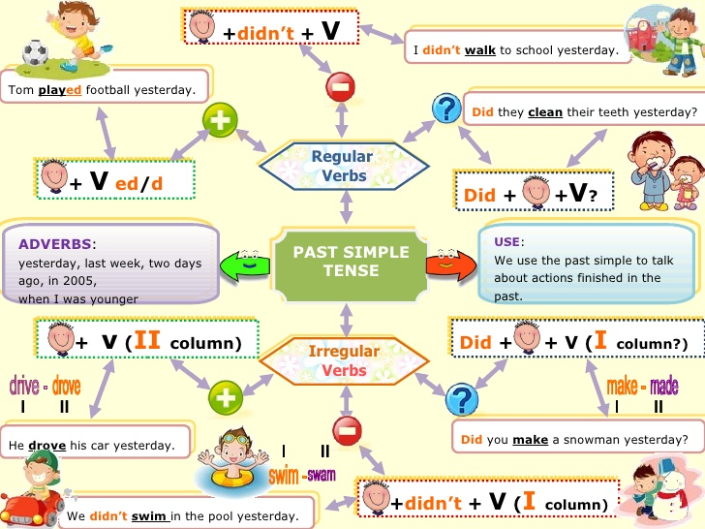

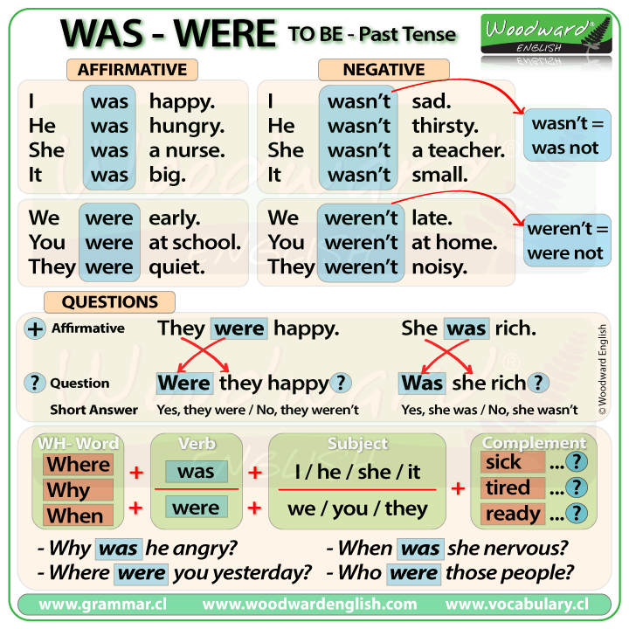
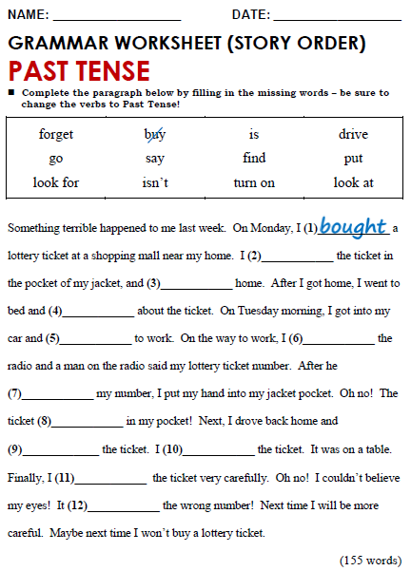

conversation

Conversation
Date: \ \14

New Vocabulary:
Words | Kind | Meaning | Examples
7- about you:
Did you ever see an interesting film on TV? What was it like? Did you ever eat at a nice restaurant ? what was it like ?
…………………………………………………………………………………………………………………………………………………………………………………………………………………………………………………………………………………………………………………………………………………………………………………………………………………………………………………………………………………………………………………………………………..
…………………………………………………………………………………………………………………………………………………………………………………………………………………………………………………………………………………………………………………………………………………………………………………………………………………………………………………………………………………………………………………………………………..

Reading

Conversation
Date: \ \14

New Vocabulary:
Words | Kind | Meaning | Examples
1- Write the correct word under each picture:

[script - calligrapher]
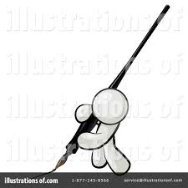

1-…………………………….. 2-……………………………
2-Write the opposite of:
1-Big# ………………… 2-beautiful # …………………. 3- simple # ………………………….
2-easiely # ………………………. 5- old #....................... 6- large#.........................

-Writing

Conversation
Date: \ \14

*Describe an interesting museum , performance or a sport event you attended . Use your notes from the chart in exercise A page 54 and ideas from this unit to write a paragraph .
……………………………………………………….
…………………………………………………………………………………………………………………………………………………………………………………………………………………………………………………………………………………………………………………………………………………………………………………………………………………………………………………………………………………………………………………………………………………………………………………………………………………………………………………………………………………………………………………………………………………………………………………………………………………………………………………………………………………………………………………………………………………………………………………………………………………………………………………………………………………………………………………………………………………………………………………………………………………………………………………………………………………………………………………………………………………………………………………………………………………………………………………………………………………………………………………………………………………………………………………………………………………………………………………………………………………………………………………………………………………………………………………………………………………………………………………………………………………………………………………………………………………………………………………………………………………………………………………………………………………………………………………………………………………………………………………………………………………………………………………………………………………………………………………………………………………………………………………………………………………………………………………………………………………………………………………………………………………………………………………………………………………………………………………………………………………………………………………………………………………………………………………………………………………………………………………………………………………………

Project

Conversation
Date: \ \14

*Check on the events in your town . Choose one , and make a brochure about it .

Date: \ \14
Form ,Meaning & Function

Conversation

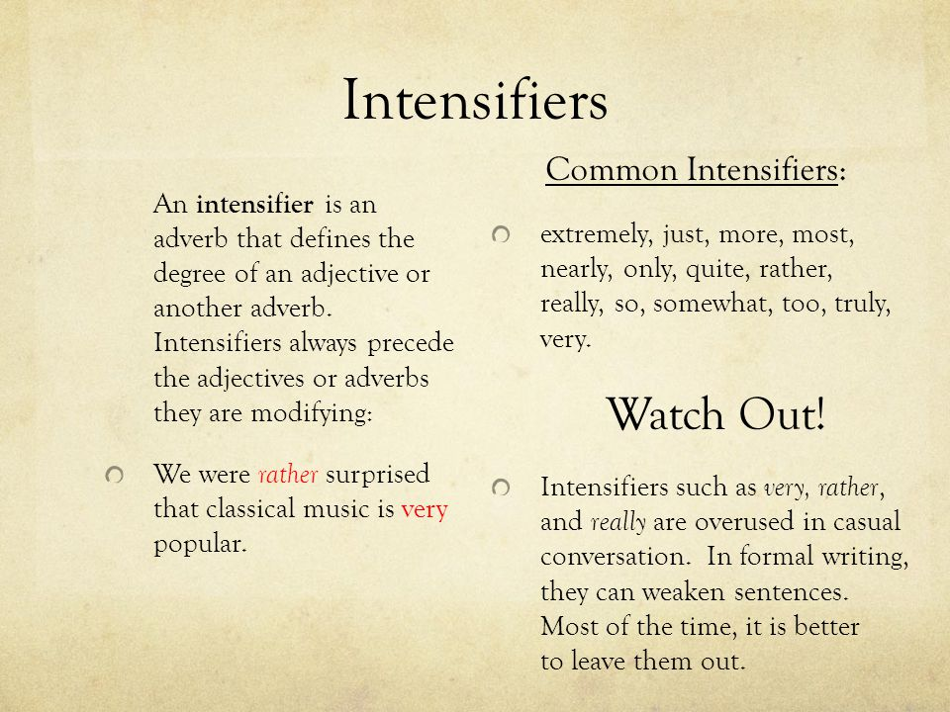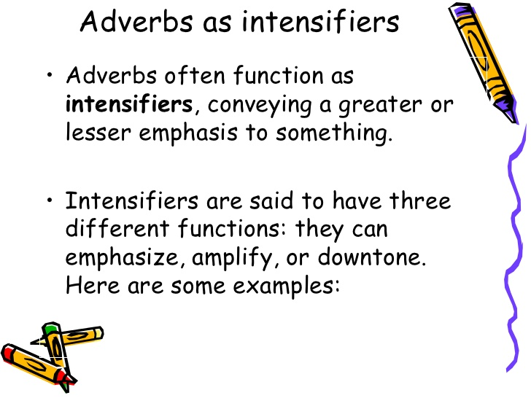
قال تعالى" قل لن يصيبنا الا ما كتب الله لنا "

Conversation
1 Listen & Discuss

Conversation
Date: \ \14

New Vocabulary:
Words | Kind | Meaning | Examples

Grammar

Conversation
Date: \ \14

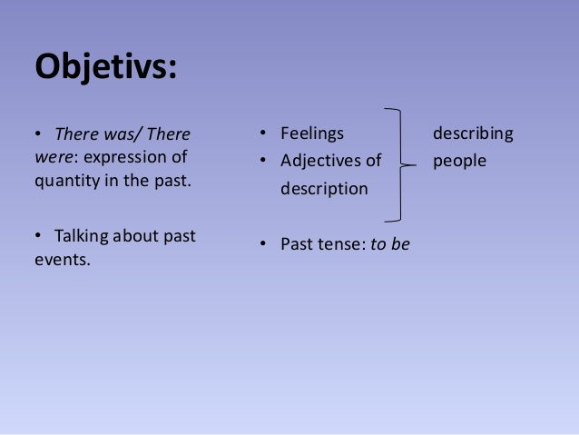
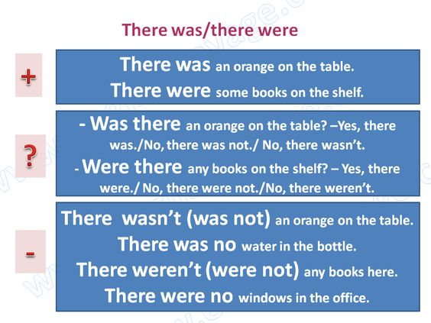

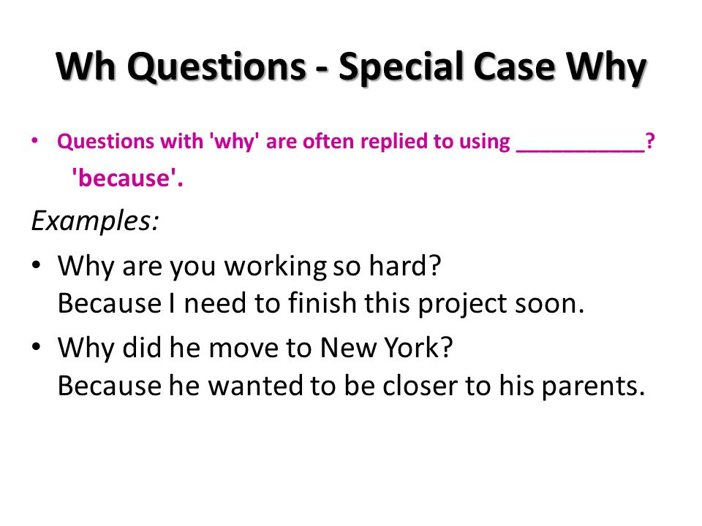
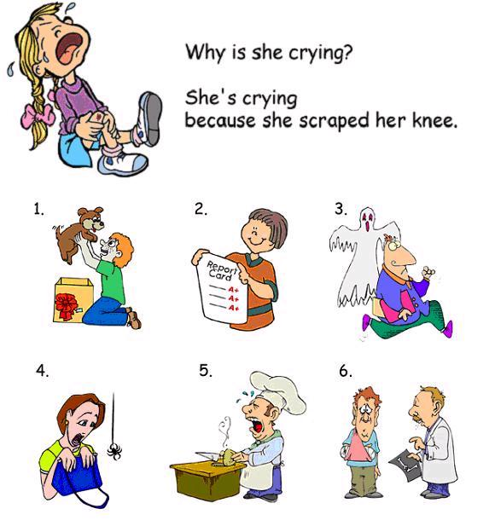
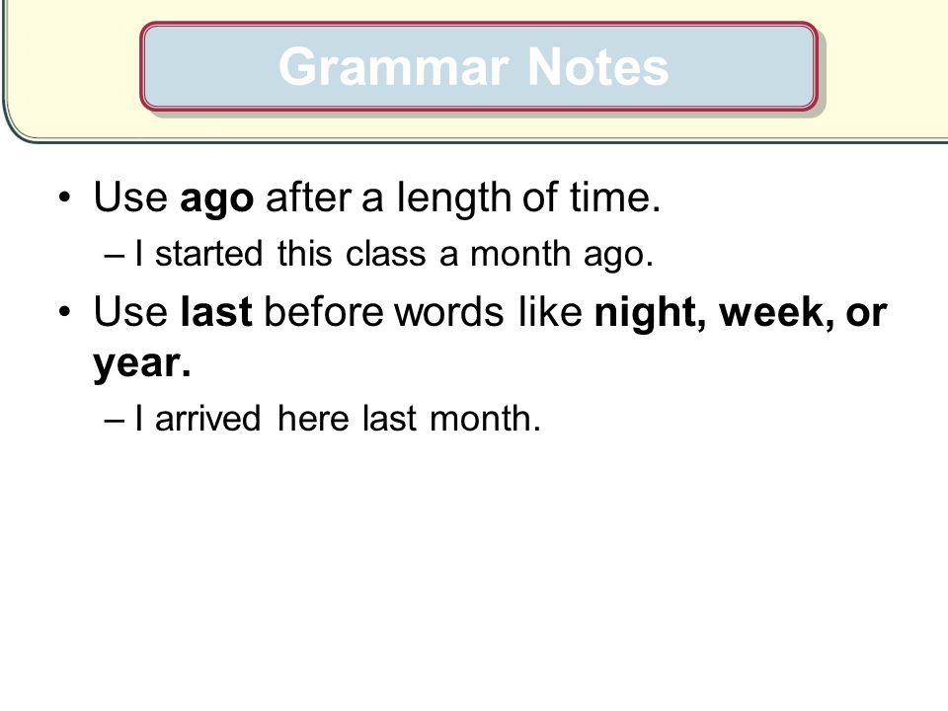
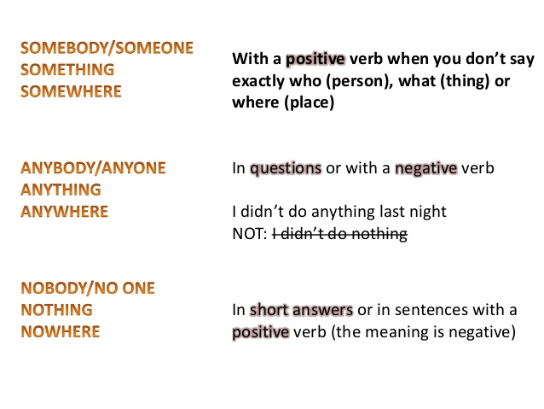
Conversation

Conversation
Date: \ \14

New Vocabulary:
Words | Kind | Meaning | Examples
Match:
1- Don't lose your cool believe me
2-The thing is The problem is
Don't get angry

7- about you:
Were you ever in an accident ? How did you or that person feel about it ?
What happened?

……………………………………………… ………………………………………………………
……………………………………………… ……………………………………………………

Date: \ \14
Reading

Conversation

New Vocabulary:
Words | Kind | Meaning | Examples
*Write the correct word under each picture:
[ well-groomed / cool / topic / silly ]
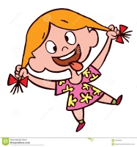



1-…………………….. 2-………………………….. 3-……………………..

Writing

Conversation
Date: \ \14

*Write your own witness report about an accidentyou saw or heard about. Use your notes from the diagram page 62and ideas from this unit :

………………………………………………………………………………………………………………………………………………………………………………………………………………………………………………………………………………………..……………….
…………………………………………………………………………………………………………………………..…………………………
………………………………………………………………………………………………………………………………………………….
……………………………………………………………………………………………………. ______________________
……………………………………………………………………………………………………. ______________________
………………………………………………………………………………………………………. ______________________
………………………………………………………………………………………………………. ______________________
……………………………………………………………………………………………………… ______________________
…………………………………………………………………………………………………….
………………………………………………………………………………………………………
……………………………………………………………………………………………………..

project

Conversation
Date: \ \14

*Make a brochure for your classmates . List things that make them happy , sad, scared, etc.
……………………………………………...... ……………………………………………….  ………………………………………………….  ………………………………………………….  …………………………………………………  …………………………………………………  …………………………………………………  ………………………………………………….  ………………………………………………….  …………………………………………………..  ………………………………………………….  ………………………………………………….  ………………………………………………….  ………………………………………………….  …………………………………………………..  ………………………………………………….  …………………………………………………  …………………………………………………  ………………………………………………….  …………………………………………………  …………………………………………………  …………………………………………………  …………………………………………………..  ………………………………………………….. | ……………………………………………...... ……………………………………………….  ………………………………………………….  ………………………………………………….  …………………………………………………  …………………………………………………  …………………………………………………  ………………………………………………….  ………………………………………………….  …………………………………………………..  ………………………………………………….  ………………………………………………….  ………………………………………………….  ………………………………………………….  …………………………………………………..  ………………………………………………….  …………………………………………………  …………………………………………………  ………………………………………………….  …………………………………………………  …………………………………………………  …………………………………………………  …………………………………………………..  …………………………………………………..
[ you can add pictures]
11 Form, Meaning &Function

Conversation

Date: \ \14

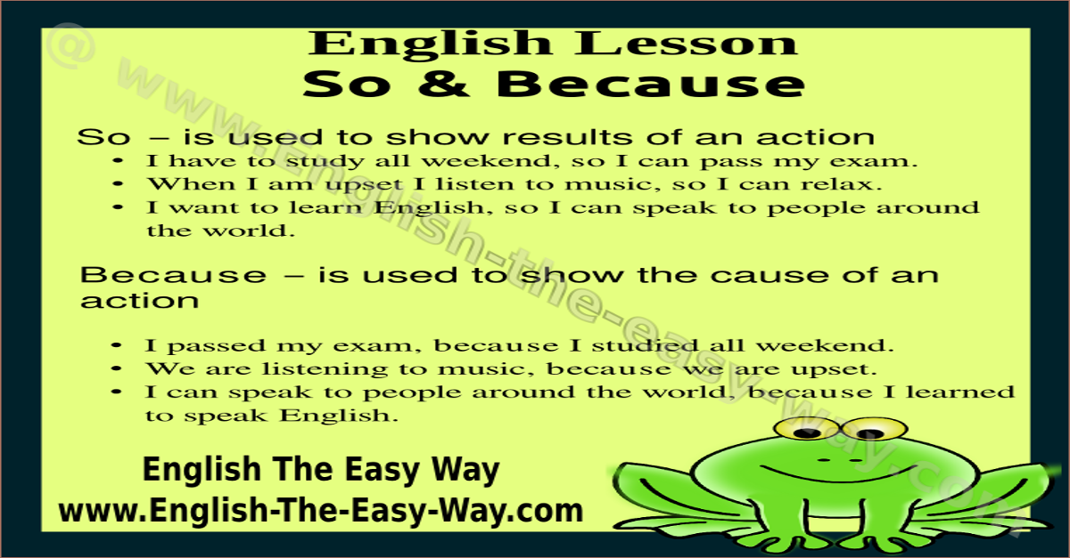

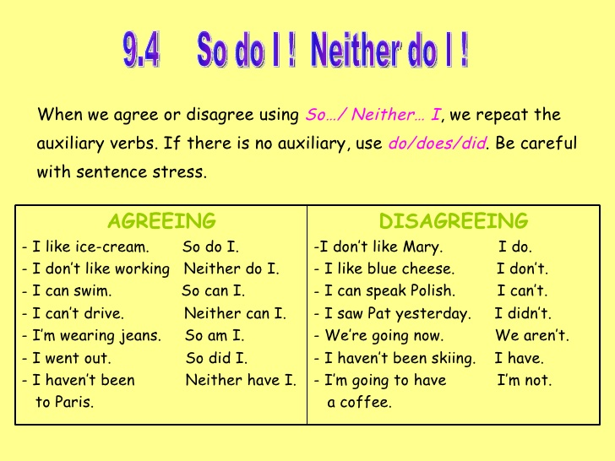

c
Date: \ \14
Listen & Discuss

Conversation

قال تعالى" و اذا مرضت فهو يشفين "

Conversation

New Vocabulary:
Words | Kind | Meaning | Examples

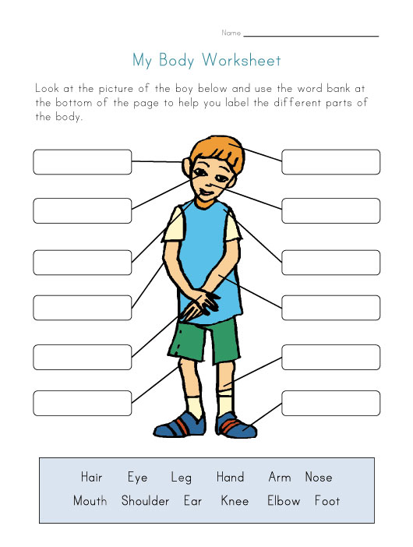

Date: \ \14
Grammar

Conversation

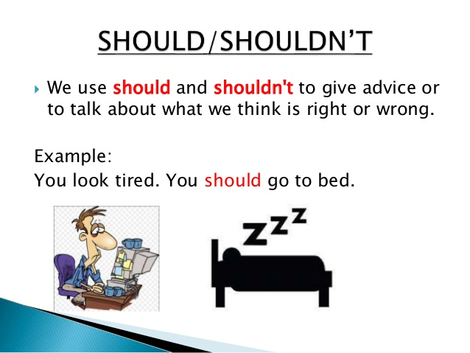
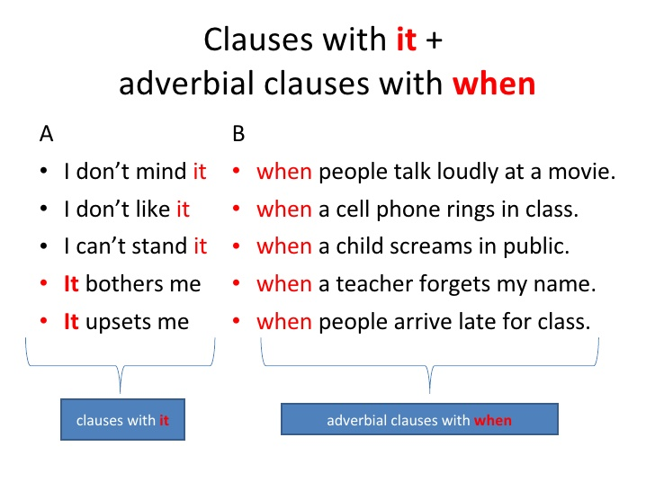

Conversation

Conversation
Date: \ \14

New Vocabulary:
Words | Kind | Meaning | Examples
Match:
1-And things like that Looking for information.
2-nothing much and similar things .
Not a great amount.

7- About You:
Write the correct word under each picture:
[ healthy / ill / work out ]

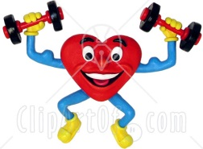


1-…………………… 2-……………………… 3-……………………….

Reading

Conversation
Date: \ \14

New Vocabulary:
Words | Kind | Meaning | Examples
Write the opposite of the following:
1-common # ……………………………………….

2- impossible#................................

3-tradiontal #..................................

4-similar #........................................

9-Writing

Conversation
Date: \ \14

*What should you do when you have flu ? Write about it . Use your notes from the chart and other ideas from this unit .

……………………………………………………………………
……………………………………………………………………………………………………………………………………………………………………………………………………………………………………………………………………………………………………………………………………………………………………………………………………………………………………………………………………………………………………………………………………………………………………………………………………………………………………………………………………………………………………………………………………………………………………………………………………………………………………………………………………………………………………………………………………………………………………………………………………………………………………………………………………………………………………………………………………………………………………………………………………………………………………………………………………………………………………………………………………………………………………………………………………………………………………………………………………………………………………………………………………………………………………………………………………………………………………………………………………………………………………………………………………………………………………………………………………………………………………………………………………………………………………………………………………………………………………………………………………………………………………………………………………………………………………………………………………………………………………………………………………………………………………………………………………………………………………………………………………………………………………………………………………………………….

project

Conversation
Date: \ \14

*Research home remedies for common illnesses.
…………………………………………………………………….
………………………………………………………………………………………………………………………………………………………………………………………………………………………………………………………………………………………………………………………………………………………………………………………………………………………………………………………………………………………………………………………………………………………………………………………………………………………………………………………………………………………………………………………………………………………………………………………………………………………………………………………………………………………………………………………………………………………………………………………………………………………………………………………………………………………………………………………………………………………………………………………………………………………………………………………………………………………………………………………………………………………………………………………………………………………………………………………………………………………………………………………………………………………………………………………………………………………………………………………………………………………………………………………………………………………………………………………………………………………………………………………………………………………………………………………………………………………………………………………………………………………………………………………………………………………………………………………………………………………………………………………………………………………………………………………………………………………………………………………………………………

Form ,Meaning &Function
Conversation
Date: \ \14

Dictation

Correction | Mark | Words | DATE

Correction | Mark | Words | DATE

Correction | Mark | Words | DATE

Correction | Mark | Words | DATE

