Unit: 4 (A Healthy life)
Question 1: general questions
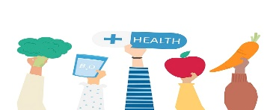

- Answer the following questions
هذه الصورة بواسطة كاتب غير معروف مرخصة بالاسم CC BY-NC
- What should you do to be healthy?
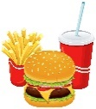
…………………………………………………
هذه الصورة بواسطة كاتب غير معروف مرخصة بالاسم CC BY
- What shouldn’t you do to be healthy?
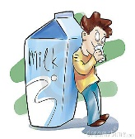
…………………………………………………
- Did you drink milk this morning ?
…………………………………………………..
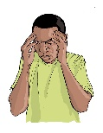
- What's the matter ?
…………………………………………………….
Question 2: controlled writing
- Rearrange the sentence:
- I / early / should / go to bed /.
………………………………………………………………………………………………..
- shouldn't / I / breakfast / skip/ .
…………………………………………………………………………………………………..
- I / can / you / help / ? ………………………………………………………………………………………………..
- have / I / earache / an / .
…………………………………………………………………………………………………..
- Which of the following you should do to live a healthy live :
1-Get up early
2- Eat too much junk food
3-Brush my teeth
4- Stay up late
I should ……………………………….. and I should …………………………………

Question 3: Reading short sentences

- Read the sentence then choose T (√ ) or F (×)
- I have a headache ( )
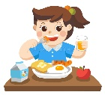
- I ate breakfast this morning ( )
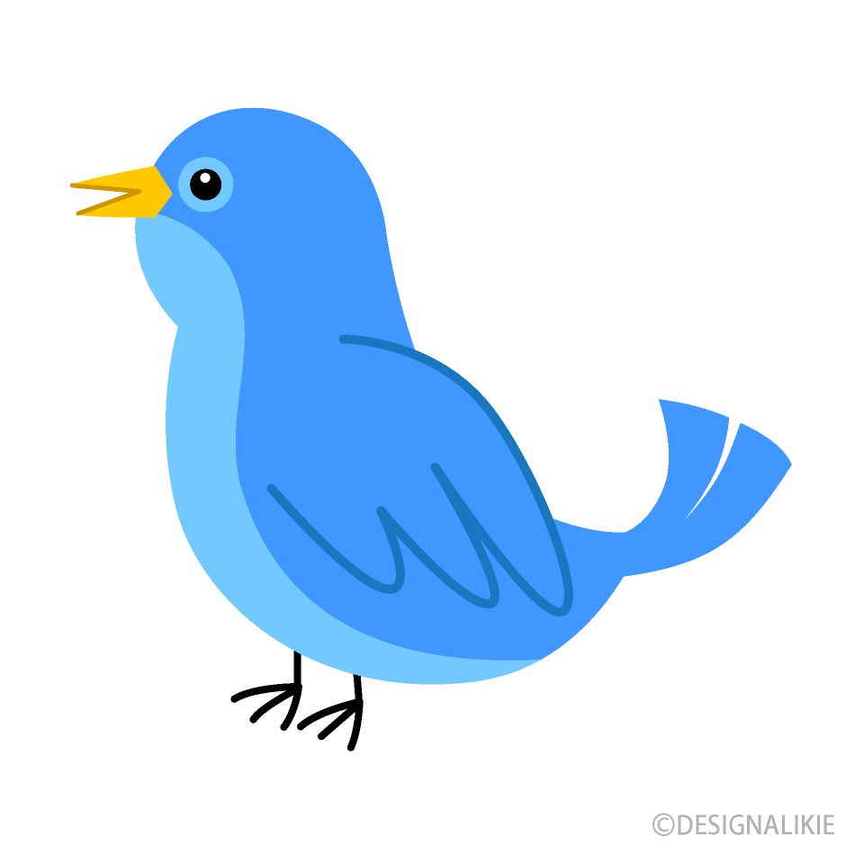
- I saw a horse in the farm ( )
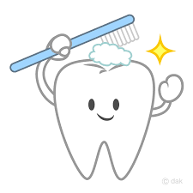
- I always brush my teeth ( )

- Choose the correct answer

- I ( should- shouldn’t ) drink a lot of water .

- I ( should- shouldn’t ) drink too much soda .

Question 4: spilling
- Choose the missing letters
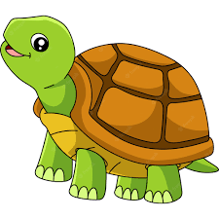
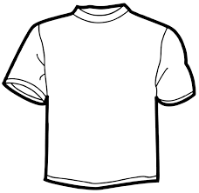
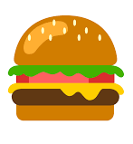
B………..ger |  | 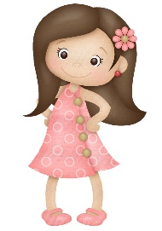  G…………l |  | Sh…………..t |  | T……………tle
ir | or | ir | ur | ir | ur | ir | ur
Question 5: Vocabulary
A - Fill in the blank with the following words :
1-Shopping 2- Do exercise 3- Stay up
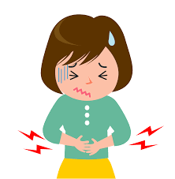
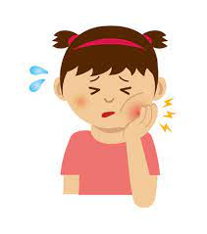
4- Toothache 5-Stomachache
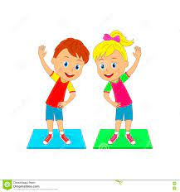 |  |  | 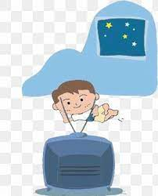

Question 6: Grammar
A-Choose the correct answer :
1- Did you (get up – got up ) early this morning ?
2- Did you eat breakfast ? - yes, I (eat- ate)breakfast.
3- Did you brush your teeth ? No, I didn’t (brush – brushed ) my teeth .
B-Write the past forms of the following :
- Play ……………………
- Get up ……………………
- Watch …………………...
- Drink ……………………

إعداد المعلمة: عهود سالم باوزير
مراجعة وتدقيق مشرفة المادة: داليا إبراهيم فرغل

