Unit: 3 (My school is cool)
Question 1: general questions
- Answer the following questions
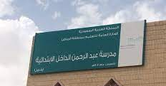
- What is the name of your school ?
………………………………………………………………..

- Which grade are you in ?
…………………………………………………………………

- Which city do you live in ?
………………………………………………………………..
- Match the questions with there answers
A |  | B
- How many students in your school? |  | I like math
- What time dose your school start? |  | It starts at 6:30
- Which subject do you like the most? |  | There are 330 students
Question 2: controlled writing
- Rearrange the sentence:
- I / in / live / Yanbu /.
………………………………………………………………………………………………..
- had / Rana / lamp / a little /.
…………………………………………………………………………………………………..
B- Write about your school :
( Yanbu – 13 - Aboshakeer – 33 – 6:30 )
I live in ……………………… . My school name is ………………………..There are about …………………….classrooms . There are ……………….students in my classroom . My school starts at …………………….
Question 3: Reading short sentences

- Read the sentence then choose T (√ ) or F (×)
هذه الصورة بواسطة كاتب غير معروف مرخصة بالاسم CC BY-NC-ND
- My school has a big yellow school bus ( )

- My school starts at 6 :30 ( )

- Math is the subject I like the most ( )

هذه الصورة بواسطة كاتب غير معروف مرخصة بالاسم CC BY
B- Match :

هذه الصورة بواسطة كاتب غير معروف مرخصة بالاسم CC BY-NC-ND
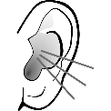
1- Last year I liked English .

3- Listen to the teacher .
هذه الصورة بواسطة كاتب غير معروف مرخصة بالاسم CC BY-NC
4- Don’t forget to do your homework .

Question 4: spilling
- complete the missing letters :
( sc - sk - sq )
 | 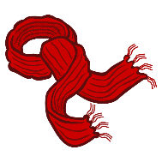 |  |  |  | 
……y | ………arf | …………an | ……….irt | ………uare | ……….uid
Question 5: Vocabulary
A - fill in the blank with the following words :
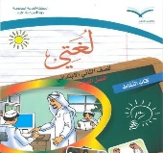

1-Science 2– Language 3– history 4 – art


B –match the picture with the suitable word :
A |  | B
- Class rules |  | 
- Lamp |  | 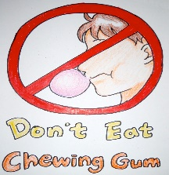  هذه الصورة بواسطة كاتب غير معروف مرخصة بالاسم CC BY-NC
- School uniform |  |   هذه الصورة بواسطة كاتب غير معروف مرخصة بالاسم CC BY-NC-ND
- School bus |  | 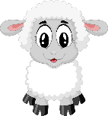

Question 6: Grammar
A-choose the correct answer :
1- last year I ( like – liked ) social studies .
2- Do you have a school uniform? - yes, we ( do- don’t ).
3- Which subject ( do – did ) you like the most this year ?
4 – Last year I ( was – were ) in 5th grade.
5- Last weak I ( go – went ) to Jeddah .

إعداد المعلمة: عهود سالم باوزير
مراجعة وتدقيق مشرفة المادة: داليا إبراهيم فرغل

