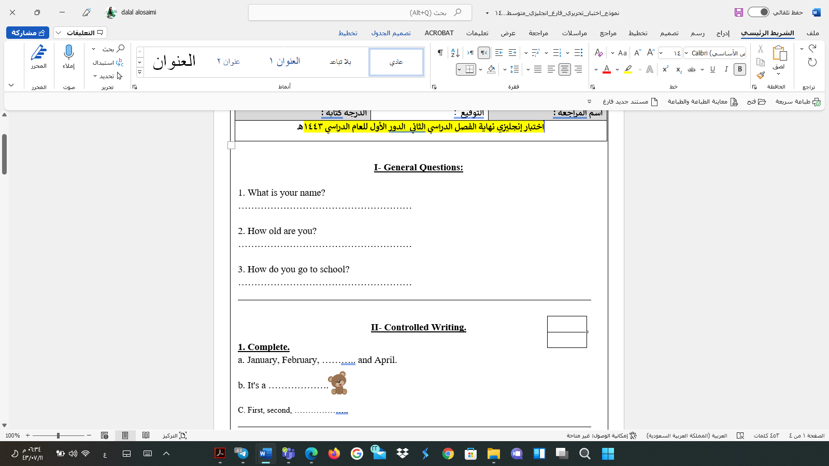
Final Exam 6th grade 1444H
6
I. General Questions
A. Match "A" with "B":
"A" |  | "B"
- Do you have school uniform? |  |  | Yes, we do.
- Which subject do you like this year? |  |  | This year ,I like English.
- What would you like to drink? |  |  | I'm going to Dubai.
- Where are you going? |  |  | I'd like some juice.
- Choose:

- How many students are there in your school?
a. About 500. b. Yes, we do
- What should you do to live a healthy life?
a. I have a headache. b. I should do some exercise.

________________________________________________________________________
IV. Controlled writing
A. Unscramble and write:
5
1.u– b – e – l
……………………………………………………………………………………….

2. u- t- e c

……………………………………………………………………………………….
B. Complete: [ Paris –snow - book store - math - orange ].
1. I'd like some………………………juice, please.
2. ……………………………..sells books.
3. It's white. You ski on it………………………….

III. Reading short sentences
4
A. Number.

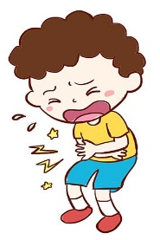
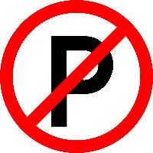
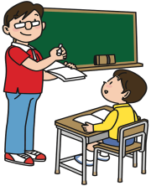
1. No parking.
2. Listen to the teacher.
3. He’s scuba diving
4. I have a stomachache.

II. Grammar
A. Choose the correct answer:
1. There ( was – were - are ) a little green house.
5
2. Last year I [ went – go – going ] to Riyadh.
3. Did you ( drink – drank - drunk ) milk in the morning?
4. I'm going to [ visit – visiting – visits ] my grandma.
5. We ( is – are – am ) going to the bookstore.
__________________________________________________________________
V. Vocabulary

A.Write the correct number under the correct picture:
6
1. bakery 2. stapler 3. School bus 4. toothache 5. science 6. skirt crocodile

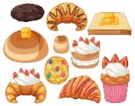
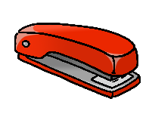

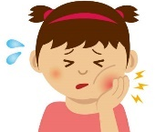

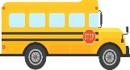

( ) ( ) ( ) ( ) ( ) ( ) .

VI. Orthography(spelling)

- Circle the correct missing litters:
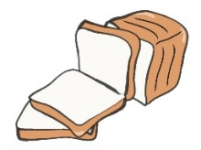
4 |  |  | 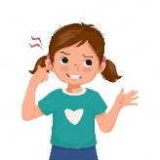
juice | No bicycle | shirt | earache
bread | 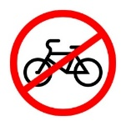  library | 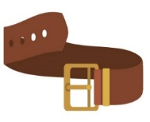  belt | backache

- Complete: [ ur – sc - ue – ir ]
 | 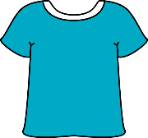 | 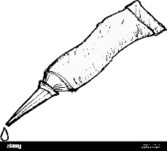 | 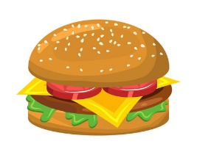
_ _ ary | sh_ _ t | gl_ _ | b_ _ ger

GOOD LUCK
Tr.Amal

