المملكة العربية السعودية |  | 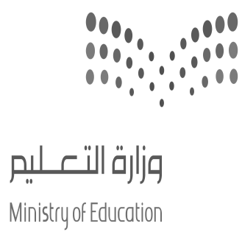 |  |  |  | المادة: |  | اللغة الانجليزية (شفوي)
وزارة التعليم |  |  |  |  |  | الصف |  | الأول متوسط
الادارة العامة للتعليم ب______ |  |  |  |  |  | التاريخ: |  | /11/1444 هـــ
مدرسة________المتوسطة |  |  |  |  |  | الزمن: |  | نصـف ساعة
اختبار نهاية الفصل الدراسي الثالث – الدور الأول للعام الدراسي 1444 هـــــ
الاستماع 5 |  | التحدث 5 |  | المجموع 10
الاسم ثلاثي |  |  |  | الفصل | أول / |  | رقم الكشف
Listen and circle the right answer:
- What did you do yesterday afternoon? |  | 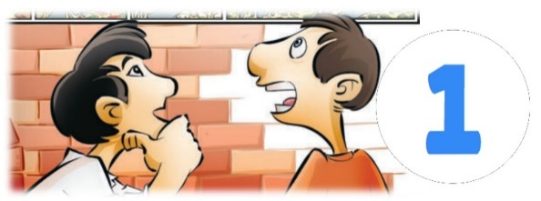
 | I went to the zoo.
 | I went to the park.
 | I went to the museum.

- Where were you? |  | 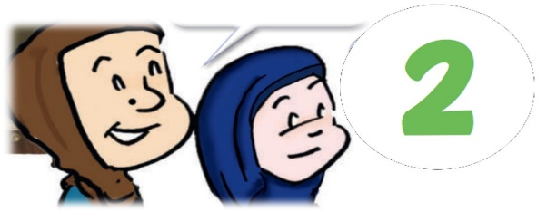
 | Sorry I was busy.
 | Sorry I was late.
 | Sorry I was sick

- When is the national holiday  in your country? |  | 
 | It is on the February 25th.
 | It is on the December 2nd.
 | It is on the September 23rd.

- I don’t know what to wear  I’m going to go shopping for………… |  | 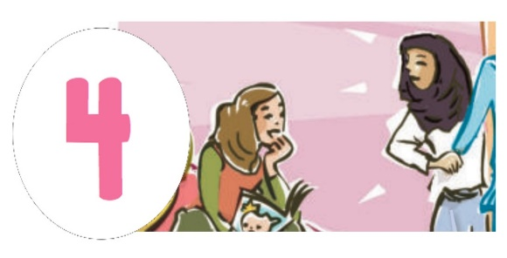
 | a formal blouse.
 | a formal dress.
 | a formal shoe.

- Do you like to draw?  I like to_______ |  | 
 | make design.
 | make models.
 | make things.
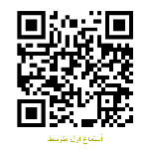
Audio: https://youtu.be/DF9771ehDeA

