6
Q1. Answer :
1-What time do you get up? Iget up at………o`clock.

2- Can elephants fly ? ………………………

.
It is …………………..

What is the weather today? 3-

___________________________________________________________________________________________
Q2. Do as shown between brackets:
1-watches. (make it singular)……….

4

3- ( 24, , , , 28) ( complete)
___________________________________________________________________________________________
Q3. Match:
-Their eyes pop out.

-it is windy.

-Snail is small

6


___________________________________________________________________________________________
Q4. Choose the correct word :

6

1-the mouse is (in – next to) the fridge
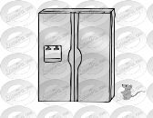
3-where is Ali? ( she – he ) at home
2-These are (wallets - wallet)

8

-bedroom - kitchen - pilot -mountain - firefighter -watch
st
Q5. Match:
 | 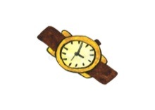 |  |  |  | 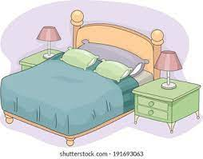
---------- | ---------- | --------- | ---------- | --------- | ---------

___________________________________________________________________________________________
Q6. Fill in the missing letters :

o / ea / oo / ) )

- m ….. ….. t t…. …… th

انتهت الاسئلة

