
اختبار الفترة الثانية.
الفصل: الدراسي الثالث 1443ه.
الصف الرابع الابتدائي.
المادة : انجليزي.
We Can2
المملكة العربية السعودية.
وزارة التعليم.
إدارة التعليم
مكتب تعليم
المدرسة

الاسم / .....................................................................................الفصل: ..../.....
General questions: (4m)

4
1 – Answer the following questions :

1 - What's the matter?
I'm ………… ( happy - sad )
2 – What day do you like?
I like ………. (Friday - pizza )

3 – What's the weather like?
It is …………… ( rainy - sunny )

4 - How many horses are there?
- They are ………………. ( 15 - 11 )

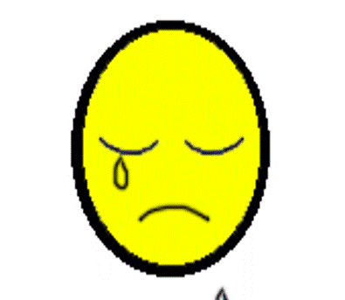

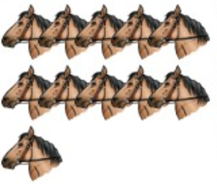

3
Reading short sentences: (3m)

4

2 – Read and put or :
1. I'm happy
2. It is a cat.

3. He is hungry.

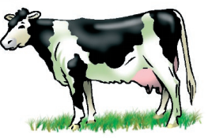

4
A – Complete:
Controlled writing : (4m)

100 | …… | 80 | ….… | 60 | …... | 40 | 30 | …... | 10

B– Rearrange:

angry / He / is ……………………………………………….
.

3
Grammar: (3m)
4 – Read and choose the correct answer:

؟ | . | 1 – What is this ….
He | my | 2 – ………… mother is angry
are | is | 3 – You ………………… happy.

Vocabulary: (3 m)
5 – Write the correct word under each picture:

………..……. | ………..……. | ………..…….

cloudy - laptop - zebra

3



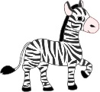

3
6 – Choose the correct letter:
Orthography (Spelling): (3m)

4
7 – Copy the following:
……………………………………
I have a bicycle.
__ un  ( s - t ) | Fo…  ( y – x ) | __olf  ( v - w)

