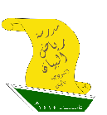



2nd Intermediate Grade - Unit 16 Revision
Grammar

- Choose the correct answer:
- Have you ever ______ a snake?
( see - saw - seen - seeing )

- I _____ ants in Mexico 3 years ago.
( eating - eats - eat - ate )

- Hameed ______ his horse every day.
( ride - rides - rode - ridden )

- I've never _____ in a helicopter.
( fly - flew - flying - flown )

- Jana _____ gone ice-skating.
( has - have - having - were )

- Do as shown between brackets:
- Has Lamar ever been to Bahrain? ( Answer )
_______________________________________________________________________
- They has visited historic places. ( Correct )
_______________________________________________________________________
- Noura has been to a museum. ( Change to Negative )
_______________________________________________________________________
- You have seen a shark. ( Make a Yes\No question)
_______________________________________________________________________

Vocabulary

- Write each word under its picture:
Cage - Hang gliding - Desert safari - Durian fruit - Kite surfing - Sunscreen
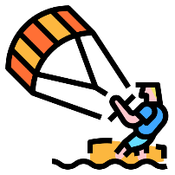
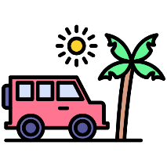





- Match the expressions from column A with their meaning in column B:
A |  | B
- Definitely | ( ) | Very frightened.
- You're out of your mind! | ( ) | You're crazy!
- Scared to death | ( ) | To tell the truth.
- To be honest | ( ) | Expressing certainty.

Dictation Words

Camel Riding>

المراجعة لا تغني عن الكتاب.

