اسم:............................................................................ الصف:............................
Choose:
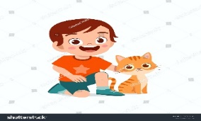
what's the matter ?
A. I am happy B. I like Sunday.

- What day do you like ? A-I am hungry B- I like Friday
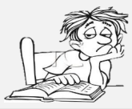
-A- Do she bored ? B- Are you bored?
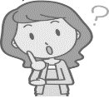
-A-Who is angry? B- What do angry.

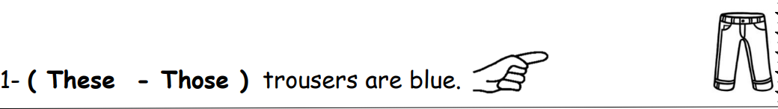
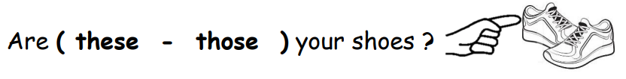
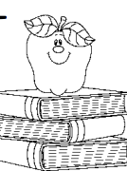
the apple ( on - next ) the books
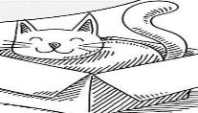
( it - she ) is ( in - at ) the box
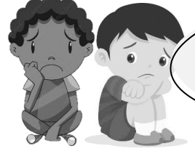
(They - she ) are sad
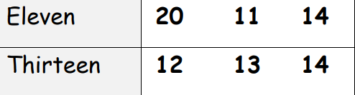
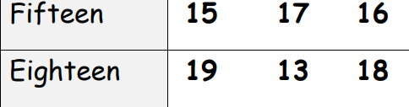
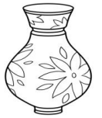 | 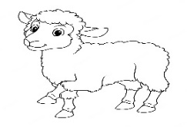 |  | 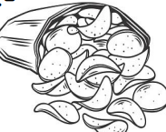 | 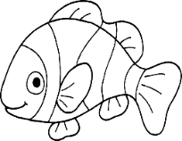 | 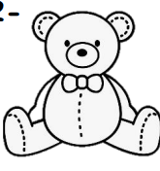
v | sh | p | sh | f | p
f | ch | b | ch | v | b
Listen then Choose the sound:
Choose :
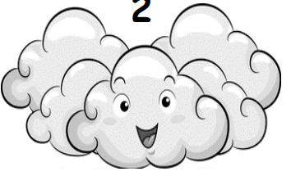 | 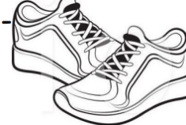 | 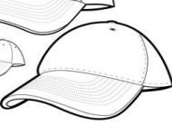 | 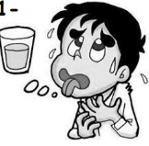 | 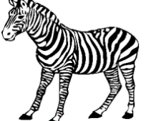 | 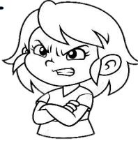
Sunny | shoes | dress | thirsty | fox | angry
Cloudy | shirt | cap | happy | zebar | happy

Copy :

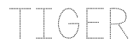
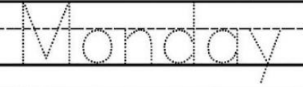

It is cat .

……………………………………………………………………………..………………………………………………………………….……..……………………………………………………………………………..……………………………………………………………………..……………………………………………………………………………..……………………………………………………………..……..

Choose:
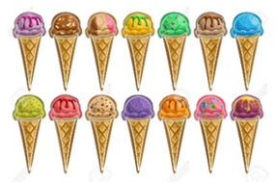 | 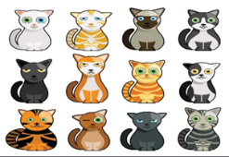 | 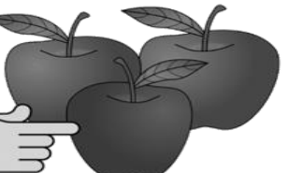
20 | 12 | 30
14 | 2 | 3

5 + 5= ………………
4 + 4 =……………….

Choose:
H ( b - h)
C (c - g)
D ( d - C)

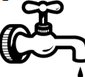 | 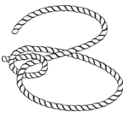 | 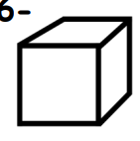
tap | nope | cupe
top | rope | cap

_
Controlled writing

4

Put
