Study these well. Unit 3
What’s the name of your school? Elementary School.
How many students are there in your school? About 500
Do you have school lunch at your school? No, we don’t.
Does your school have a school bus? Yes, it does.
Do you have a school uniform? No, we don’t.
What time does your school start? It starts at 7:00
1. Which subject do you like most this year? This year I like math.
2. Which subject did you like most last year? Last year I liked PE.
3. Which grade are you in this year? This year I am in the 6th grade.
4. Which grade were you in last year? Last year I was in the 5th grade.
5. Which city do you live in? We live in Najran.
6. Which city did you and your parents go to last year? Last year we went to Riyadh.
School Rules
Use استخدم your CD when you study English.
Ask اطلب for help when you have a problem. Speak تحدث English in class.
Stand up قف when you present. Don't shout لا تصيح Speak clearly.
Don't forget لا تنسى to do your homework. Don't make لا تعمل too much noise.
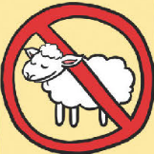
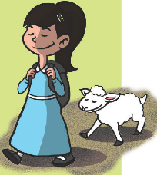
Rana had a Little Lamb
Rana had a little lamb. Its fleece was white as snow.
Everywhere that Rana went, The lamb was sure to go.
It followed her to school one day, Which was against the rules.
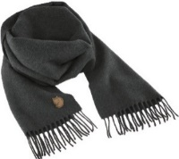
It made the children laugh and play, To see a lamb at school.

sky
scarf

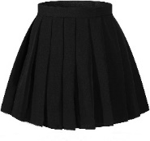

scary
sk
skirt

scan
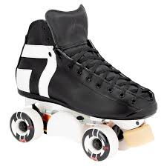
sc
skate
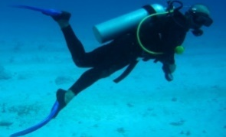
scuba
diving


square

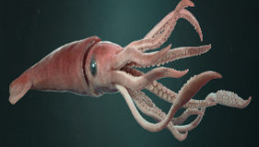
squid
sq

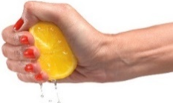
squeeze

النصيحة Advice Unit 4
نستخدم للأشياء الجيدة كلمة (يجب should) ونستخدم للأشياء السيئة كلمة (لا يجب shouldn't)
should
Shouldn't

You should sleep early. You shouldn't eat too much.
You should study hard. You shouldn't play in the street.
لاحظ أن should / shouldn't لابد أن يأتي بعدها فعل مصدر
Yes / No questions: أسئلة نعم / لا في الزمن الماضي
- Did you play football yesterday?هل لعبت كرة قدم بالأمس
Yes, I played football yesterday.نعم أنا لعبت كرة قدم بالأمس
No, I didn’t play football yesterday.لا أنا لم ألعب كرة قدم بالأمس
إذا كانت الإجابة نعم فإن الفعل يتحول إلى الزمن الماضي، أما إذا كانت الإجابة لا فإن الفعل يظل بنفس الصيغة والزمن لا يتغير.
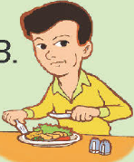
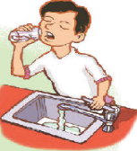
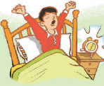
Good things
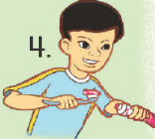
1. I should get up early. 2. I should drink a lot of water.
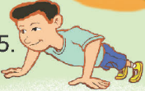
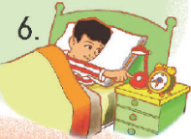
3. I should eat three meals a day. 4. I should brush my teeth well.
5. I should do some exercise. 6. I should go to bed early.
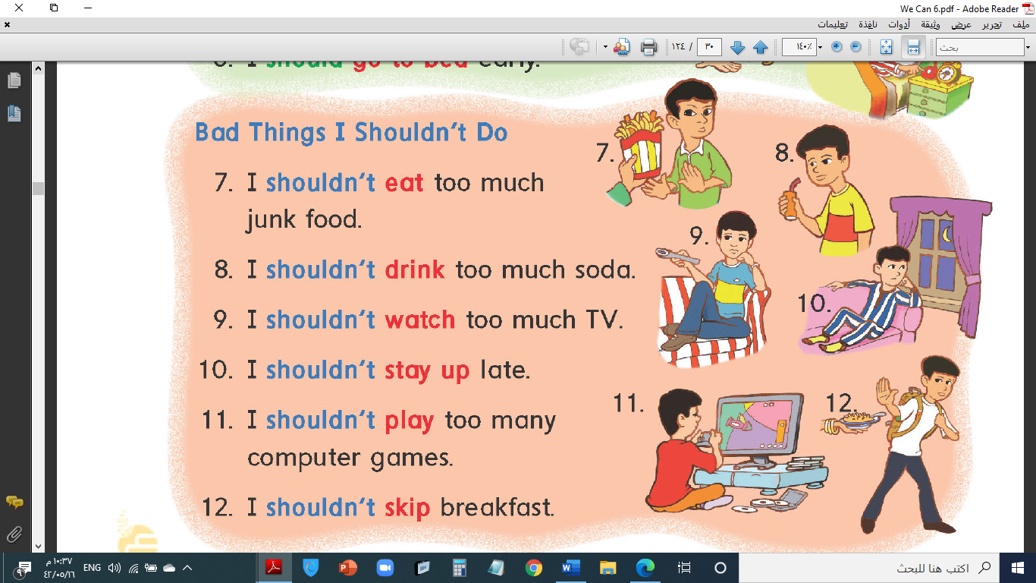
Bad things
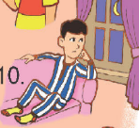
7. I shouldn't eat too much junk food. 8. I shouldn't drink too much soda.
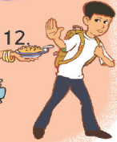
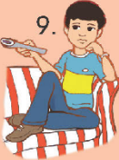
9. I shouldn't watch too much TV. 10. I shouldn't stay up late.
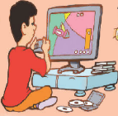
11. I shouldn't skip breakfast. 12. I shouldn't play too many computer games.

Early to Bed (healthy – wealthy – wise)
Early to rise

Late to Bed (sleepy – tired – grumpy)


Late to rise

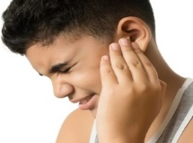

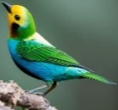
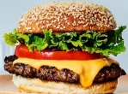
acheألم / وجع (headache – earache – toothache – stomachache)
burger bird


turtle girl
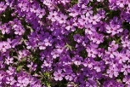
ur ir
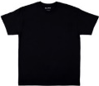
purple shirt

Unit 5 Directions: الاتجاهات
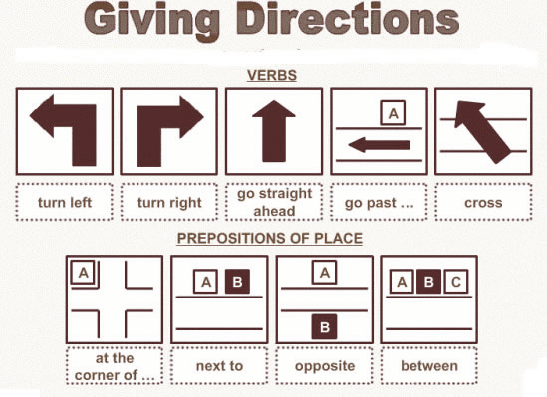
- Excuse me. من فضلك
Yes? نعم
- Where is the bank? أين البنك
Go straight. اذهب للأمام
Then, turn left. ثم انعطف لليسار

- Is it far? هل هو بعيد
لديك 4 خيارات للإجابة
- It is far from here. إنه بعيد من هنا
- It's near here إنه قريب
- It's right over there. إنه هناك مباشرة
- It's just around the corner. هناك بعد المنعطف

- How long does it take? كم المسافة أو المدة حتى أصل
لديك خيارين للإجابة
- It's only a few minutes.
- It's about _____ minutes.

Excuse me. Where's the gym? > Go straight and turn left.
Is it far from here? > No, it's near.
How long does it take? > It's about 5 minutes.
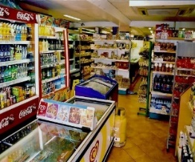
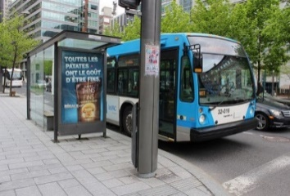
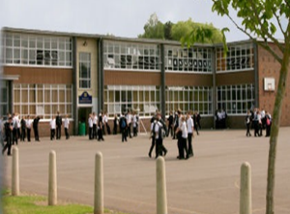
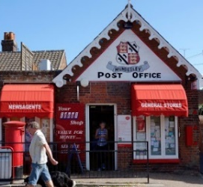
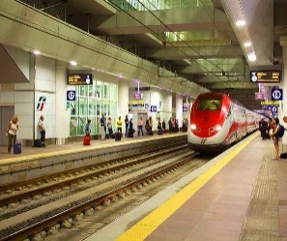

train station post office school bus stop store

زمن المضارع المستمرPresent Prog.
* يتكون من: am, is, are + الفعل + ing
* يدل على: حدث يحدث الآن.
I am going to the mall. He is going to the bank. She is going to the market.
We are going to the store. They are going to the hospital. You are going to the zoo.
يمكنك استخدام الصيغة المختصرة بدلاً من الصيغة الكاملة مثل:
I am= I'm He is= He's She is= She's It is= It's We are= We're You are = You're They are = They're
*عند النفي نستخدم كلمة not بعد am, is, are (isn't / aren't)
- He is going to the park. > He is not going to the park.
*عند السؤال نستخدم المقص:
He is going to the store. > Is he going to the store?

المضارع present past الماضي
There is + مفرد There was + مفرد
يوجد There are + جمع كان يوجد There were + جمع
There is a book. There was a book.
There are books. There were books.

going to مكان to get/buy كذا
Things | Place |  | Things | Place
stapler | stationery store |  | newspaper | convenience store
candy | candy store |  | bread | bakery
DVD | DVD store |  | meat | butcher shop
flowers | flower store |  | coffee | coffee shop
books | book store |  | eggs | supermarket
I'm going to the bookstore to get some books.
To get some flowers, he's going to the flower store.

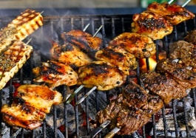
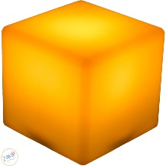
barbecue
cube
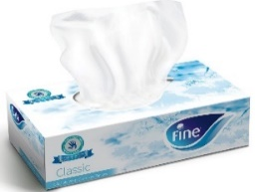
tissue

cute
Tuesday

u-e
ue
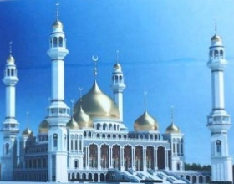
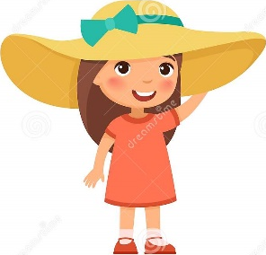
huge
mosque
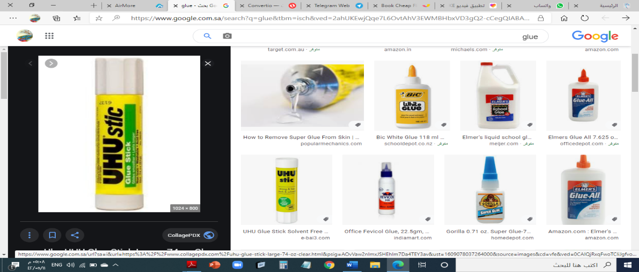
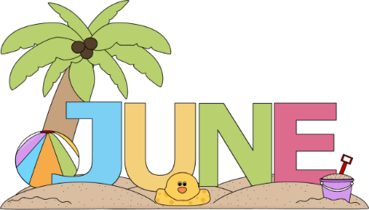
glue
June

blue

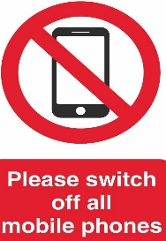
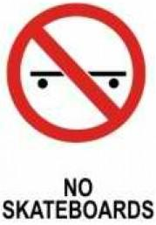
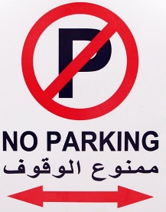
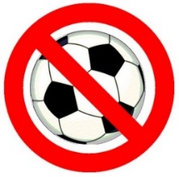
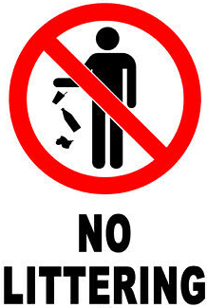
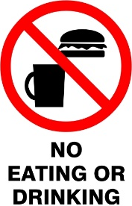
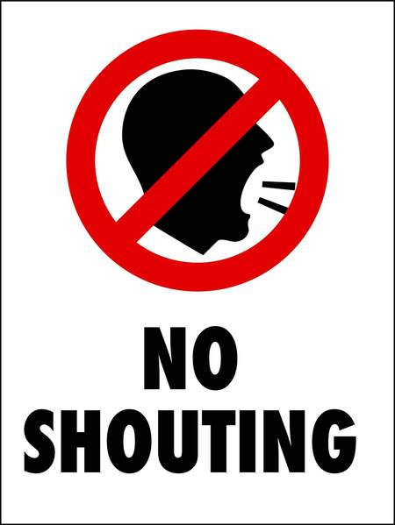

No Balls

Unit 6
1. Days: Sunday, Monday, Tuesday, Wednesday, Thursday, Friday, Saturday.
2. Months: January, February, March, April, May, June, July, August, September, October, November, December
4. Pronouns: I, you, he, she, it, we, they mine, yours, his, hers, ours, theirs
1. Sounds and Letters: beautiful, clouds, seas, enough, interesting, silently, white, shining, barbecue, laughing, photo, square, scarf, squid ….

I'm going to Najran.
Where are you going?
It takes about 2 hours.
How long does it take?
What are you going to do?
I'm going to go shopping.
I'd like some fish.
What would you like to eat?

I'd like some coffee.
What would you like to drink?

Why = لماذا because = بسبب ، لكي ، لأن
عند السؤال باستخدام why فإن الإجابة دائما تبدأ بكلمة because
Because I am happy.
Why are you smiling?

too = أكثر من اللازم
تستعمل كلمة too قبل الصفة للتعبير عن صيغة المبالغة لدرجة السلبية
The shirt is too big.
The tea is too hot.

enough كفاية
تستعمل كلمة enough للتعبير عن الصفة المناسبة على أقل تقدير
The tea is not hot enough.
The room isn't clean enough.
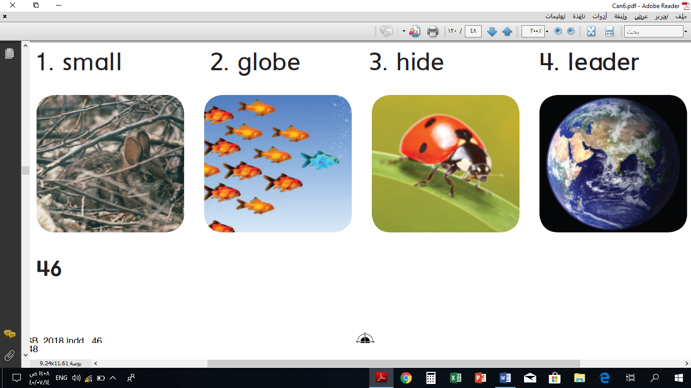

hide leader small globe


Third Term

WE CAN 6

Final Revision المراجعة النهائية
Unit 3 My school is cool
Choose : What - Where - How
1-………………… is the name of your school ?
2-…………… many students are there in school ?
3-………………… is the time of your school ?
4-…………………would you like to drink ?
Read the text and answer the questions:
Hi! Let me introduce my school.
The name of my school is ……………….. There are about ………. students in my school. We……………. school lunch at our school. Our school ……………. a bus. We …………………. a school uniform. Our school starts at ………………….
Read the text and answer the questions:
This year Amal likes English. Last year she liked art. This year Hashim likes Arabic, last year he liked science.
Complete:
1. Amal likes ………………………… 2. Hashim liked ………………………
Choose:
3. Last year (Amal – Hashim) liked science. 4. This year (Amal – Hashim) likes English
Complete:
1. This year, I like ……………………. 2. Last year, …………………………
Read and match:
1- Don't shout ………… to the teacher
2- Listen …………to do your homework
3- speak ……….. speak clearly
4- Don't forget ………English in the class!
Complete use: sk , sc , sq
__ __y __ __ uare __ __arf
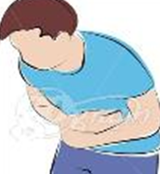
Unit 4 A healthy life
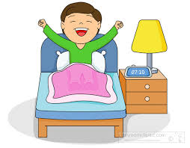


Read and match:
1-I should get up early
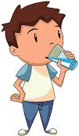
2-I should drink a lot of water. ------ ------- ------- ------
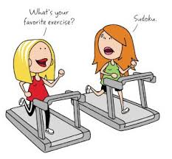

3-I should do some exercise
4-I should go to bed early
5-I have a headache.
6-I have a toothache
7-I have stomachache. ----------- ------------ ------
Answer:
1) Did you get up early this morning ?
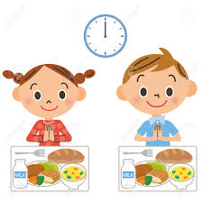
a- Yes , I did. b- No, I didn't.
2) Did you eat breakfast this morning ?
a- Yes, I did. b- No , I didn't.
Listen and choose:
What should you do to live a healthy life?
a- I should watch too much TV. b- I shouldn't eat junk food. c- I should play too much games.
Complete the dialogue: Goodbye. – Which one? This one? – Can I help you? – Here you go.
Amal: …………………………………………………………….?
Bushra: Yes, please. I want a sweater
Amal: ………………………………………………?
Bushra: Yes, thanks. How much is it?
Amal: It's 60 SR
Bushra: ……………………….
Amal: Here's your change.
Bushra: Thank you and goodbye.
Amal: ……………………………
Write:
1- I should …………………………………………………………………
2- I shouldn't ………………………………………………………………….
3- This morning, I ……………………………………………………………….
Answer:
Did you get up early this morning? ………………………………………
Did you drink milk this morning? ..........................................................
Did you brush your teeth this morning? ...............................................
Choose:
1- She has an earache ( because – and – but ) she has a bad cold .
2- She has a toothache ( and – but – because ) she never goes to the dentist .
Read and fill in the missing words: Farm – purple – park – bird – flew away
A horse from a …………... asked a ……………... bird in the …………..., Do you like corn? Yes, I do. answered the purple ………………. and chirp, chirp, she ………

Unit 5 Hanging out in the town
Choose: There was There were
1-………………………………………. a big house.
2-………………………………………. three floors.
3-………………………………………. a kitchen.
4-………………………………………. two bedrooms.
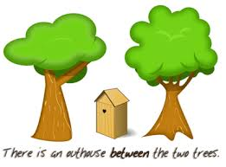
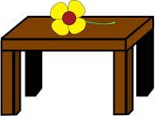
Read and match: 1- in front of 2- between 3- behind 4- next to 5- on
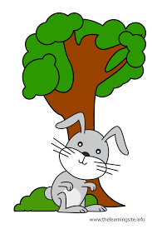
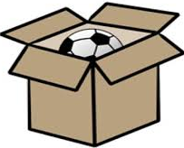
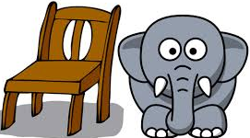


------ -------- -------- ------ ------- -------
Listen and complete:
1- I want some flowers, I'm going to the ………………...
2- I want some …………………………..., I'm going to the bookstore.
3- I want some bread, I'm going to the ………………………
Choose: What - where - who - why
1- ………………………. do you want? I want some books.
2- ……………… are you going? I'm going to bakery.
3- ……………... is the post office? Go straight then turn left.
Choose: There is - There are
1- …………………………. a chair.
2- ………………………….. papers
3- ………………………….. a key.
4- ………………………….. radios.
Complete use: u-e , ue
1- c__b__ 2- bl__ __ 3- gl__ __ 4-h__g__
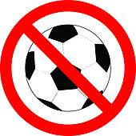
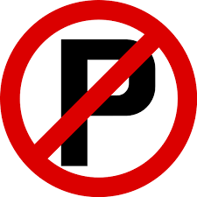
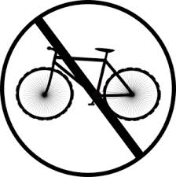
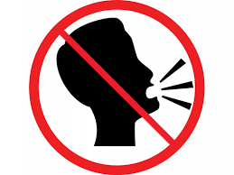
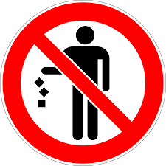
Read and match:
1- No parking
2- No bicycles
3- No shouting
4- Please do not litter. ------ ------- ------ ------- -----
5- No balls
Unit 6 My dream vacation
Choose: What , Where , Why
1-…………. are you going?
2-…………. are you going to do there?
3-………... would you like to drink?
3- ………...did you eat breakfast?
Write use: going to:
I'm ……………………………………………………………………
Choose: very hungry - so cute - very sleepy
1- Why did you eat all soup? Because I was …………………………………
2- Why did you sleep in mt bed? Because I was ………………………….
3- Why did you drink all juice? Because I was ……………………………………
Activities Final Exam
A. Match words and pictures:
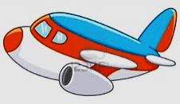
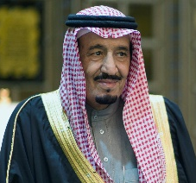
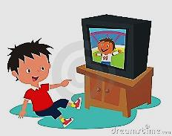
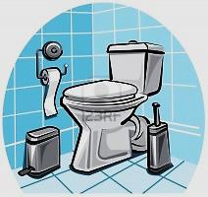
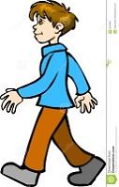
1. walk
2. watch
3. plane
4. king ---------- ----------- ---------- ------------- ---------
5. bathroom
B. Circle the odd word:
- hotel hospital zoo traffic light
- bedroom carpet bathroom kitchen
- father mother uncle fisherman
- deer hippo tram leopard
- doctor teacher aunt engineer

C. Read the sentences, look at the pictures, and circle ( Yes ) or ( No ):
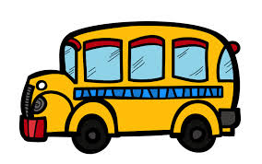
1. He's a policeman. Yes No
2. I go to school by bike. Yes No
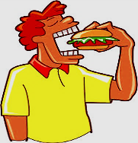
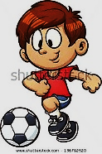
3. I drank orange juice. Yes No
4. I'm doing my homework. Yes No

D. Match questions and answers:
- Who's that? ( ) In a house.
- What was that? ( ) That's my aunt.
- Where do you live? ( ) Go across the bridge.
- Where's the airport? ( ) It was an elephant.

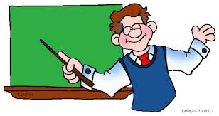

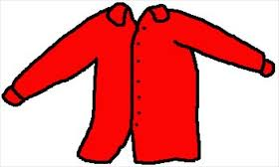
E. Write the missing letters:

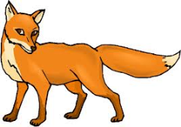
_ hirt _ osque tea _ her for _ y
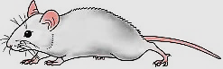
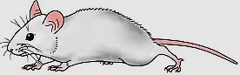
F. Look at the pictures and write the missing words:

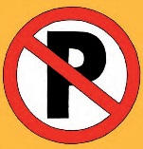
1. I'm afraid of the ………………… 2. There's a ……………………
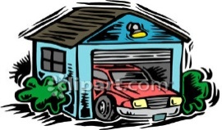
3. You …………… park. 4. The car is in the ………………………….
G. Rearrange to make sentences:
1. is – A cheetah – fastest – the.
2. was – grandfather – My – a fisherman.
3. school – It's – holiday – a.
4. did – Where – work – he?

