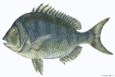
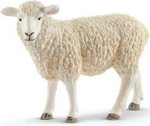


Unit 3 Animalsالحيوانات
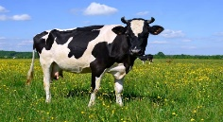
قطة cat كلب dog بقرة cow خروف sheep سمكة fish
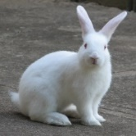
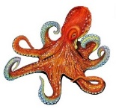
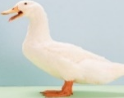
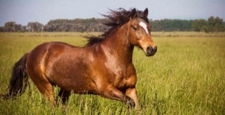
بطة duck حصانhorse أرنب rabbit اخطبوط octopus

عندي/ لدي / أمتلك have
I have a cat. أنا عندي...... I don't have a dog. أنا ليس عندي ....
10 11 12 13 14 15 16 17 18 19 20
هل عندك حيوان أليف؟ Do you have a pet? Yes, I have a -------.
هل عندك حيوان أليف؟ Do you have a pet? No, I don't have a ------------.
ماعز goat طائر bird ببغاء parrot دب bear سلحفاة turtle دجاجة chicken جمل camel فأر mouse حمار وحشي zebra
S s sunشمس T t tiger نمر U u umbrella مظلة V v vase مزهرية

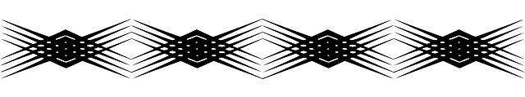
الوحدة الرابعة Unit 4
الأحد Sunday الاثنين Monday الثلاثاء Tuesday الأربعاء Wednesday الخميس Thursday الجمعة Friday السبت Saturday
ما اليوم الذي تحبه؟ What day do you like? I like Friday.

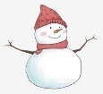
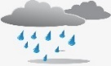
الطقس Weather
مشمس sunny ممطر rainy مثلج snowy عاصفwindy غائم cloudy hot cold

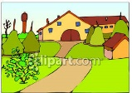
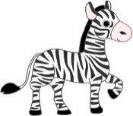
What's the weather like? ما حال الطقس؟ It's sunny today.
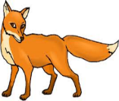
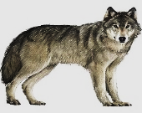
W w wolf X x Fox Y y yard Z z zebra




Unit 5 الوحدة الخامسة
What's the matter? ما بك / ما الأمر


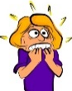
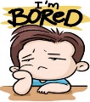

I'm happy. أنا سعيد I'm sad. أنا حزين I'm angry. أنا غضبان I'm hungry. أنا جوعان
I'm thirsty. أنا عطشان I'm sleepy. أنا نعسان I'm scared. أنا مرعوب I'm bored. أنا طفشان

أنا عندي... I have ….
- I have a book. - I have a pencil. - I have a computer. - I have a laptop.

هل أنت....؟ Are you happy?
Yes, I am. No, I am not.
- الضمائر pronouns
أنا I am - هو He is - هي She is نحن We are – أنتم You are – هم They are
الإشارة
المفرد
هذا (قريب) This is a ….. مفرد This is a book. What is this?
هذا (بعيد) That is a ….. مفرد That is a star. What is that?

الجمع
هؤلاء (قريب) These are ….. جمعs These are pens. What are these?
هؤلاء (بعيد) Those are ….. جمعs Those are birds. What are those?

لا تنسى أن a / an يأتي بعدها مفرد .. لكن an تأتي قبل الحروف المتحركة الخمسة (a,e,i,o,u)
a dog an apple an orange a cat

لا تنسى أن الجمع نضيف في أخر الاسم حرف s أو es
book – books zebra – zebras dog – dogs
لكن هناك أسماء تنتهي بحرف o , s , x , ch , sh فاننا نضع أخرها es
Fox – foxes bus – buses watch – watches box - boxes
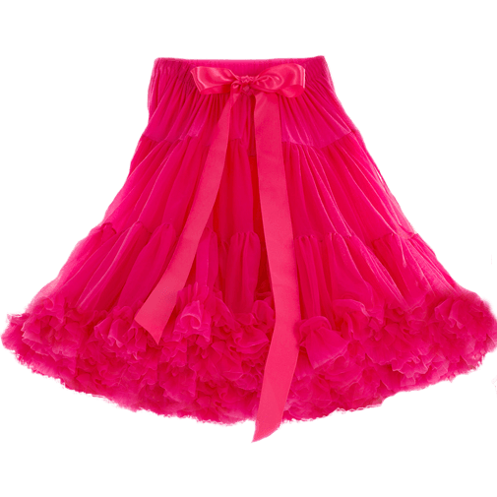
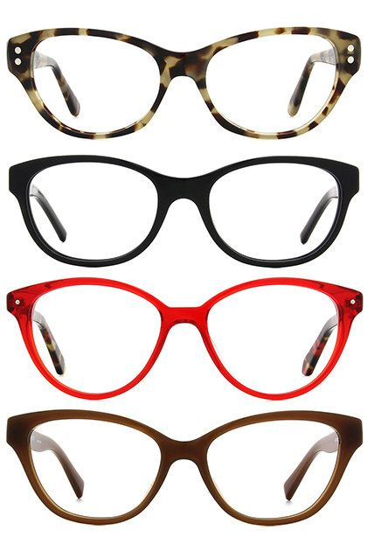
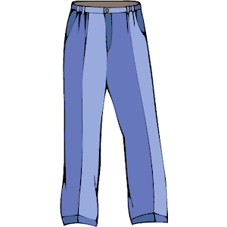

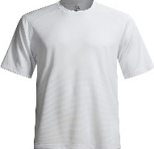





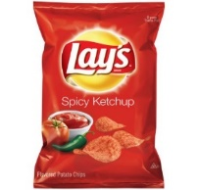
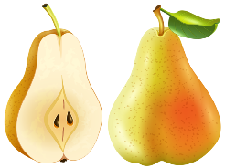
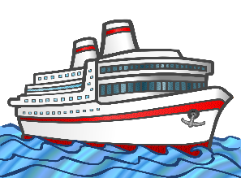
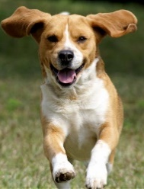
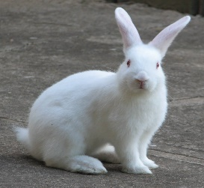
Skirt trousers glasses cap shoes T-shirt on
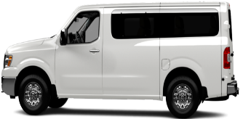
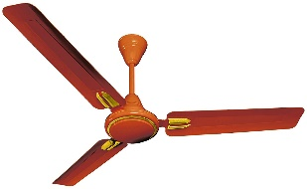

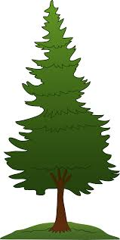
bear pear van fan ship chips


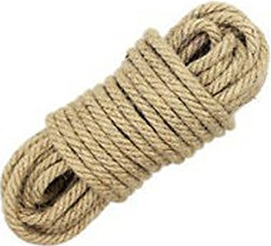
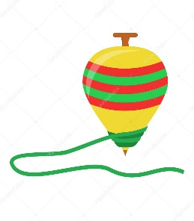
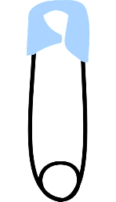
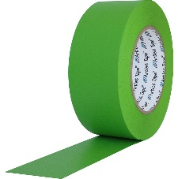
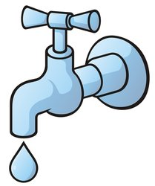


tap tape pin pine top rope cub cube
Third Term

WE CAN 2

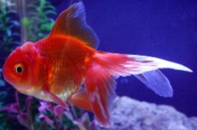
What can you see?
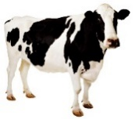
1. (fish – cow – cat)
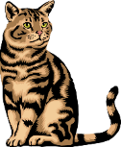
2. (fish – cow – cat)
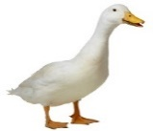
3. (fish – cow – cat)
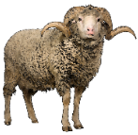
4. (duck – sheep – bird)
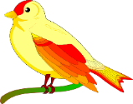
5. (duck – sheep – bird)
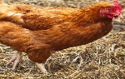
6. (duck – sheep – bird)

7. (horse – chicken – mouse)
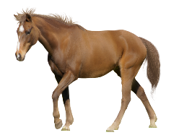
8. (horse – chicken – mouse)
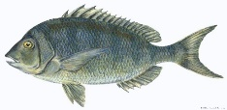
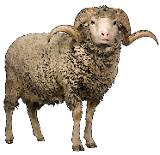
9. (horse – chicken – mouse)

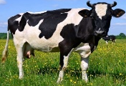
Match the words: Match the words:
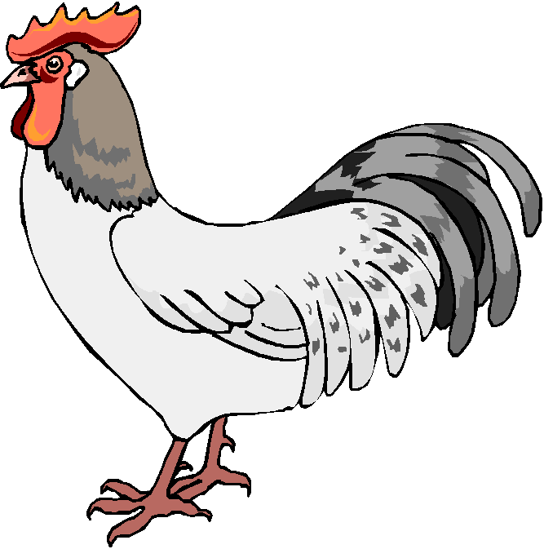
1) cat 6) duck
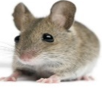
2) cow 7) sheep

3) fish 8) chicken
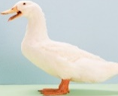
4) horse 9) turtle
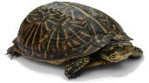
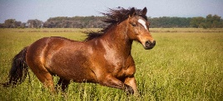
5) bird 10) mouse
Write the missing letter:
C__w du__k hor__e mo__se b__rd chic__en she__p turt__e
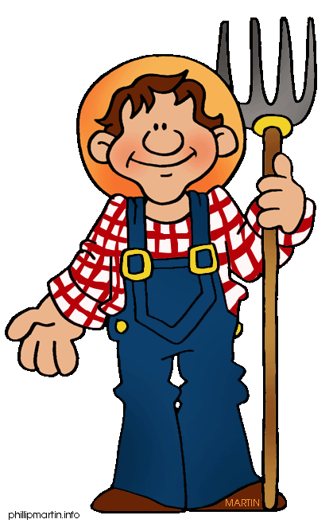
What can you see?
1. (farm – farmer – tiger)

2. (farm – farmer – tiger)
3. (farm – farmer – tiger)
4. (sun – octopus – vase)
6. (sun – octopus – vase)
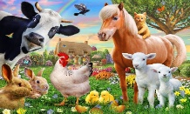
7. (animals – umbrella – parrot)
8. (animals – umbrella – parrot)

Match the words: Match the words:
1) umbrella 1) animals

2) vase 2) farm
3) sun 3) farmer
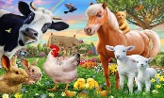
4) tiger 4) tiger
5) farm
Write the missing letter:
S__n tig__r va__e umbre__la far__er an__mals v__se far__
Complete the missing parts:
1) Do you have a pet? Yes, ----------------.
2) Do you have a cat? No, -----------------.
3) Do you have a cow? ---, I have a cow.
4) Do you have a fish? --, I don't have a fish.
5) Do you have a horse? Yes, I ---- a horse.

What is the number?

1. (eleven – eighteen – twenty)

2. (eleven – eighteen – twenty)

3. (eleven – eighteen – twenty)

4. (twelve – fourteen – sixteen)

5. (twelve – fourteen – sixteen)
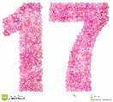
6. (twelve – fourteen – sixteen)

7. (thirteen – fifteen – seventeen)
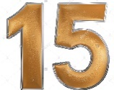
8. (thirteen – fifteen – seventeen)
9. (thirteen – fifteen – seventeen)
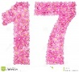


Match the words: Match the words:
1) twelve 1) eleven
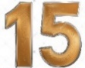

2) fourteen 2) thirteen

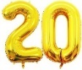
3) sixteen 3) fifteen


4) thirty 4) seventeen
5) twenty 5) eighteen
Write the missing letter:
el__ven fo__rteen seven__ee sixte__n eightee__ fi__teen
Rearrange the days: رتب الأيام
Friday – Sunday – Wednesday – Saturday – Thursday – Monday – Tuesday
Sunday ________, ________, ________,Thursday,______, ____
Complete the missing parts about days:
1) What day do you like? I like ----------.
2) What day do you like? I like ----------.
3) What --- do you like? I like Wednesday.
4) ---- day do you like? I like Thursday.
5) What day ---- you like? I like Tuesday.
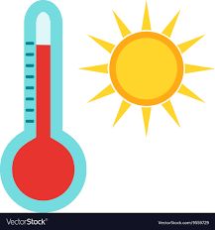
What can you see?
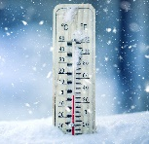
1. (hot – cold – weather)

2. (hot – cold – weather)

4. (sunny – rainy – windy)
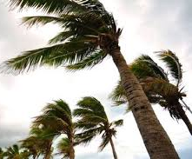
5. (sunny – rainy – windy)

6. (sunny – rainy – windy)
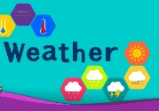
7. (cloudy – snowy – weather)

8. (cloudy – snowy – weather)
9. (cloudy – snowy – weather)

Match the words: Match the words:
1) sunny 5) cloudy

2) snowy 6) weather
3) rainy 7) hot
4) windy 8) cold

Write the missing letter:
Co__d rai__y wi__dy sn__wy su__ny clo__dy weath__r h__t

Complete the missing parts about weather:
1) What's the weather like? It's ----------.
2) What's the weather like? It's ----------.
3) What's the -------- like? It's sunny.
4) ------ the weather like? It's rainy.
5) What's the weather -----? It's snowy.
What can you see?
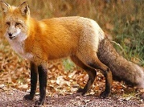
1. (zebra – vase – fox)
2. (zebra – vase – fox)
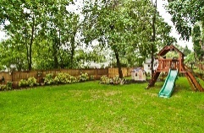
3. (zebra – vase – fox)
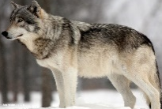
4. (wolf – tiger – yard)
5. (wolf – tiger – yard)
6. (wolf – tiger – yard)
7. (sun – umbrella – Sunday)
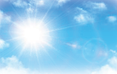
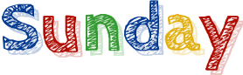
8. (sun – umbrella – Sunday)
9. (sun – umbrella – Sunday)

Match the words: Match the words:
1) wolf 5) sun
2) fox 7) tiger
3) yard 8) umbrella
4) zebra 9) vase
Write the missing letter:
Zeb__a ya__d w__lf f__x vas__ tige__ su__ umbrell_

Write ( a – an ):
__ egg __ tomato __ cake __ mouse
__ tree __ ear __ umbrella __ ice cream
__ apple __ fish __ shoe __ duck

Make Plural جمع:
I have two -------------------------. (box)
I have three -------------------------. (apple)
Ann ha pretty -------------------------. (dress)
Travis has four -------------------------. (watch)
He has six -------------------------. (cat)

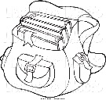
Fill in with: (This – That - These - Those):
1-……………… is a bag.
2-……………… are chairs.


3-………………… are keys.
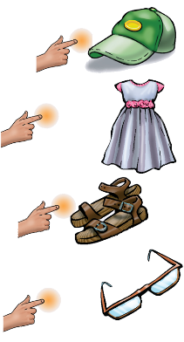
4- ……………… is a window.
5-……………… is a cap. 6-……………… is a dress. 7-………………… are sandals. 8-……………… are glasses.

What can you see?

1. (scared – happy – sad)

2. (scared – happy – sad)

3. (scared – happy – sad)
4. (thirsty – hungry – angry)


5. (thirsty – hungry – angry)

6. (thirsty – hungry – angry)
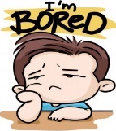
7. (sleepy – bored – laptop)

8. (sleepy – bored – laptop)
9. (sleepy – bored – laptop)

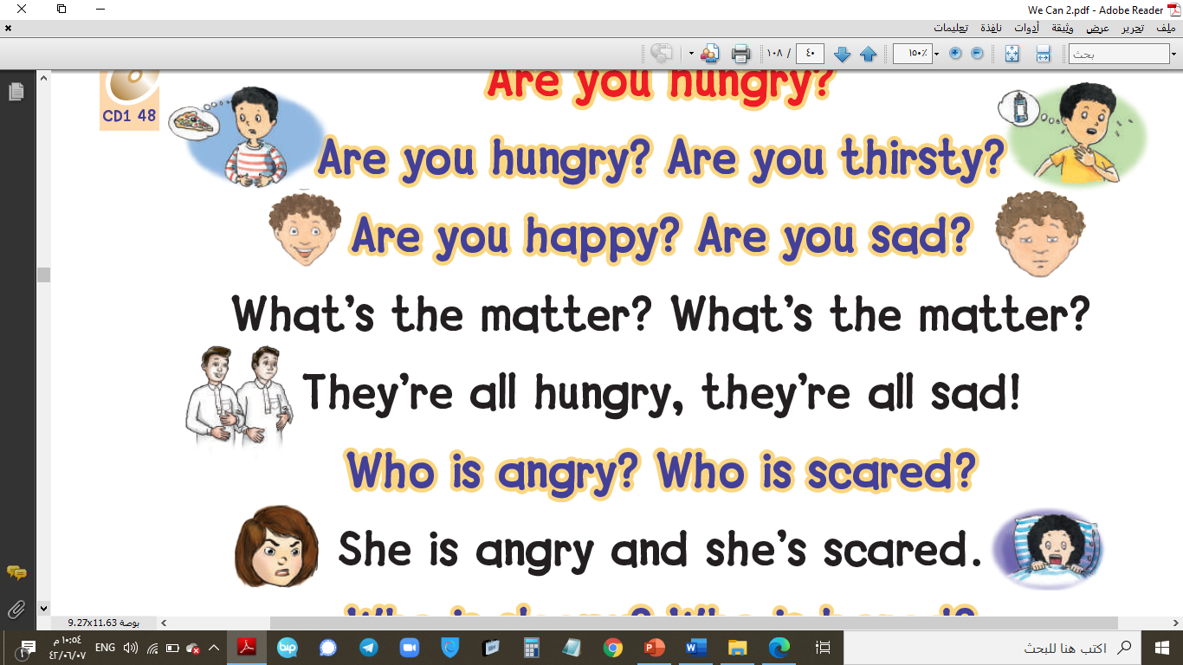

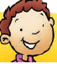
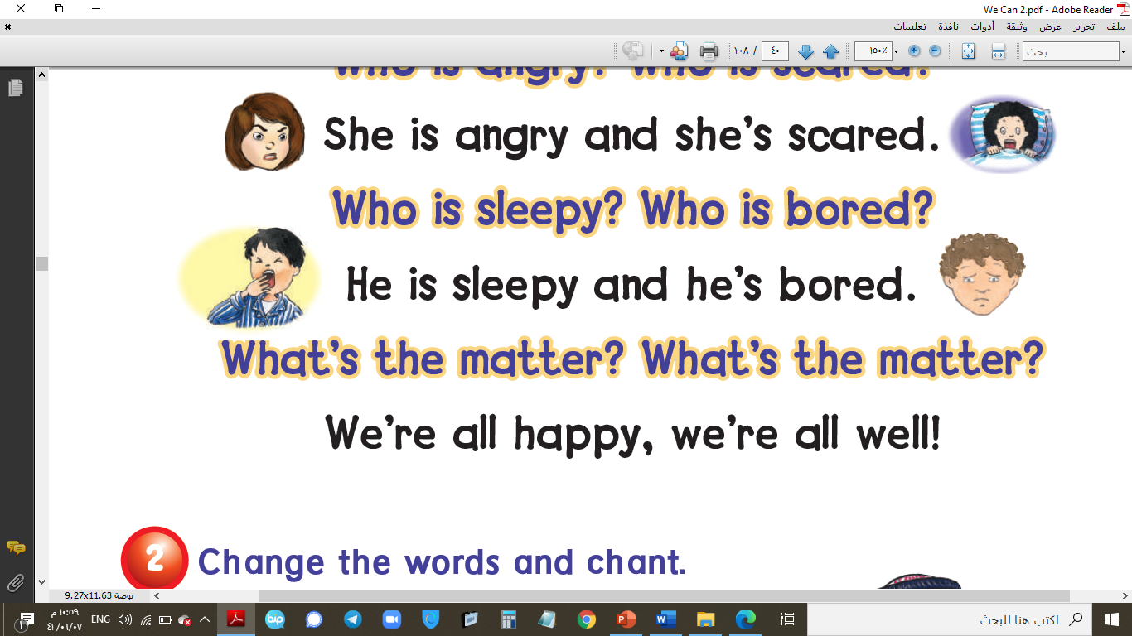
Match the words: Match the words:
1) happy 6) laptop
2) sad 7) bored

3) angry 8) sleepy
4) hungry 9) scared
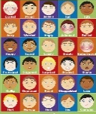
5) thirsty 10) feelings
Write the missing letter:
S__d hap__y ang__y h__ngry sc__red sle__py thir__ty bor__d feelin__s
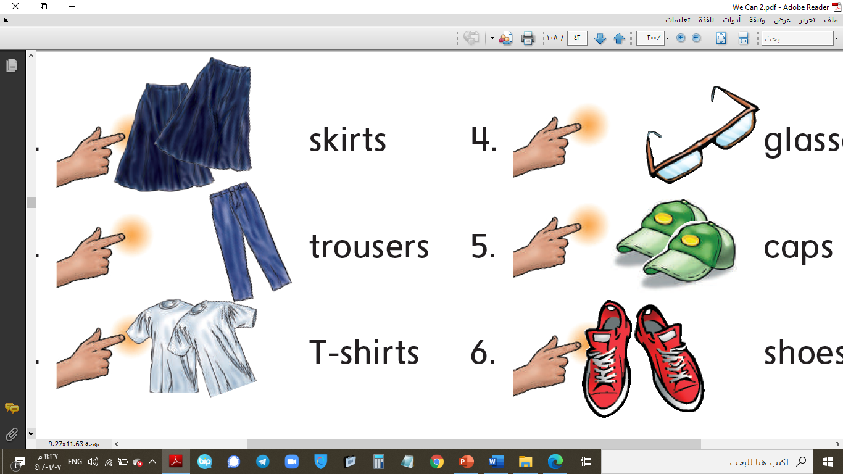
What can you see?
1. (glasses – shoes – trousers)
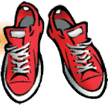
2. (glasses – shoes – trousers)
3. (glasses – shoes – trousers)
4. (cap – skirt – T-shirt)
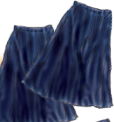
5. (cap – skirt – T-shirt)
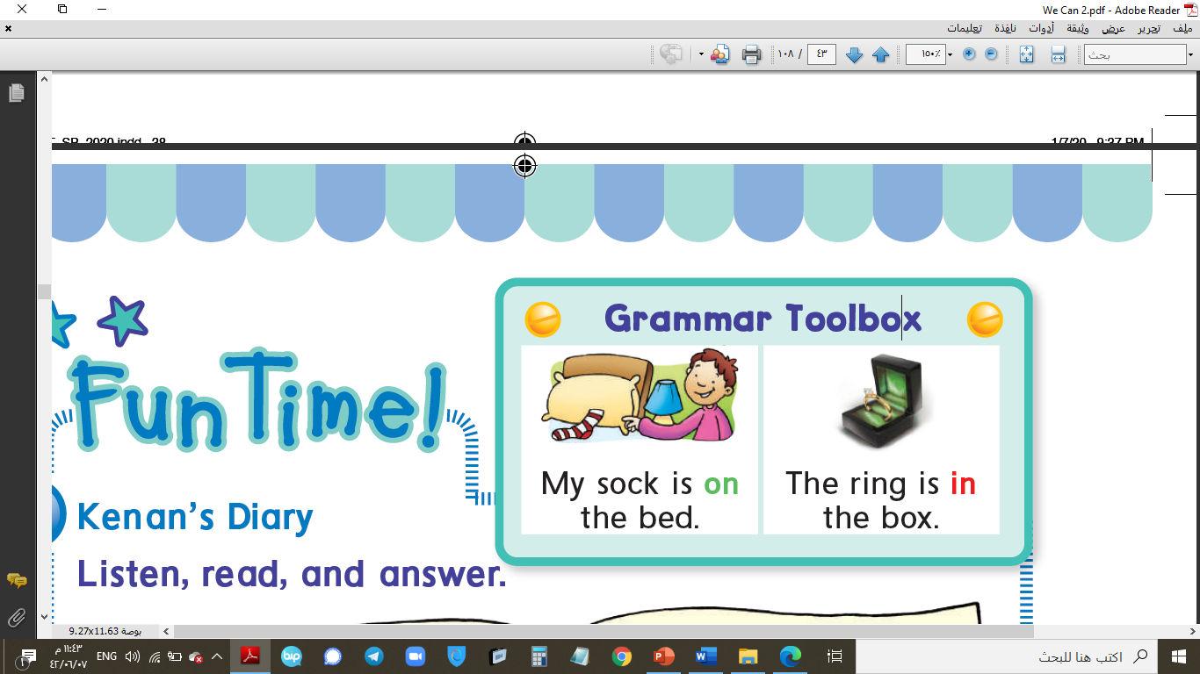
6. (cap – skirt – T-shirt)
7. (on – in – under)

8. (on – in – under)
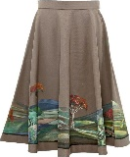
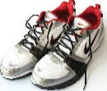
9. (on – in – under)

Match the words: Match the words:
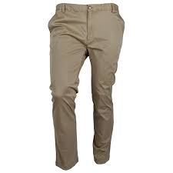
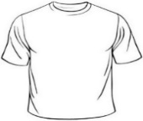
1) cap 6) trousers
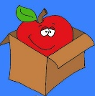
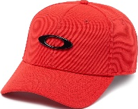
2) shoes 7) skirt
3) glasses 8) in
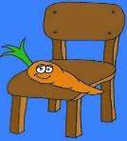
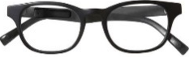
5) T-shirt 10) on
Write the missing letter:
sh__es tro__sers sk__rt glass__s T-shi__t c__p

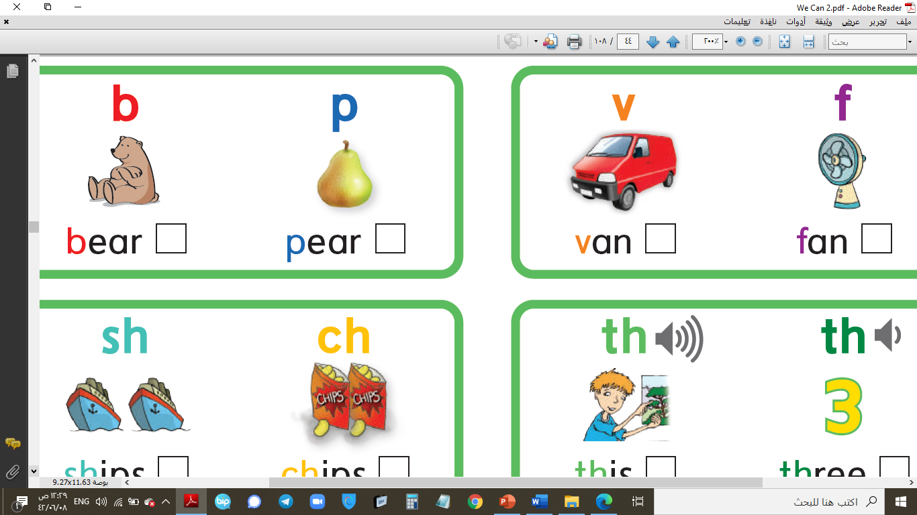
What can you see?
1. (bear – van – ship)
2. (bear – van – ship)
3. (bear – van – ship)
4. (pear – fan – chips)
5. (pear – fan – chips)
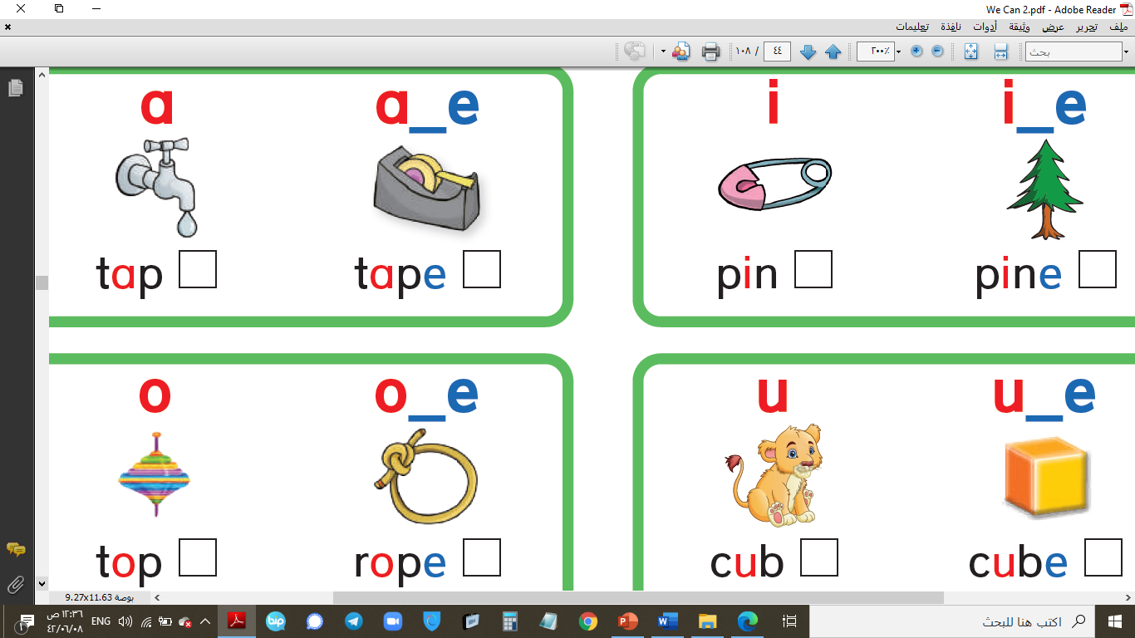
6. (pear – fan – chips)
7. (tape – pine – rope)
8. (tape – pine – rope)
9. (tape – pine – rope)
10. (tap – pin – top)
11. (tap – pin – top)
12. (tap – pin – top)
13. (cub – cube – cap)
14. (cub – cube – cap)
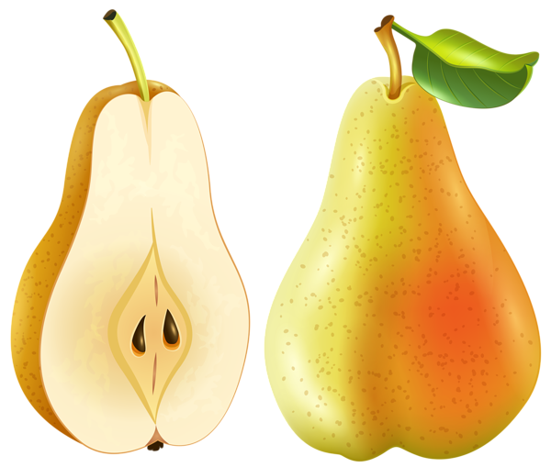
Write the missing letter:
op__ t__pe c__be p__ne be__r ch__ps s__ip pe__r c__b
Third Term

WE CAN 2

