
Unit 4 Places
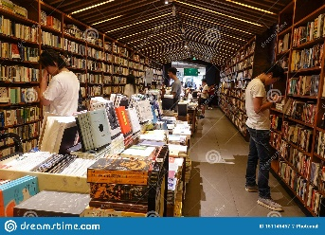
1. You can go shopping and meet friends. = mall
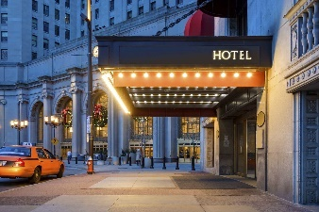
2. You can buy books.= bookstore

3. Visitors can sleep there.= hotel
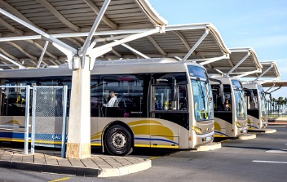
4. You can open an account.= bank
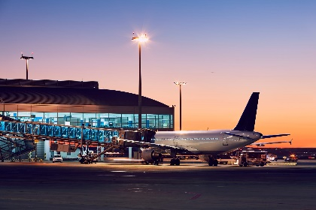
5. You can take a bus.= bus station
6. You can fly to places.= airport
Grammar
لا يستطيع/ يستطيع
Can / can't + مصدر
I can play football. >> I can't play football.
Can you play football? Yes, I can.
No, I can't.
Like to + مصدر
We like to swim. >> We don't like to swim. Do we like to swim? Yes, we do. No, we don't.
He likes to drive. >> He doesn't like to drive. Does he like to drive? Yes, he does. No, he doesn't.
فعل+s فعل
جمع
We, You, They, I
مفرد
He, she, It

doesn't + مصدر… . don't + مصدر…
Does__مصدر…..? Do__مصدر…..?
Unit 5
Women
Clothes
Men

tie

shirt blouse skirt
thobe dress
suit
jacket

shorts boots pants Coat shoes abaya
Grammar
نستخدم be going to
للتعبير عن خطط في المستقبل
Future المستقبل

سوف be going to + مصدر
الكلمات الدالة عليه
tomorrow, next, soon, in the future..

He is going to eat fish. Yes, he is.
He isn't going to eat fish. Is he going to eat fish? No, he isn't.
They are going to sleep. Yes, they are.
They aren't going to sleep. Are they going to sleep? No, they aren't.
am='m I am = I'm
Be is ='s He is = He's She is = She's It is = It's
Are='re We are = We're You are = You're They are = They're
I am going to help mom. I am not going to help mom.
Are you going to help mom? Yes, I am. No, I am not.
Unit 6
اليوم الوطني
National Day

Saudi Arabia Oman Kuwait UAE
Cities and towns are covered in green.
People fly flags & celebrate in the streets.
National Day There are official celebrations, parades, and fireworks.
Families and friends get together to share meals.
People decorate the streets, buildings, homes with bright lights
Grammar
Object pronouns ضمائر المفعول
me, him, her, it, us, you, them
Help me. give us.
Thank you. Send her.
Come with me

Subject Pronouns ضمائر الفاعل  في بداية الجملة | Object Pronounsضمائر المفعول
I | me
He | him
She | her
It | it
We | us  بعد فعل أو حرف جر
You | you
They | them
need
want
like
+ inf.مصدر
to

يحتاج أن need to / want to / like to + المصدر
I need to eat. I want to sleep. He likes to play.
هيا بناLet's +مصدر
Let's play football. Let's go home. Let's eat out.
Grammar
Unit 7
PAST TENSE زمن الماضي
Simple past of /be/ الماضي من الفعل يكون
Be
الحاضر am is are
الماضي was were
الفعل be يعني (يكون (، وله ثلاث كلمات is, are, am
نستخدم is للمفرد و are للجمع وam للأنا
الماضي من هذه الأفعال هي was / were
للمفرد مثل: was
I was a child. He was in Jeddah.
للجمع مثل: were
They were in Abha. We were students.

للنفي Negative
was = wasn’t
were = weren’t

كان was / were
He was happy. Yes, he was.
He wasn't happy. Was he happy? No, he wasn't.
They were fat. Yes, they were.
They weren't fat. Were they fat? No, they weren't.
I was born in Najran. We were born in Najran.
علامات الماضي: yesterday, last, ago
Unit 8
breakfast morning pizza
Meals Lunch Time afternoon foods cookies
dinner evening kebab
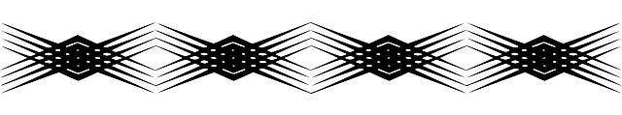
supper night sushi

football smartphone English
Ball volleyball جوال cellphone Arabic
basketball mobile PE.
handball high-tech phone Subjects Art
baseball Math
Science
History
Computer
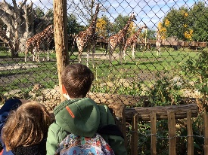

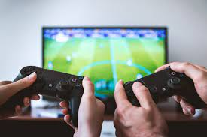
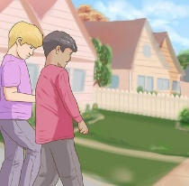
Summary:

Omar went to a friend's house.
played video games.
watched a car race.
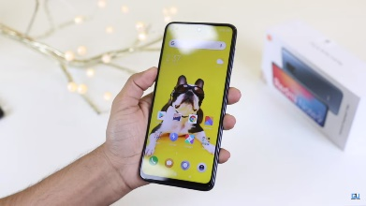
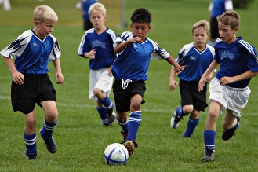
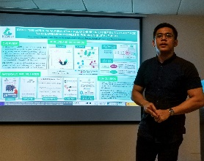
went to the zoo.

Ahmed presented his project.
played football.
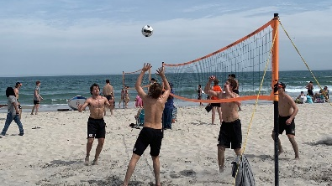

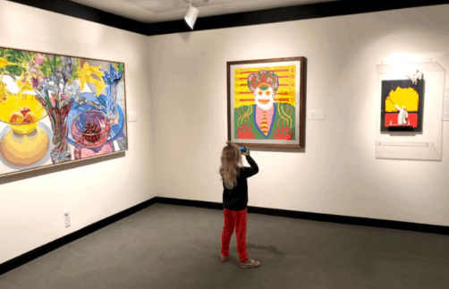
bought a new smartphone.
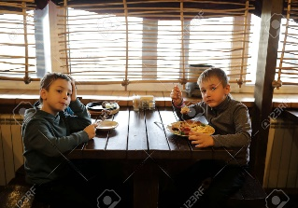

Saeed went to the Art Museum.
drove to the beach.
played beach volleyball.
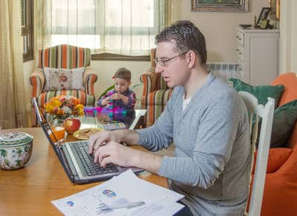
ate lunch at a restaurant.

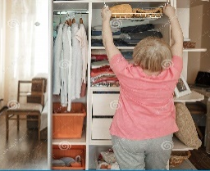


Imad stayed home.
studied for the science test.
cleaned the closet.
searched for information on the internet.
1. competition with cars = car race 3. a high-tech phone = smartphone
2. equipment for video games = console 4. Looking for = searching

Past Simple الماضي البسيط
Grammar
وهو يدل على شيء حدث في زمن الماضي. وللكلام في زمن الماضي يجب تحويل الفعل إلى صيغة الماضي.
* يتكون من: التصريف الثاني للفعل V2 وذلك بإضافة d , ed , ied للفعل العادي regular ما عدا الشواذ.
open > opened cook > ----------- help > ------------- work > -----------
live > lived use > ------------ close > ------------ complete > ------
try > tried study > ------------ carry > ------------- marry > ---------
لاحظ : play > played enjoy > ---------------- obey > --------------- stay > ------------
Stop > stopped travel > ---------------- drop > ----------------- step > ------------
go > went eat > ate sleep > slept buy > bought is/are > was/were

* يدل على: فعل تم وانتهي في الماضي.

* علاماته: yesterday, last , ago, in the past, in….
He played football yesterday. Last year, I went to London.
* نفيه: باستخدام didn't + inf.
She didn't cook lunch. We didn't help our Dad.
* سؤاله: باستخدام Did + inf.
He played tennis. Yes, he did.
He didn't play tennis. Did he play tennis? No, he didn't.

We went home. Yes, we did.
We didn't go home. Did we go home? No, we didn't.
للسؤال في الماضي نستخدم الأفعال المساعدة: did / was / were لتدل على السؤال عن الماضي، أمثلة:

- Did you like the museum? Yes, I did / No, I didn’t. -How was the museum? It was great.
- Where did you go yesterday? I went to the mall. -Were you at home last night? Yes, I was.
- Did you study English? Yes, I did - No, I didn't - Did you see the movie?

الشواذ Irregular Verbs
buy bought drink drank get (up) got (up) have had sleep slept
come came drive drove give gave read read swim swam
do did eat ate go went see saw take took

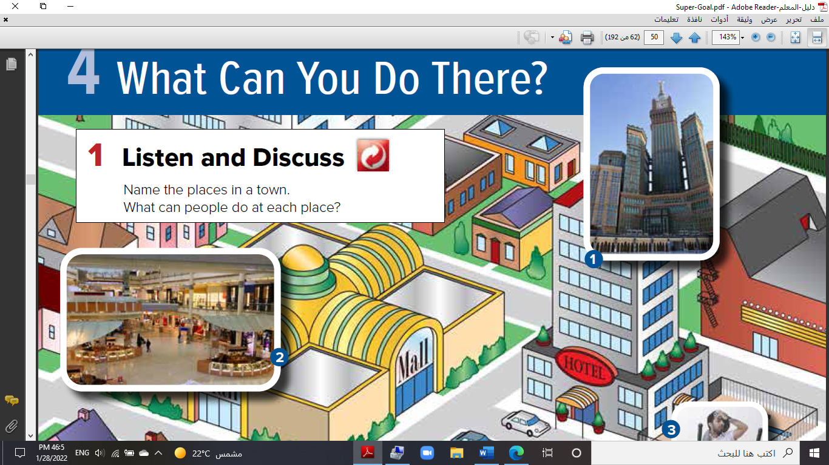
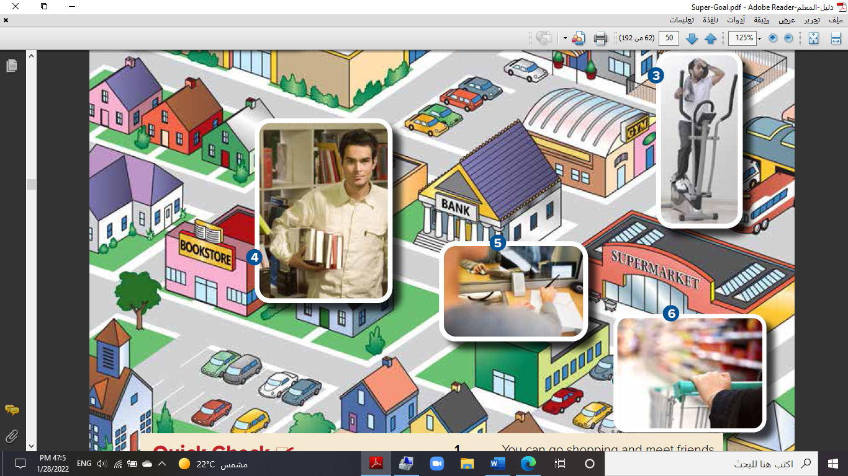
المراجعة النهائية Final revision
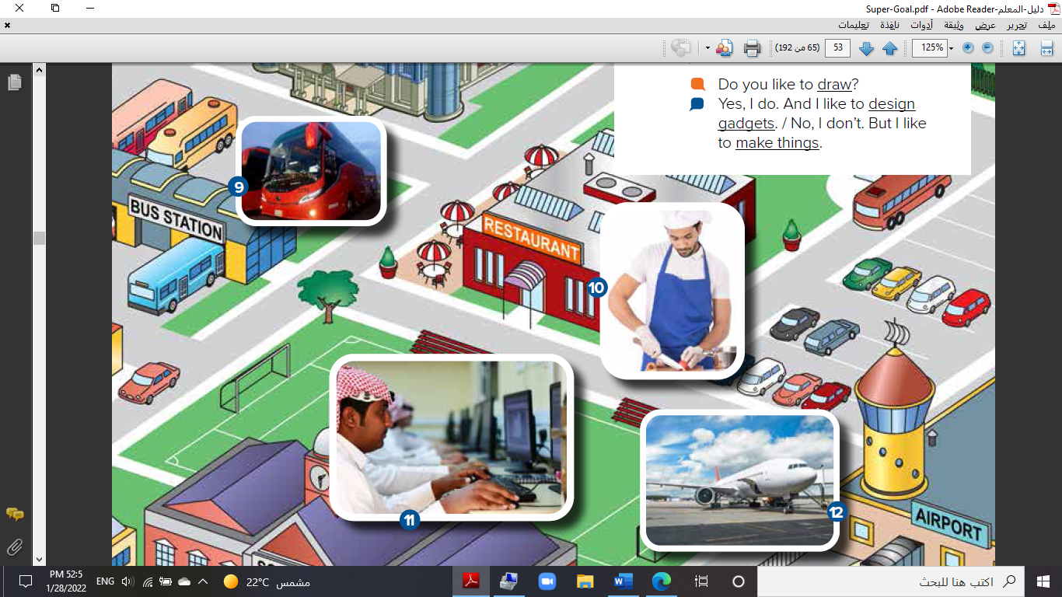

--------------- --------------- -------------------- ----------------------- ---------------------- ---------------
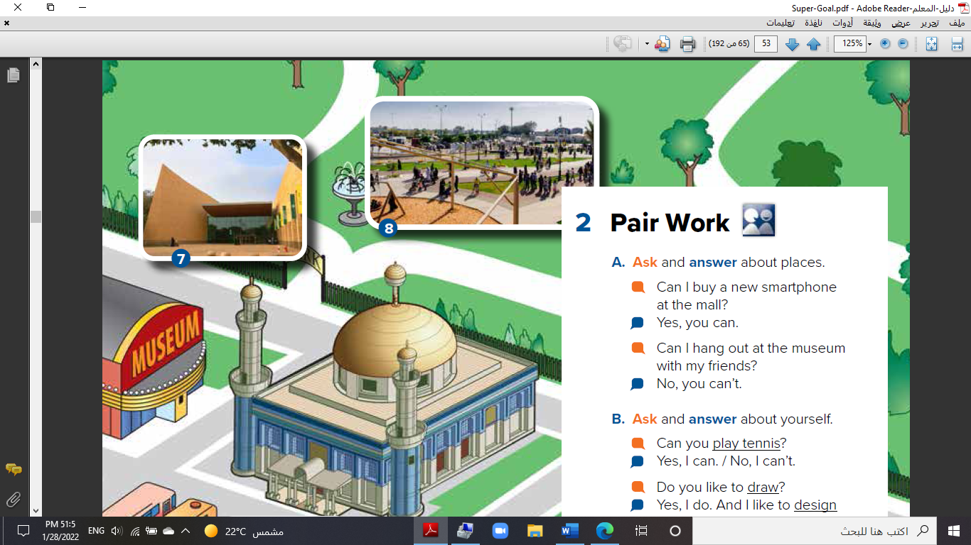
gym – supermarket – park – school – restaurant – museum

---------------- ------------- ---------- -------- ----------- ------
Choose the correct answer:
1.You can go shopping and meet friends at the (mall – bank - school).
2.You can buy books at the (bookstore – hotel – gym)

3.You can study at (school – bus stop – restaurant)
Fill in with: (can - can't)
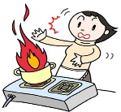
1. He ________ swim.

2. She _________ cook.
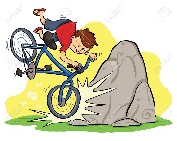
3. I _________ ride a bicycle.

Change into negative:
- I can speak English. .………………………………………………………………………
- You can play golf at the resort. …….……………………………………………………
- She likes to read. …..……………………………………………………………………………
- They like to read. ….……………………………………………………………………
Choose the correct answer:
1. She can (study – go shopping – sleep) in the mall.
2. They can (read – play – eat) in the bookstore.
3. Mom can (cook – buy – sleep) in the supermarket.
4. I can (fly – swim – sleep) in the airport.
5. My father can take (candy – money – food) from the bank.
Choose the correct answer:
1. I can (speak – speaks – speaking) English.
2. She can (cook – cooks – cooking) delicious food.
3. He (not can – doesn't can – cannot) drive today.
4. Ali likes to (watch – watches – watching) movies.
5. I (like – likes – liking) to paint.
6. Ali (like – likes – liking) to ride his bike.
7. They (doesn't like – don't like – not like) to go by bus.
8. She (doesn't like – don't like – not like) to clean by herself.
Match the words with their definitions:
a. you can go shopping |  | 1. Restaurant.
b. you can buy books. |  | 2. The park
C. you can eat. |  | 3. Mall
D. you can take a walk. |  | 4. Health Club
e. you can workout |  | 5. Book Store
Choose the correct answer:
1. He (am – is – are) going to play tennis. 2. They (am – is – are) going to help family.
3. I (am – is – are) going to clean the room. 4. (Am – Is – Are) you going to visit uncle?
5. (Am – Is – Are) she going to help us? 6. (Am – Is – Are) Ali going to come home?
7. Is he (go – goes – going) to study English? 8. Are we (goes – going – go) to relax here?
9. Nora is going (too – two – to) work hard. 10. We are going to (cooks – cooking – cook).
11. She is going to (works – work – working) hard. 12. I am going to (help – helps – helping) dad.
13. I ('m – 's – 're) going to watch TV. 14. He ('m – 's – 're) going to study French.
15. You ('m – 's – 're) going to visit Egypt. 16. I -------- going to study English.
17. He ----------- going to write English. 18. We ------------ going to read French.
19. She is ------------ to sleep early. 20. They are going ------------- run fast.
Find and circle the word that not belong.
shirt jeans blouse T-shirt
1. shorts jeans pants shirt
2. skirt blouse tie dress
3. coat jacket sweater sunglasses
4. shirt boots sandals shoes
5. dress jeans abaya skirt
6. T-shirt shirt gloves blouse
Write the clothes:

………………… ……………………… ……………………… ……………………… ……………………… …………………

------- ---------- ----------- ---------- ------------ -----------
Choose the best answer to fill in the blank.
1. In Saudi Arabia, people fly _____ on September 23rd.
flags - streets - fireworks - celebrations
2. On special days, families and friends usually get together and share ____.
buildings - meals - decorations - lights
3. You _____ the street when the light is red.
mustn’t cross - should cross - must not to cross - should cross not
4. We _____ kind and generous to others.
must always - should always being - must to always be - should always be
Choose:
1. We need (to buy – buy – buying) some snacks.
2. I want (to invite – invite – inviting) you to my party.
3. She likes (watch – to watch – watches) TV.
4. I (like – need – likes) chocolate. (I like – want – likes) to buy some.
5. I will invite (me – you – he) to my party.
6. I want to meet my neighbors. I don’t know (them – you – she)
7. Please, help (I – me – my).
Unscramble the sentences.
1. my / to call / need / I / friends
2. the house / likes / to decorate / Mariam
3. snacks / to buy / you / Do / need / ?
4. like / laptop / He / to share / doesn’t / his
5. don’t / an invitation / need / We / to send
Match the Sentence with the picture:
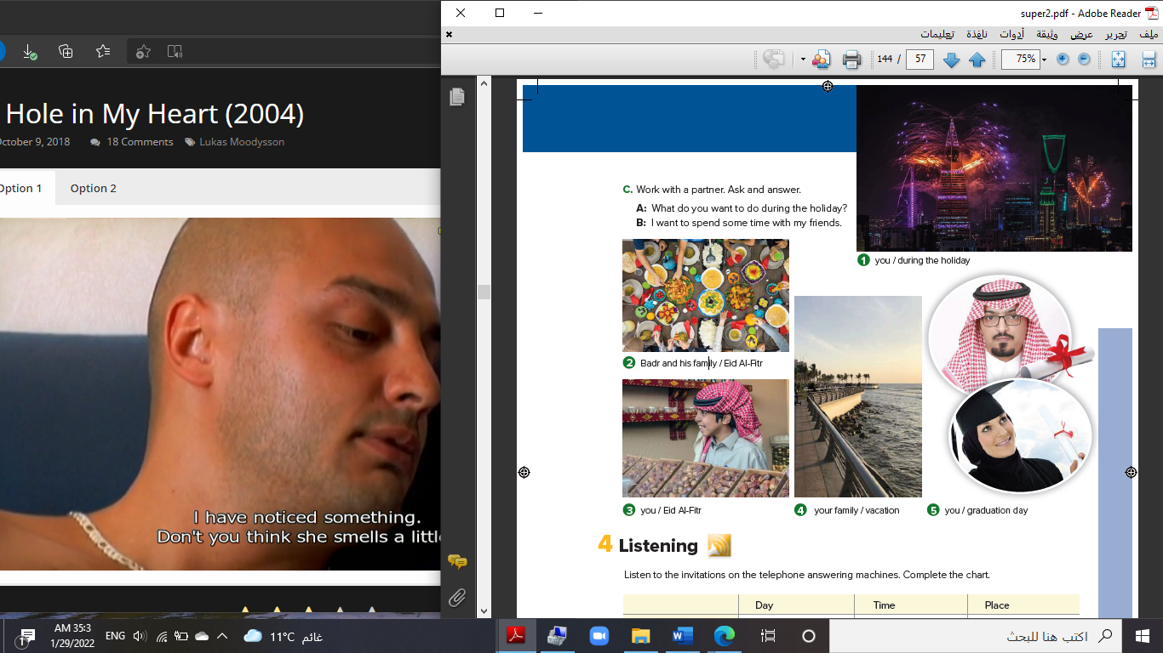

1. I want to spend some time with my friends.
2. They want to have a family dinner or traditional meal.
3. I want to see my cousins, eat dates, and drink tea.
4. They want to go to the beach.
5. I want to have a graduation party.
Choose the correct answer:
1- He (was – were – are) at home. 5- They (was – were – is) at school.
2- (Was – Were – Is) you fat? 6- (Was – Were – Are) she clever?
3- We (wasn't – weren't – isn't) happy. 7- Ali (wasn't – weren't – aren't) here.
4- The boys (wasn't – weren't – isn't) nice. 8- The cat (wasn't– weren't– aren't) thin.

Choose the best answer to fill in the blank.
1. In old Riyadh, many houses were made from (mud – town – city) bricks.
2. In modern Riyadh, you can see many (skyscrapers - walls – population)
3. My grandfather (was – were – are) a car salesman.
4. Majid Ahmed Abdullah (is born – were born – was born) in Jeddah.
5. When I was a child, I (wasn't – weren't – isn't) a good student.
Choose the correct answer:
1- What (is – was – did) you do last weekend? 6- I (didn’t – isn't – doesn't) stay home.
2- Where did they (go – goes – going) on Thursday? 7- They (went-goes- going) to the beach.
3- They didn’t (goes – going – go) to the Cinema. 8- (Does- Is- Did) they like the museum?
4- (Do – Is – Did) she come early? 9- No, she (did – didn't – aren't)
5- Yes, we (did – didn't – is). 10- (Yes – No), I didn't.
Choose the correct answer:
1. I (go – went – goes) to beach yesterday.
2. What did you (buy – bought – buying) yesterday?
3. We (travel – travelled – travels) to Makkah last week.
4. (Did – Does – Do) she study yesterday?
Do as shown between brackets:
1. Hind worked at hospital. (Make negative)
2. He came to school late. (Make negative)
Match the phrases to make sentences.
1. ___ Sabah finished a. because it’s boring.
2. ___ Sabah always finishes b. vacation to Malaysia last summer.
3. ___ My family and I go on c. her assignment last Monday.
4. ___ My family and I went on d. have for breakfast?
5. ___ I don’t like this art exhibit e. her assignments on time.
6. ___ I didn’t like the art exhibit f. have for breakfast this morning?
7. ___ What did you g. because it was boring.
8. ___ What do you usually h. vacation twice a year.
Choose the correct answer:
1. He (take – taking – took) a walk in the park.
2. He (isn't – don't – didn’t) do the laundry yesterday.
3. He (goes – go – went) to the mall last Friday.
4. He didn’t (go – went – going) to the football game.
5. (Did – Does – Is) you read a book?
6. He didn’t (work – worked – works) outside in the garden.
7. He (talked – taking – talk) on the phone.
8. He didn’t eat a snack (tomorrow – now – yesterday).
9. He (drank – drinking – drink) hot chocolate.
10. Did you play tennis? (Yes, I didn't – No, I didn't – No, I did).

