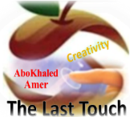

المملكة العربية السعودية
Kingdom of Saudi Arabia
Ministry of Education
------- Educational Directorate
------- Future Educational Schools
1st grade intermediate 2022
3rd Term – Final Exam
وزارة التعليم
الإدارة العامة للتعليم بن
مدارس م ن التعليمية
الصف الاول المتوسط
الاختبار النهائي للفصل الدراسي الثالث1443
Total  written | 5 spelling | 4 Vocabulary | 3 Grammar | 2 Comprehension |  | 1 Composition | Q. NO.  Model Answers نموذج اجابة
 |  |  |  |  |  |  | Mark Given
30 | 4 | 7 | 7 | 6 |  | 6 | Mark
 |  |  | Reviser |  |  |  | Corrector
زمن الاختبار: ساعتان
اسم الطالب: ------------------------------------ رقم الجلوس: ------------- الصف الأول المتوسط

6

1) Composition
1- Write a paragraph about “Your Favorite Place"
You may use 50 words:
…………………………………………
………………………………………………………………………………………………………………………………………………………………………………………………………………………………………………………………………………………………………………………………………………………………………………………………………………………………………………………………………………………………………………………………………………………………………………………………………………………………….

2) Comprehension

6
2- Read the following passage then answer the questions:

The Sports Center
I like to go to the sports center. I go there every weekend. At the sports center, you can do many things. For example, you can play golf or tennis. There is a pool, so you can also swim or relax by the pool. There is a beach next to the sports center. You can swim, water-ski, or windsurf in the ocean. You can also sail on windy days. There aren’t any fish near the beach, so you can’t snorkel. When I go to the sports center, I like to play volleyball on the beach. I also like to jog on the beach. I can’t swim well, so I don’t like to water-ski or windsurf.
A- Put ( ) or ( x ):
1. The writer likes the sports center. ( √ )
2. You can swim in the pool or in the ocean. ( √ )
3. People can windsurf in the pool. ( X )
4. You can’t use a boat in the ocean. ( X )
5. In the sports center, there aren't many things. ( X )
B- Choose the correct answer:
1. There is a (peach – beach – fetch) next to the sports center.
2. There aren’t any (fish – meat – fruit) near the beach
3. He doesn’t like to water-ski or (windows – doors – windsurf).
4. You can also sail on (rainy – snowy – windy) days.
C- Answer the following questions:
To the sports center.
1. Where does the writer like to go?.............................
Every weekend.
2. When does he go?...........................
Golf or tennis.
3. What does he play on the beach? ..............................
3) Grammar

A: Choose the correct answer:

7
1. She (can – can't – does) cook well. She is bad at cooking.
2. We (don't like – doesn't like – isn't like) to stay up for late hours.
3. She (am – is – are) going to visit her friends.
4. Ali is a nice guy. I want you to meet (them – him – her)
5. He wants (to reads – to reading – to read) some books.
6. We (was – were – is) at home, waiting for you.
7. They (eat – eating – ate) a delicious meal last weekend.
8. Did you do your homework? No, I (is – did – didn't).
B: Chang into Negative:
1. They can play football.
They can't play football.
…………………………………………………………………………………………………………………………………………………………………………………………………………………
2. He is going to dust his room.
He isn't going to dust his room.
……………………………………………………………………………………………………………………………………
3. We stopped at the supermarket to buy ice cream.
We didn't stop at the supermarket..
……………………………………………………………………………………………………………………………………
C: Make Yes/No question:
1. He can read English well.
Can he read English well?
……………………………………………………………………..……………………………………………………………
2. She is going to call her friend.
Is she going to call her friend?
……………………………………………………………………………………………………………………………………

3. We visited our friends in Najran.
Did we visit our friends in Najran?
……………………………………………………………………………………………………………………………………
4) vocabulary:

7
A- Match the words with the pictures:
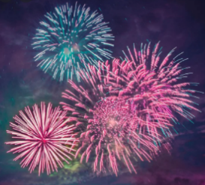
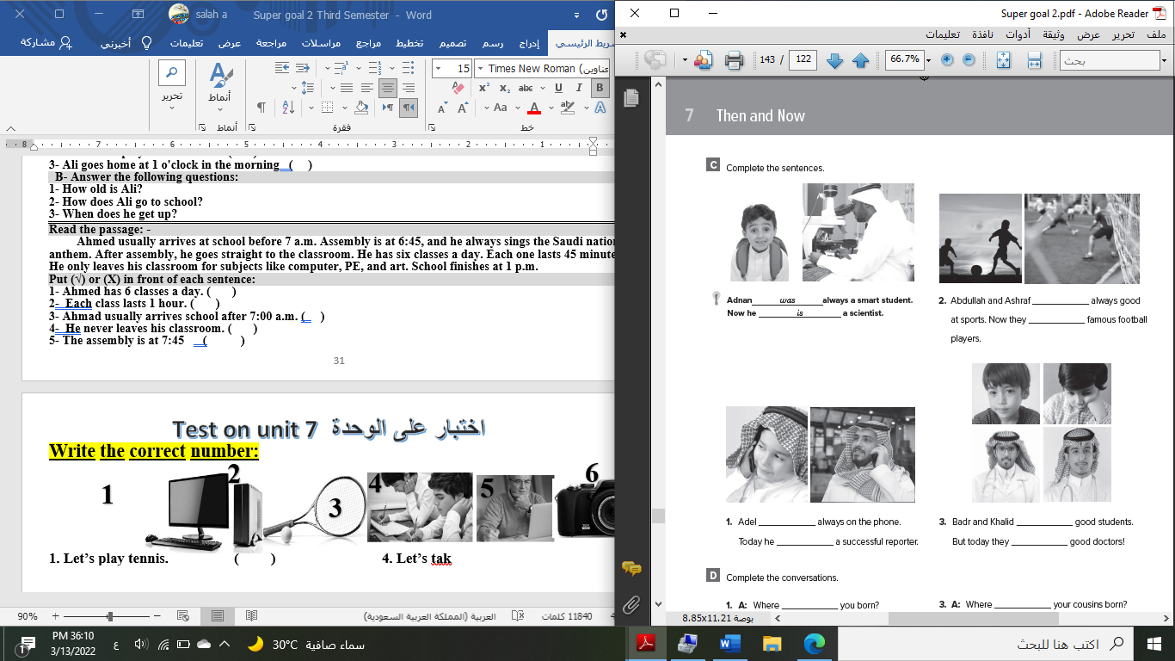
doctor - meal – shirt – bus stop – fireworks – beach

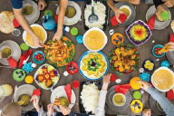

bus stop shirt meal fireworks doctor beach
B- Match the answers:
a. green color | 1. You can open an account. ---c---
b. Riyadh | 2. Men wear it for work. ---d---
c. bank | 3. In Saudi Arabia, people decorate houses in ---a---
d. thobe | 4. The King of Saudi Arabia is ---e---
e. King Salman | 5. It was a traditional place then it became the capital ---b---

C- Circle the correct spelling:

1. natonial - nashional – national
2. house – huoes - hosue
3. yesteday – yesterday – yetserday

5) Orthography:

4

A- Fill in the missing letters:

1- buil_d_ing
p – d – r – o – s
2- cons_o_le
3- celeb_r_ation
4- air_p_ort
B- Choose the odd one out:
1. suit jeans tie abaya
2. watch school help eat
3. Emirates Kuwait under Oman
4. teacher morning afternoon evening

End of Questions
Best of Luck

