English Language
Mega Goal 1.3
1st Secondary Grade
Time: 0:45 minutes
Kingdom of Saudi Arabia
Ministry of Education
…………………………….. Education Directorate
……………………………………. Secondary School



English Language Midterm Exam Form of the Year 1444 AH – 3rd Semester/1st Session/Pathway System

Name: …………………………………………………………………………………………………..……… . Class: ……………………… .

10

Units 1-3

2

1. Guided Composition

Consider the following pictures. Then, speculate what happened using "can't/must/maybe".
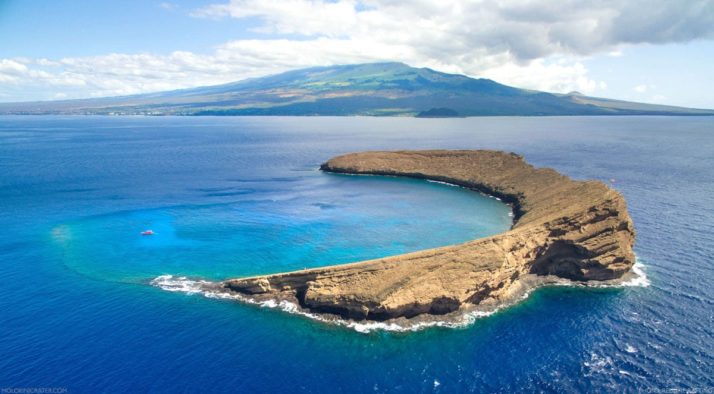
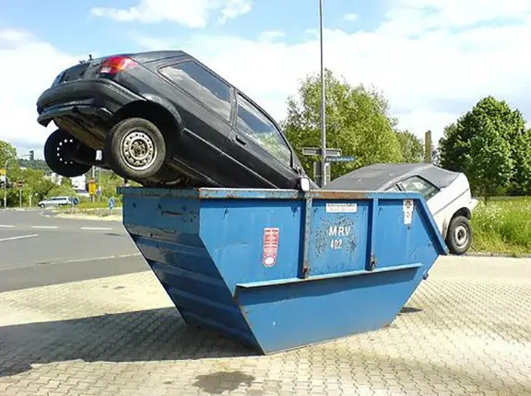

1
Please turn the page over

2
3. Reading Comprehension

Read the following passage. Then, answer the given questions:
Teenage is a very important stage in human life. It is full of stress. There are many things that make teenagers feel stressed and cause teenage stress.
What is stress?
Stress is the mental and physical strain or the nonspecific response of the body to any demand made upon it. Stress is a chemical reaction that takes place inside the body when there is a basic need to adapt to or resist changing internal or external influences. It is a response meant to return the body and mind to a state of equilibrium and balance.

1. This passage is about …
□ how to send email
□ teenage stress
□ new recipe

2. The main idea of the passage is …
□ working hard
□ calling for help
□ definition of stress

3. Stress is a chemical reaction that occurs inside the body, isn't it?
□ Yes, it is.
□ No, it isn't.

4. Stress results from adapting to or resisting changing internal influences, only.
□ True
□ False

5. On line (4), the adjective " mental " relates to ……………… .
□ body
□ mind
□ soul

6. The pronoun "It" on line (5) refers to …………………. .
□ stress
□ the body
□ teenage stage

2
Please turn the page over

3
3. Grammar
A). Tike the correct answer:
1. That period of history was ……………… fascinating!
□ bit
□ very
□ little
□ absolutely

2. Turn off your cell phone and enjoy ……………… on the beach.
□ sit
□ sits
□ sitting
□ doesn't sit

3. The whole city was destroyed by the hurricane, ……………… the citizens moved to another place.
□ or
□ so
□ and
□ but

4. Could you ……………… this form, please?
□ fill in
□ to fill in
□ filled in
□ filling in

B). Underline the correct verb:

 | Hind hasn't contacted her relatives ………….. Monday. She called them ………….. night.
 | A. [ in – since – for ] |  | B. [ on – ago – last ]

C). Highlight the correct answer:

1. | If Rana ………………… faster, she will finish sooner.
A. | write | B. | wrote | C. | written | D. | writes
2. | You needn't worry. The police have ………………… found the lost child. Listen to the live news!
A. | yet | B. | just | C. | already | D. | still

D). Choose the correct option:

1. | The button on the shirt is (A). It needs to (B). I want to (C) it (D).
A. | go  gone | B. | sewed  be sewn | C. | has  have | D. | repair  repaired
2. | I shouldn't (A) at the park longer. If I (B) earlier, I could (C) lunch before you (D) home.
A. | stayed  have stayed | B. | leaves  had left | C. | had prepared  have prepared | D. | arrived  arriving
3

Please turn the page over
1
1

3
4. Vocabulary

1. Fill in the blanks with the correct words:

urban –– states –– scratched DVD –– asset –– Excuse me
- The new invention will be a great …………………………………………………….…….. to our country.
- Telecommunications will be updated in …………………………………………………….…….. and rural areas.
- Murphy's Law …………………………………………………….…….. : If anything can go wrong, it might go wrong!".
- …………………………………………………….……. . What's going on?

2. Replace the underlined words with the correct synonym:

seems to be –– constantly checking –– lasting –– far away –– sleeves

Sentence | Synonym
a). My house is in a remote district.
b). You don't have a boss breathing down your neck.
c). We need a sustainable energy and a secure environment.
d). What a dress! It sounds like one of Donna Karan's creation.

3. Match each expression from column (A) with what fits (as a meaning) in column (B):

A |  | B
1 | That noise at the kitchen maybe from a dripping faucet or a leaky pipe! You never know. | ( ) | Plan activities.
1 |  | ( ) | Anything is possible.
1 |  | ( ) | What to be aware of.
1 |  | ( ) | Self-esteem is a real need.
2 | I want to go get a job and go out into the world. | ( ) | Having no idea.
2 | I want to go get a job and go out into the world. | ( ) | Share and share alike.
2 | I want to go get a job and go out into the world. | ( ) | 'd rather have a refund.
2 | I want to go get a job and go out into the world. | ( ) | Start to be on my own and independent.

Questions Over

With best wishes,
Nourah Abdul Aziz
4

