Vocabulary

1. ……………… is antibacterial drugs.
A | Oil | B | Penicillin | C | Inventions | D | Infections

2. …………………. allow heavy objects to be moved easily.
A | Wheels | B | Computer | C | Oil | D | Gaslights

3. in 5000 B. C. Stands for
A | Anno Domini | B | historical | C | new | D | Before Christ

4. ……………….. is the flow of electrical power or charge.
A |  | B |  | C | Electricity | D

5. Match to form expressions ( load - bulb – well – guard )
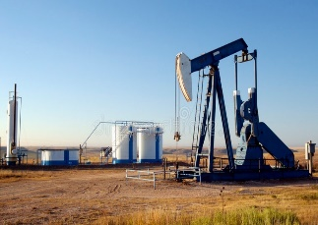 | 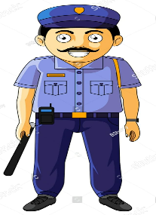 |  | 
oil ……….. | security……… | heavy ……… | electric ………..

Match
1. Regret | 4 | ruined
2. Traveling on ship or …. | 3 | disadvantages
3. advantages # | 2 | airplane
4. devastated | 1 | feel sad or disappointed
5. heirloom |  | advice
6. go out into the world | 8 | be firmly decided
7. breathing down someone`s neck | 7 | constantly checking
8. have one`s mind set on something | 6 | start to be on one`s own and independent
 | 5 | a valuable object that has belonged to a family of several generations.

Grammar
1. – If it …………………………… , we wouldn’t have gone shopping.
A | had rain | B | had rained | C | had raining | D | has rain

2. He failed the test. He should ……………. studied harder .
A | has | B | have | C | had | D | hadn't

3. If I had studied hard, I would ………………………… the exam .
A | have passed | B | have pass | C | has passed | D | pass

4. If they had worked harder, they …………………………… more money .
A | might have make | B | might make | C | might made | D | might have made

5. If I hadn’t _________ my book, I would have been in trouble.
A | find | B | finds | C | found | D | finding

6. We moved to Dubai 5 years __________.
A | ago | B | for | C | when | D | since

7. She has been here ………………… 7 o’clock .
A | when | B | yet | C | for | D | since

8. …………………… I use your pen, please?
A | May | B | should | C | would | D | shouldn’t

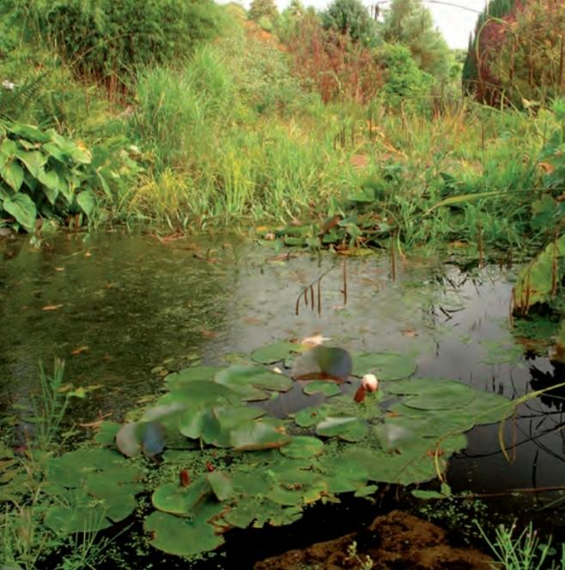 Regrets – I've had a few!
My name's Jack and I want to tell you about something I regret. It happened over twenty years ago, but I still remember it as if it was yesterday. I must have been around five years old. It was a summer day and I was in a park playing with some other kids from the neighborhood. There was a boy there named Jeremy who I didn't like very much, but I can't remember why. Anyway, we were playing near a pond. The water was very dirty and it was full of weeds and slime. You can guess what I did, right…? I waited until he was standing near the edge of the pond, and then I crept up behind him and gave him a good hard push in the back ... he went flying straight into the filthy, slimy water! His dad rushed over and pulled him out. Jeremy was crying and pointed at me, saying "It was him. He pushed me!" Of course, I denied it. My parents were there, but I insisted I was innocent and without any proof they took my side. The bad thing is that Jeremy's parents and mine used to be good friends, but after that they never spoke to each other again. I should have told my parents the truth, but I didn't. To this day, I still regret pushing that boy into the pond.
A. Write (T) for true And (F) for False
1. There was a boy there named Jeremy. (refer to) in the park | T
2. I crept up behind him. (refer to ) Jack`s parents | F
3. I denied it. (refer to ) pushing him in the pond | T

B. Choose the Correct meaning:
1. neighborhood = …………
A | nearness | B | farness | C | distance
2. innocent = …………
A | guilty | B | guiltless | C | at fault

