Vocabulary

1. The synonyms of dirty is …. .
A | filthy | B | noisy | C | leaky | D | worry

2. To get one`s payment back means ….
A | repair | B | warranty | C | refund | D | replace

3. Someone who makes repair called …..
A | assistant | B | costumer | C | consumer | D | technician

4. The T-shirt is torn. This damage is refer to ……. Problem.
A | Car Repair | B | Housing | C | Clothing | D | Products

5. No power in the battery means ……… battery.
A | charging | B | dead | C | full | D | powerless

6. Which is consumer problem does NOT belong to the Electronic Products?
A | scratched DVD | B | TV- lines on screen | C | no signal | D | broken doorknob

7. Which is consumer problem does NOT belong to the Housing?
A | Loose floorboards | B | Missing button | C | Broken windowpane | D | Filthy walls

8- The ……. has a dent.
A | car | B | pants | C | sleeve | D | tap

9. Identify the items (dripping faucet - stained shirt – flat tire - leaky pipe – dented in the body – cracked windshield )
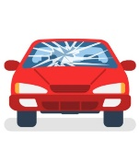 | 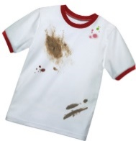 | 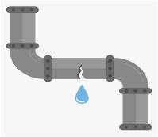 | 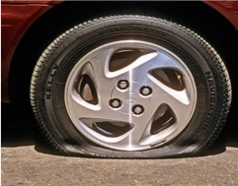 | 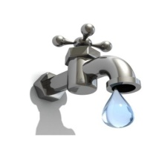
cracked windshield | stained shirt | leaky pipe | flat tire | dripping faucet
10. Match
1. upright # | 4 | unclear
2. faded | 3 | Thin , not strong
3. flimsy | 2 | brightness
4. fuzzy | 1 | Upside down
 | -- | error

Grammar
1. The floor has …………. tiles.
A | break | B | broken | C | breaking | D | breaked

2. The tire is ………. .
A | wear | B | wore | C | worn | D | wearing

3. It ………….. fixed.
A | to be | B | needs be | C | need to | D | needs to be

4. I`m going to have the roof …… .
A | cleaned | B | clean | C | cleaning | D | cleaner

5. The pencils ……… sharpened.
A | to be | B | need to be | C | need to | D | needs to be

6. No, I haven’t cleaned them ……… .
A | already | B | just | C | yet | D | not

7. He can`stand …………….. in line.
A | wait | B | waited | C | waiten | D | waiting

8. I don’t enjoy ………… in the sun.
A | sitting | B | sit | C | sat | D | sitted

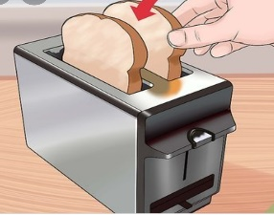
Complaint regarding replacement of defective Electric Toaster

Dear M. Ali,

I hereby wish to bring to you notice that the electric toaster that I have purchased from your company on 03rd January 2022 is defective. I received a sealed piece from your stores along with the warranty card. However, when I opened the toaster and started to use it according to the instructions it did not work at all.

I am a loyal customer who has purchased many electronic products from your stores before but never faced such issues in earlier occasions. I request you kindly to replace the defective electric toaster at the earliest.

I am also enclosing a copy of the purchase bill for your perusal and records.
Thanking you in anticipation of a quick and positive response.
Sincerely,
Saad.

A. Write (T) for true And (F) for False
1. The name of faulty product is toaster. | T
2. Buying time of this product was on 03/Oct/2022 | F
3. The costumer asked for refund | F

B. Choose the Correct meaning:
1. purchase = …………
A | sell | B | borrow | C | buy
2. defective = …………
A | good | B | faulty | C | work

